

**FPT UNIVERSITY TEST**

Capstone Project Document

**Design and implement a management system for a chain of hotels and motels using IoT technology**

|  |  |
| --- | --- |
| **Group GSU22SE44** | |
| **Group members** | Lê Hồng Nguyên – SE130342 Nguyễn Quốc Trường Huy – SE140296 Hoàng Tuấn Anh– SE140335 |
| **Supervisor** | Mr. Nguyễn Đức Lợi  Mr. Nguyễn Tấn Danh |
| **Capstone Project code** | DIMS |

*- Ho Chi Minh City, 18 May 2022 –*

# Table of Contents

Table of Contents 2

List of Tables 4

List of Figures 6

Acknowledgement 8

Definition and Acronyms 8

I. Project Introduction 9

1. Overview 9

**1.1.** **Project Information** 9

**1.2.** **Project Team** 9

2. Product Background 9

3. Existing Systems 10

**3.1.** **App 1: Pin Bike** 10

**3.2.** **App 2: GoVNU** 10

4. Business Opportunity 11

5. Software Product Vision 11

6. Project Scope and Limitations 11

**6.1.** **Major Features** 11

**6.2.** **Limitations and Exclusions** 12

II. Project Management Plan 12

1. Overview 12

**1.1.** **WBS and Estimation** 12

**1.2.** **Project Objectives** 15

**1.3.** **Project Risks** 15

2. Management Approach 16

**2.1.** **Project Process** 16

**2.2.** **Quality Management** 16

**2.3.** **Training Plan** 17

3. Project Organization 17

**3.1.** **Team and Structures** 17

**3.2.** **Roles and Responsibilities** 18

4. Project Communication 18

**4.1.** **Communication Plan** 18

**4.2.** **External Interface** 19

5. Configuration Management 19

**5.1.** **Tools and Infrastructures** 19

**5.2.** **Document Management** 20

**5.3.** **Source Code Management** 20

III. Software Requirement Specification 20

1. Overall Description 20

**1.1.** **User Requirement Overview** 20

**1.2.** **Business Rules** 22

**1.3.** **Overview** 28

**1.4.** **Use Case Specifications** 34

2. Functional Requirements 140

**2.1.** **System Functional Overview** 140

3. Non-Functional Requirements 146

**3.1.** **External Interfaces** 146

**3.2.** **Quality Attributes** 147

IV. Software Design Description 147

1. Overall Description 147

**1.1.** **Assumptions** 147

2. System Architecture Design 147

**2.1.** **Overall System Architecture** 147

**2.2.** **Component Diagram** 149

**2.3.** **Package Diagram** 150

3. Activity Diagram 151

4. System Detailed Design 154

**4.1.** **Class Diagram** 154

**4.2.** **Class Specification** 155

**4.3.** **State Machine Diagrams** 178

**4.4.** **Sequence Diagram** 179

5. Data and Database Design 183

**5.1.** **Database Design** 183

**5.2.** **Data File Design** 183

6. Algorithm 202

V. Software Testing Documentation 204

1. Overall Description 204

**1.1.** **Test Model** 204

**1.2.** **Testing Levels:** 204

2. Test Plan 204

**2.1.** **Test Stages** 204

**2.2.** **Resources** 204

**2.3.** **Test Milestones** 205

3. Test Cases & Test Reports 205

VI. Release Package and User Guides 205

1. Deliverable Package 205

**1.1.** **Source Codes and Documents** 205

2. Installation Guide 206

**2.1.** **System Requirements** 206

**2.2.** **Setup Files** 207

**2.3.** **Installation Instruction** 207

3. User Manual 215

**3.1.** **Terms and Definitions** 215

**3.2.** **System Requirement** 215

**3.3.** **Application Usage** 215

**3.4.** **Troubleshooting** 265

VII. Appendix 265

# List of Tables

Table 1. Definition and Acronyms 9

Table 2. Supervisor 9

Table 3. Team members 9

Table 4. WBS and Estimation 15

Table 5. Project Objectives 15

Table 6. Project Risks 16

Table 7. Training Plan 17

Table 8. Team and Structures 18

Table 9. Roles and Responsibilities 18

Table 10. Communication Plan 19

Table 11. FPTU Contacts 19

Table 12. Tools and Infrastructures 20

Table 13. Business Rules 28

Table 14. System Actors 30

Table 15. Use Cases List 34

Table 16. System Architecture 149

Table 17. Component Diagram Description 150

Table 18. Package Diagram Description 151

Table 19. AppUser Class Attribute 157

Table 20. AppUser Class Method 157

Table 21. Bike Class Attribute 158

Table 22. Bike Class Method 158

Table 23. UserAddress Class Attribute 159

Table 24. UserAddress Class Method 159

Table 25. Intimacy Class Attribute 159

Table 26. Intimacy Class Method 160

Table 27. Report Class Attribute 160

Table 28. Report Class Method 160

Table 29. S.O.S Class Attribute 161

Table 30. S.O.S Class Method 161

Table 31. Point History Class Attribute 162

Table 32. Point History Class Method 162

Table 33. Trip Class Attribute 163

Table 34. Trip Class Method 163

Table 35. Route Class Attribute 164

Table 36. Route Class Method 164

Table 37. Station Class Attribute 165

Table 38. Station Class Method 165

Table 39. Area Class Attribute 165

Table 40. Area Class Method 166

Table 41. Feedback Class Attribute 166

Table 42. Feedback Class Method 167

Table 43. Trip Transaction Class Attribute 167

Table 44. Trip Transaction Class Method 167

Table 45. Wallet Class Attribute 168

Table 46. Wallet Class Method 168

Table 47. Redemption Class Attribute 168

Table 48. Redemption Class Method 169

Table 49. Voucher Category Class Attribute 169

Table 50. Voucher Category Class Method 169

Table 51. Voucher Class Attribute 170

Table 52. Voucher Class Method 170

Table 53. Voucher Address Class Attribute 171

Table 54. Voucher Address Class Method 171

Table 55. Address Class Attribute 171

Table 56. Address Class Method 172

Table 57. Advertisement Address Class Attribute 172

Table 58. Advertisement Address Method 172

Table 59. Advertisement Class Attribute 173

Table 60. Advertisement Class Method 173

Table 61. Voucher Image Class Attribute 173

Table 62. Voucher Image Class Method 173

Table 63. Voucher Code Class Attribute 174

Table 64. Voucher Code Class Method 174

Table 65. Momo Transaction Class 175

Table 66. Momo Transaction Method 175

Table 67. Role Class Attribute 175

Table 68. Role Class Method 175

Table 69. Notification Class Attribute 176

Table 70. Notification Class Method 176

Table 71. Configuration Class Attribute 177

Table 72. Configuration Class Method 177

Table 73. App User Table 185

Table 74. Bike Table 186

Table 75. Intimacy Table 186

Table 76. Wallet Table 187

Table 77. Trip Tabel 189

Table 78. Route Table 189

Table 79. Station Table 190

Table 80. Area Table 190

Table 81. Trip Transaction Table 191

Table 82. Feedback Table 192

Table 83. Redemption Table 192

Table 84. Voucher Table 193

Table 85. Advertisement Table 194

Table 86. Report Table 195

Table 87. S.O.S Table 195

Table 88. Point History Table 196

Table 89. User Address Table 196

Table 90. Address Table 197

Table 91. Advertisement Address 197

Table 92. Advertisement Image Table 198

Table 93. Voucher Code Table 198

Table 94. Voucher Category table 199

Table 95. Voucher Image Table 199

Table 96. Voucher Address Table 199

Table 97. Role Table 200

Table 98. Notification Table 201

Table 99. Bike Availability Table 201

Table 100. Momo Transaction Table 202

Table 101. Configuration Table 202

Table 102. Source Codes and Documents 206

Table 103. Software Requirement 207

Table 104. Hardware Requirements 215

# List of Figures

Figure 1. Incremental Model 16

Figure 2. Use Case Diagram 29

Figure 3. Mobile App Screen Flow 140

Figure 4. Web Admin Screen Flow 141

Figure 5. Entity Relationship Diagram 146

Figure 6. System Architecture Diagram 148

Figure 7. Component Diagram 149

Figure 8. Package Diagram 150

Figure 9. Activity Diagram - Create trip 152

Figure 10. Activity Diagram - Redeem voucher 153

Figure 11. Activity Diagram - Accept a trip 154

Figure 12. Class Diagram 155

Figure 13. Trip's States 179

Figure 14. Create Trip Now Sequence Diagram 180

Figure 15. Create Schedule Trip Sequence Diagram 180

Figure 16. Redeem Voucher Sequence Diagram 181

Figure 17. Search Trip Sequence Diagram 182

Figure 18. Send Trip Feedback Sequence Diagram 183

Figure 19. Physical Diagram 183

Figure 20. Application Usage Overview 216

# Acknowledgement

Foremost, we would like to express our sincere gratitude to our mentor Mr. Nguyen Duc Loi and Mr. Nguyen Tan Danh for the continuous support of our capstone project, for his patience, motivation, enthusiasm, and immense knowledge. His guidance helped us in all the time of research, designing, building, and developing of this thesis. We could not have imagined having a better advisor and mentor for our capstone project.

Last but not the least, we would like to thank our family for giving birth to us at the first place and supporting us spiritually throughout our life.

# Definition and Acronyms

|  |  |
| --- | --- |
| **Acronym** | **Definition** |
| DIMS | Management system for a chain of hotels and motels using IoT technology |
| BR | Business Rule |
| ERD | Entity Relationship Diagram |
| GUI | Graphical User Interface |
| UC | Use Case |
| W | Web App |
| M | Mobile App |
| API | Application Program Interface |

Table 1. Definition and Acronyms

1. Project Introduction
2. Overview
   1. **Project Information**

* Project name: Design and implement a management system for a chain of hotels and motels using IoT technology
* Project code: DIMS
* Group name: GSU22SE44
* Software type: Web Application, Mobile Application, Hardware system of lock door
  1. **Project Team**

1. **Supervisor**

|  |  |  |  |
| --- | --- | --- | --- |
| **Full Name** | **Email** | **Phone Number** | **Title** |
| Nguyễn Đức Lợi | loind9@fpt.edu.vn | 0916 7439 39 | Lecturer |
| Nguyễn Tấn Danh | danhnt16@fpt.edu.vn |  | Lecturer |

Table 2. Supervisor

1. **Team members**

|  |  |  |  |
| --- | --- | --- | --- |
| **Full Name** | **Email** | **Mobile** | **Role** |
| Lê Hồng Nguyên | nguyenlhse130342@fpt.edu.vn | 0934 0924 25 | Leader |
| Nguyễn Quốc Trường Huy | huynqtse140296@fpt.edu.vn | 0706 7496 73 | Member |
| Hoàng Tuấn Anh | anhhtse140335@fpt.edu.vn | 0797 9917 07 | Member |

Table 3. Team members

1. Product Background

In today's era when people's economic life is improved and they really focus on activities such as travel, experience, private life. Especially young people today, the demand for renting hotels and motels is very high. They are a group of customers who can access high technology very quickly, often they want the procedures of room rental and check-out to be quick, convenient and private, discreet and comfortable. At the same time, the owners of hotels and motels also want to have more customers access to their services. For the manager of a series of hotel chains, motels they also have to implement a smart management system to easily track all activities there.

1. Existing Systems
   1. **App 1: Booking**

An application that helps customer easier in finding room , flight for the trip .

* Pros:
  + Help user easier in finding room
  + Help partner sell the room .
  + Help user can booking the room from every where .
* Cons:
  + The app does not support English version which is hard for user to use.
  + Since the app is quite nearly not supported anymore, sign up step is not working as it supposed to be along with some other functions.
  1. **App 2: GoVNU**

A hitchhiking platform for students of HCM National University.

* Pros:
  + Provide a platform for students of HCM National University to use to help other student on transportation with optional amount of money.
  + Allows user to find other user by phone numbers.
* Cons:
  + Anyone can use this app without verification.
  + User can book trip at any time, even past time.
  + Does not provide a safe solution for student: anyone can see the trip information and user information without any constraint.
  + User pay by optional amount of money which is not fair and square that may leads to driver hesitate in accept the trip because they might want to wait for another request that has higher paid.

1. Business Opportunity

In today's era when people's economic life is improved and they really focus on activities such as travel, experience, private life. Especially young people today, the demand for renting hotels and motels are very high. They are a group of customers who can access high technology very quickly, often they want the procedures of room rental and check-out to be quick, convenient and private, discreet and comfortable. At the same time, the owners of hotels and motels also want to have more customers access to their services. For the manager of a series of hotel chains, motels they also have to implement a smart management system to easily track all activities there. The hotel and motel chain management system applies technology, including functions such as booking, check-in, check-out, payment, budget management and statistics, history tracking ...

1. Software Product Vision

To help modern people change their habits of transportation, Biiké is an Internet-based and Smartphone-enable application that will help connect Biker (who offer a free ride) and Keer (who seek for a free ride). Unlike the existing systems, people who use Biiké will not have to pay money after every trip. On the contrary, through using this app, they earn their points after trips and use that point for other services provided by Biiké.

1. Project Scope and Limitations
   1. **Major Features**
2. **Users use Web Application:**

As a user who use DIMS web application, I want to use these following features:

**FE-01:** Authentication

**FE-02:** View Booking history

**FE-03:** View Booking details: View total cost,view detail cost

**FE-04:** Search hotel by date

**FE-05:** View hotel detail room

**FE-06:** Booking rooms in hotel

**FE-07:** Use Qr in mail to checkin

**FE-08:** Use Qr to enter rooms

1. **Supporter use System Admin Web Application:**

As a DIMS’s Supporter, I want to view Users requests for hotel manager role , create and update hotel with following features:

**FE-9:** Manage requests: view, accept request

1. **Hotel Manager use Web Application:**

As a Hotel Manager who use DIMS web application, I want to use these following features:

**FE-10:** View Total Money by filter

**FE-11:** View All Room Status

**FE-**12: View Room Status Details

**FE-**13: Add , Edit , Delete Room in Hotel

**FE-**14: View, Add , Edit , Delete Category in Hotel

**FE-15:** View Hotel Booking history

**FE-**16: View Detail Booking history

1. **Hotel Manager use Mobie Application:**

As a Hotel Manager who use DIMS Mobie application, I want to use these following features:

**FE-17:** View Rooms avaiable to booking

**FE-18:** View Room booked

**FE-19:** View Room not clean

**FE-20:** View Room Checkin

**FE-21:** Checkin users ( 2 mode , Check In 1 Room or Check In Multi Room )

**FE-**22: Scan ID Card Of Customer to Add customer to list Customers ,

**FE-23:** Checkout users

**FE-24:** Add extra fee

**FE-25:** Local Booking

FE-26: View, Add , Edit , Delete use item

FE-27: Export list customers being in the hotel ( Check in but not check out)

* 1. **Limitations and Exclusions**
     + **LE1:** Only develop for FPT University’s student, staff and lecturer currently (first area deployment)
     + **LE2:** User cannot choose random positions for their trip; the trip is created based on defined routes and stations
     + **LE3:** The Routes and Stations at this moment is limited around FPT Campus
     + **LE4:** Since this app is for FPT University’s Student only, once user graduated and the old email is not available, user cannot create a new account with different Gmail

1. Project Management Plan
2. Overview
   1. **WBS and Estimation**

|  |  |  |  |
| --- | --- | --- | --- |
| **#** | **WBS Item** | **Complexity** | **Est. Effort** |
| 1 | Log in | Complex | 3 |
| 2 | Sign up | Complex | 3 |
| 3 | Verify Email | Average | 2 |
| 5 | Reset Password | Average | 2 |
| 6 | Log out | Simple | 1 |
| 7 | View Profile | Simple | 1 |
| 8 | User View search hotel by date in the range | Complex | 3 |
| 9 | User Filter Hotels by Price , Star , … |  |  |
| 10 | User Sort Hotels |  |  |
| 11 | User View A Detail Hotel | Simple | 1 |
| 12 | User Add to Cart Rooms | Average | 2 |
| 13 | User View Cart |  |  |
| 14 | User Remove Room From Cart |  |  |
| 15 | User Booking Rooms | Average | 2 |
| 16 | User View Booking details | Simple | 1 |
| 17 | User View Booking history | Simple | 1 |
| 18 | User View Booking history detail | Simple | 1 |
| 19 | User send request to receiver QR code | Simple | 1 |
| 20 | User send request to change QR code | Simple | 1 |
| 21 | Supporter deny request | Simple | 1 |
| 22 | Hotel Manager request create hotel | Simple | 1 |
| 23 | Hotel Manager request update hotel | Simple | 1 |
| 24 | Hotel Manager create categories | Simple | 1 |
| 25 | Hotel Manager update categories | Simple | 1 |
| 26 | Hotel Manager create rooms | Simple | 1 |
| 27 | Hotel Manager update rooms | Simple | 1 |
| 28 | Hotel Manager create special prices | Simple | 1 |
| 29 | Hotel Manager update special prices | Simple | 1 |
| 30 | Hotel Manager view Statistical tables earning daily day and month |  |  |
| 31 | Hotel Manager view list booking history by search in range |  |  |
| 32 | Hotel Manager create menus | Simple | 1 |
| 33 | Hotel Manager update menus | Simple | 1 |
| 34 | Hotel Manager view list hotel | Simple | 1 |
| 35 | Hotel Manager view list categories | Simple | 1 |
| 36 | Hotel Manager view list rooms | Simple | 1 |
| 37 | Hotel Manager vew list special prices | Simple | 1 |
| 38 | Hotel Manager view list menus | Simple | 1 |
| 39 | Hotel Manager view All Room Status |  |  |
| 40 | Hotel Manager checkin users at local | Average | 2 |
| 41 | Hotel Manager checkout users | Average | 2 |
| 42 | Hotel Manager scan Qr checkin for user booking online | Average | 2 |
| 43 | Hotel Manager Scan Id Card of users then add to customers list | Average | 2 |
| 44 | Hotel Manager export customer list to excel |  |  |
| 44 | Hotel Manager checkout users | Simple | 1 |
| 45 | Hotel Manager add extra fee | Simple | 1 |
| 46 | Hotel Manager view booking history | Simple | 1 |
| 47 | Hotel Manager view booking history detail | Simple | 1 |
| 48 | Hotel Manager view total money by filter | Simple | 1 |
| 49 | Hotel Manager view room status not booking | Simple | 1 |
| 50 | Hotel Manager view room status booked | Simple | 1 |
| 51 | Hotel Manager view room status clean | Simple | 1 |
| 52 | Hotel Manager view avaiable room search | Simple | 1 |
| 53 | System auto create qr | Average | 2 |
| 54 | System auto send mail | Average | 2 |
| **Total Estimated Effort (man-days): 68** | | | |

Table 4. WBS and Estimation

* 1. **Project Objectives**

|  |  |  |  |  |
| --- | --- | --- | --- | --- |
| **#** | **Quality Stage** | **No. of Defects** | **% of Defect** | **Notes** |
| 1 | Reviewing | 20 | 27.6 % |  |
| 2 | System Test | 40 | 72.4% |  |
| 3 | User Acceptance Test | X | X |  |
| **Total** | | **60** | **100%** |  |

Table 5. Project Objectives

* 1. **Project Risks**

|  |  |  |  |  |
| --- | --- | --- | --- | --- |
| **#** | **Risk Description** | **Impact** | **Possibility** | **Response Plans** |
| 1 | Technology risk: cannot find the suitable solution for technique problems, the software cannot fulfill the expectation | High | Medium | Do more research on official resources, discuss with mentor |
| 2 | Requirement changes: requirements unexpected changes | Critical | Medium | Choose another way of solution to respond to those changes |
| 3 | Communication risk during COVID-19 crisis: lack of communication leads to lack of clarity and confusion | Critical | High | Schedule an online meeting plan and write meeting minutes include time, tasks, reports, opinions of each members |

Table 6. Project Risks

1. Management Approach
   1. **Project Process**



Figure 1. Incremental Model

Biiké project is developed using the Incremental model which is known as a software development where requirements are divided into different separated modules of development cycle. Using this model, each separated module developed through the requirements, design, implementation, testing phases. The reasons Biiké using this model are:

* We focus on the priority requirements to implements the main functions first.
* Easy to manage risks.
* Design and implements the phrase step by step → Easy to find errors.
* The development team is not very skilled.
* As some of the function is priority to implements first, user gets to use the application earlier.
  1. **Quality Management**

To increase the project quality and user experience, Biiké team apply those:

* Coding convention:
* Pascal casing: "PascalCasing" for class, record, or struct name.
* Camel casing: "camelCasing" for private or internal fields name, and prefix them with _ for private fields.
* Use meaningful names for variables.
* Do prefix interfaces with the letter I.
* Cross-check each member’s code.
* Run Integration testing and System testing.
* Due to the Covid-19 pandemic, there was difficulty in testing the application in real life. Some of the functions require testing in real life which was hard to do. The other functions that can be tested is well tested with real data.
* Acceptance testing:
* Do survey to understand how users receive the application and collect feedbacks.
* Based on users’ feedbacks, fix bugs and update.
  1. **Training Plan**

|  |  |  |  |
| --- | --- | --- | --- |
| **Training Area** | **Participants** | **When, Duration** | **Waiver Criteria** |
| Flutter, GetX | Đỗ Hữu Phát Lê Nguyễn Thảo Vân Nguyễn Thế Thanh Tâm Nguyễn Lê Phương Uyên | Week 1 – 3 days | Mandatory |
| C# Entity Framework | Nguyễn Lê Phương Uyên Đinh Phan Hải Triều | Week 1 – 6 days | Mandatory |
| Project flow, GIT management | All members | Week 1 – 2 days | Mandatory |
| PathShare API | Nguyễn Thế Thanh Tâm | Week 2 – 2 days | Mandatory |
| Firebase | Đỗ Hữu Phát Lê Nguyễn Thảo Vân | Week 2 – 2 days | Mandatory |

Table 7. Training Plan

1. Project Organization
   1. **Team and Structures**

|  |  |
| --- | --- |
| **Role** | **Full name** |
| Project Mentors | Nguyễn Đức Lợi Nguyễn Tấn Danh |
| Technical Master | Hoàng Tuấn Anh |
| Technical Members | Nguyễn Quốc Trường Huy Lê Hồng Nguyên |

Table 8. Team and Structures

* 1. **Roles and Responsibilities**

|  |  |
| --- | --- |
| **Role** | **Responsibility** |
| Project Mentor | Help team finish the project with advice on business and technical issues |
| Technical Members | Implement the task Keep track and help members to finish their task on time |
| Technical Master | Help members to finish their technical task on time and decide the technical solution for the issue  Divide the project into tasks and sign it to specific members.  Schedule the process plan for team. |

Table 9. Roles and Responsibilities

1. Project Communication
   1. **Communication Plan**

|  |  |  |  |  |
| --- | --- | --- | --- | --- |
| **Communication Item** | **Who/ Target** | **Purpose** | **When, Frequency** | **Type, Tool, Method(s)** |
| Phone | Team Members | Emergency cases: sudden meeting, quick talk to confirm an issue | Rarely | Personal Phone / Messenger Free Call |
| Zalo Texting | Supervisor | Confirm Meeting Time, Report Working Progress | Usually | Zalo |
| Meeting Online | Team Members + Supervisor | Progress Reports, Show Demo, Report Problem and receive reviews from Supervisor | Always | Google Meet |
| Messenger Texting | Team Members | Internal conversations, internal reports between members | Always | Messenger |
| Meeting Online | Team Members | Internal conversations, internal reports between members | Always | Discord |

Table 10. Communication Plan

* 1. **External Interface**

1. **FPTU Contacts**

|  |  |  |  |
| --- | --- | --- | --- |
| **Function** | **Contact Person (name, position)** | **Contact address (email, telephone)** | **Responsibility** |
| Supervisor | Nguyễn Đức Lợi  Nguyễn Tấn Danh | [loind9@fpt.edu.vn](mailto:loind9@fpt.edu.vn)  [danhnt16@fpt.edu.vn](mailto:danhnt16@fpt.edu.vn) | - Provide document template  - Guide project team with problems  - Review project result  - Supervise project status |

Table 11. FPTU Contacts

1. Configuration Management
   1. **Tools and Infrastructures**

|  |  |
| --- | --- |
| **Programming languages** | **Dart, C#, TypeScript** |
| Framework | Entity Framework, React,Python , C++ |
| API | ASP.NET Core (.NET 6) |
| DBMS | SQL Server |
| IDEs/Editors | Visual Studio Code, Visual Studio, Arduino IDE |
| UML tools | Draw.io |
| Version Control | GitHub |
| Deployment server | Azure |
| Project management tool | Excel , Github |

Table 12. Tools and Infrastructures

* 1. **Document Management**
* Use OneDrive to save document and for real-time editing on Microsoft Word.
* Upload the links of diagrams, images, documents to each category that divided on Github.
  1. **Source Code Management**
* GitHub server to store source code.
* Follow the rule of team when using Git:
* Commit and note the changes details often.
* Review carefully before push into develop branch.
* Fetch, review and resolve conflicts when merging usually.

1. Software Requirement Specification
2. Overall Description
   1. **User Requirement Overview**
      1. **Unauthenticated User**

Users that are not authenticated gets to use following functions:

* Sign up for user role
* Sign up for hotel manager role
* Forgot password
* Search hotel
* View list hotel
* View hotel detail
* View avaiable rooms
* Add rooms to cart
  + 1. **Authenticated User**

Users that are authorizes, can be “User” or “Hotel Manager” role and can sign up later, they get to use the following functions:

* + Log in
  + Log out
  + View profile
  + Update profile
    1. **User**

For User, they get to use following functions:

* + Search avaiable hotel by date
  + View list hotel
  + View hotel detail
  + View avaiable rooms
  + Add room to cart
  + Booking rooms
  + Use qr to checkin
  + Use qr to enter rooms
  + View booking history
  + Change QR code enter room
  + View booking detail history
    1. **Hotel Manager**

Hotel Manager gets to use these functions:

* + Send request create hotel
  + Send request update hotel
  + Manage Categories
  + Manage rooms
  + Manage special prices
  + Manage menus
  + Manage Vouchers
  + Manage hotels
  + Manage booking history
  + Manage rooms status
  + Manage checkin checkout user
  + Manage customer list
  + Manage budget
    1. **Supporter**

Supporter gets to use these functions:

* + Manage hotel request
  1. **Business Rules**

|  |  |
| --- | --- |
| **Code** | **Business definition** |
| BR-0001 | Users must active account by the code in mail to be able to perform the functions of the mobile application, web application. |
| BR-0002 | An authentication token for administrator and manager lasts for 60 minutes and for users lasts for 7 days. |
| BR-0003 | Expired token cannot be used to do any action with the system including login. |
| BR-0006 | Users who have forgotten their password need to access the email of the account to receive the password recovery code. |
| BR-0007 | Users need real email to create new accounts to get active code. |
| BR-0008 | After users created an account, the email containing the activation code would be sent by the system, users need to type the activation code in the web application to activate their account. |
| BR-0009 | Accounts with roles hotel manager are allowed to log in to the web application and mobie application |
| BR-0010 | Hotel manager can create a staff for Dims Web application. |
| BR-0011 | Hotel manager can manage hotel view budget in web application and help custommer checkin checkout in mobie application |
| BR-0012 | Supporter can manage hotel manager request (accecpt, deny) |
| BR-0013 | Booking created by user in web application will have the method "Online". |
| BR-0014 | Booking created by hotel manager in mobie application will have the method "Local". |
| BR-0015 | Only show hotel that have one or more room left when search for users |
| BR-0016 | Voucher hotel only available when the limit use > 0 and the expire date >= date time now |
| BR-0017 | User that booking in web applicaiton have to use the main qr to checkin |
| BR-0018 | Use after checkin they can use the other qr to enter rooms |
| BR-0019 | For each room user booking have each qr code and one main qr to checkin |
| BR-0020 | One hotel manager can have a lot hotel |
| BR-0021 | Any action related to the hotel needs to be checked by a supporter before adding, deleting and editing that hotel expect for everything else in hotel |
| BR-0022 | For Requesting with "pending" status, the supporter can choose to "accept" or "deny" to change the status of the request , allowing the hotel be updated ,created or deleted |
| BR-0023 | Hotel manager can view the budget chart of that hotel in web application |
| BR-0024 | With the mobie application hotel manager can help user to checkin if they not booking online |
| BR-0025 | If user booking local they can go direct to their room without using the main qr to checkin |
| BR-0026 | Hotel manager in mobie application can keep track user who booking in that date or in already checkin |
| BR-0027 | Hotel manager can create a special date for their hotel with another price |
| BR-0028 | User can decide to pay full or pay some when checkin |
| BR-0029 | Before checkout hotel manager will check the room for any damed and other service use have order then calculate it |
| BR-0030 | Hotel manager in mobie application when chekin for user the will can the id card to confim all the user use that room |
| BR-0031 | User booking online will be Check In at 14:00 on Arrival Date , and Check Out at 12:00 on Depart Date . |
| BR-0032 | User can Check In early if The Hotel allowed |
| BR-0033 | User can check out after 12:00 if the hotel allows and user need to pay extra fee for overtime |
| BR-0034 | When Check-In, Hotel will take at least 1 user's id card and will return it after the customer checks out of the hotel. |

Table 13. Business Rules

User Requirement Specification

* 1. **Overview**

1. **Use Case Diagram**

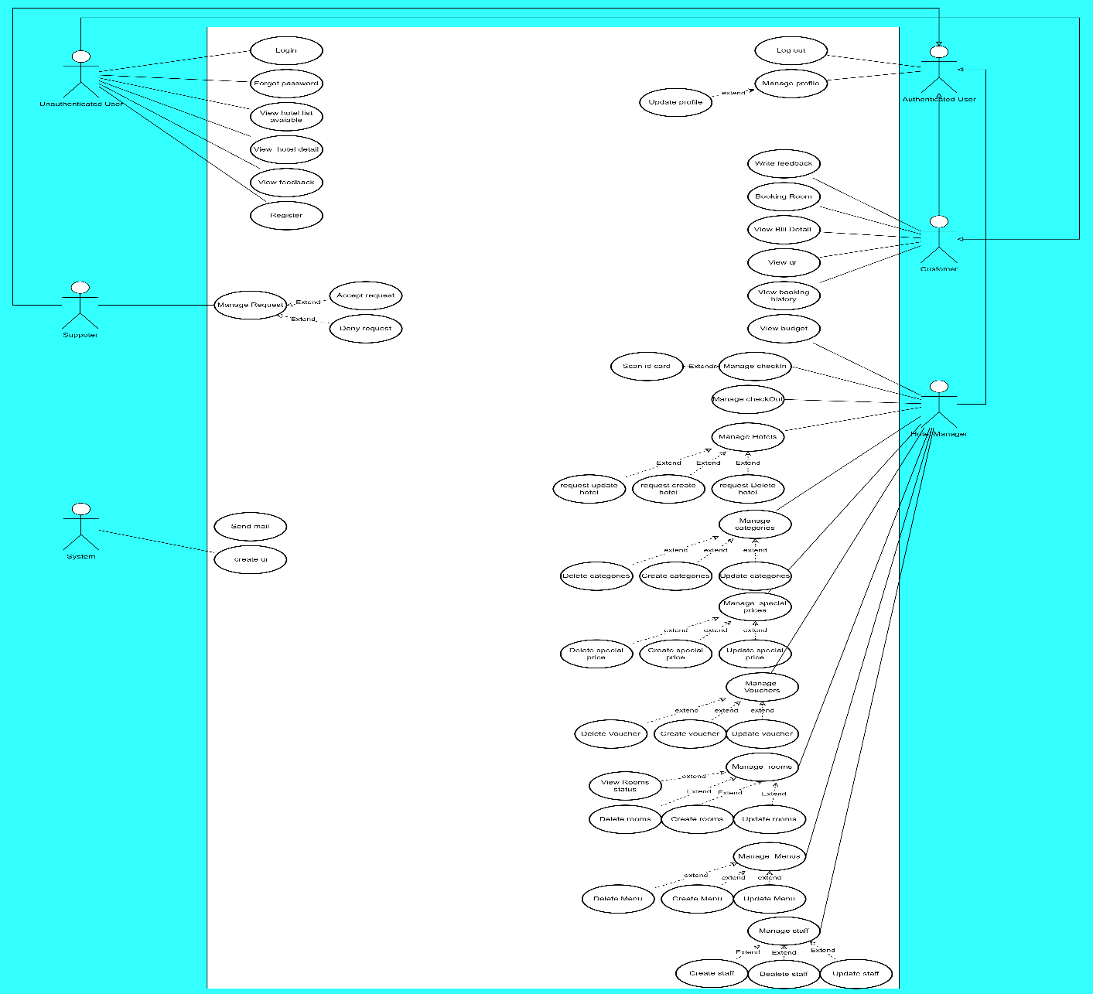

Figure 2. Use Case Diagram

1. **System Actors**

|  |  |  |
| --- | --- | --- |
| **#** | **Actor** | **Description** |
| 1 | Unauthenticated User | Users that have not logged in to the DIMS application. |
| 2 | Authenticated User | Users that have logged into the DIMS application and have been verified by mail code |
| 3 | Customer | Users that logged in to DIMS application as User role |
| 4 | Hotel Manager | Users that logged in to DIMS application as Hotel Manager role |
| 6 | System Handler | DIMS system |
| 7 | Supporter | Users that logged in to DIMS web application as Supporter role |

Table 14. System Actors

1. **Use Cases List**

|  |  |  |  |
| --- | --- | --- | --- |
| **ID** | **Use Case** | **Primary Actors** | **Secondary Actors** |
| 1 | Log in | Unauthenticated User |  |
| 2 | Sign up for user | Unauthenticated User |  |
| 3 | Sing up for hotel manager | Unauthenticated User |  |
| 4 | Forgot password | Unauthenticated User |  |
| 5 | View hotel list available | Unauthenticated User |  |
| 6 | View hotel detail | Unauthenticated User |  |
| 7 | View requests | Supporter |  |
| 8 | Accept requests | Supporter |  |
| 9 | Deny requests | Supporter |  |
| 10 | Send mail | System Handler |  |
| 11 | Create qr | System Handler |  |
| 12 | Log out | Authenticated User |  |
| 13 | View profile | Authenticated User |  |
| 14 | Update profile | Authenticated User |  |
| 15 | Booking room | Customer |  |
| 15 | View booking history | Customer |  |
| 16 | View booking detail | Customer |  |
| 17 | View qr | Customer |  |
| 18 | Change QR code | Customer |  |
| 19 | View Budget | Hotel Manager |  |
| 20 | Checkin users | Hotel Manager |  |
| 21 | Scan Id card | Hotel Manager |  |
| 22 | Checkout users | Hotel Manager |  |
| 23 | View list hotels | Hotel Manager |  |
| 24 | Request update hotel | Hotel Manager |  |
| 25 | Request create hotel | Hotel Manager |  |
| 26 | Request delete hotel | Hotel Manager |  |
| 27 | View list categories | Hotel Manager |  |
| 28 | Add category | Hotel Manager |  |
| 29 | Update category | Hotel Manager |  |
| 30 | Delete category | Hotel Manager |  |
| 31 | View list special prices | Hotel Manager |  |
| 32 | Add special price | Hotel Manager |  |
| 33 | Update special price | Hotel Manager |  |
| 34 | Delete special price | Hotel Manager |  |
| 35 | View list voucher | Hotel Manager |  |
| 36 | Add voucher | Hotel Manager |  |
| 37 | Update voucher | Hotel Manager |  |
| 38 | Delete voucher | Hotel Manager |  |
| 39 | View list menu | Hotel Manager |  |
| 40 | Add menu | Hotel Manager |  |
| 41 | Update menu | Hotel Manager |  |
| 42 | Delete menu | Hotel Manager |  |
| 43 | View list room | Hotel Manager |  |
| 44 | Add rooms | Hotel Manager |  |
| 45 | Update room | Hotel Manager |  |
| 46 | Delete room | Hotel Manager |  |
| 47 | View list status room | Hotel Manager |  |

Table 15. Use Cases List

* 1. **Use Case Specifications**
     1. **Login**

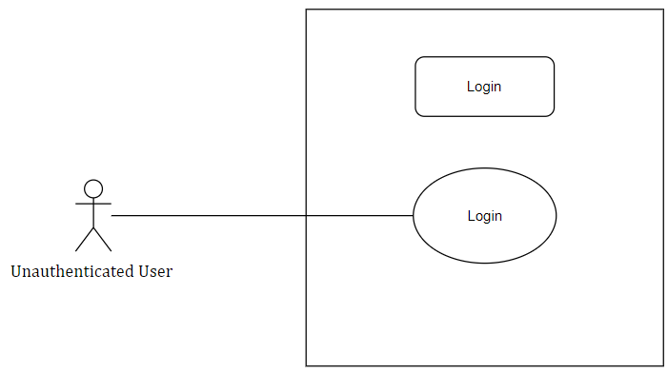

|  |  |  |  |  |  |
| --- | --- | --- | --- | --- | --- |
| ID and Name: | **UC-01. Login** | | | | |
| Created By: | HuyNQT | |  | |  |
| Primary Actor: | Unauthenticated User | |  | |  |
| Trigger: | The user sends Login request. | | | | |
| Description: | This feature allows users to login to the application, determine if user is exist in databse. | | | | |
| Preconditions: | Actor has authenticated Dims account. | | | | |
| Post-conditions: | **Success**: User will be redirected to choose mode screen.  **Failure**: System show error message | | | | |
| Normal Flow: | Step | Actor Action | | System Response | |
| 1 | Actor goes to login screen | | System redirects to login screen with email and password fields | |
| 2 | Actor input username and password | |  | |
| 3 | Actor taps “Login” / “Đăng nhập” button | | Rdirect Actor to choose mode screen | |
| Alternative Flows: | N/A | | | | |
| Exceptions: | No | Cause | | System Response | |
| 1 | Actor inputs invalid account | | System show error message “Email/Password is incorrect” | |
| Priority: | High | | | | |
| Frequency of Use: | High | | | | |
| Business Rules: | BR-0001,BR-0002,BR-0003, BR-0007, BR-0008 | | | | |
| Other Information: | N/A | | | | |
| Assumptions: | Internet Connection is available. | | | | |

* + 1. **Sign up for user**

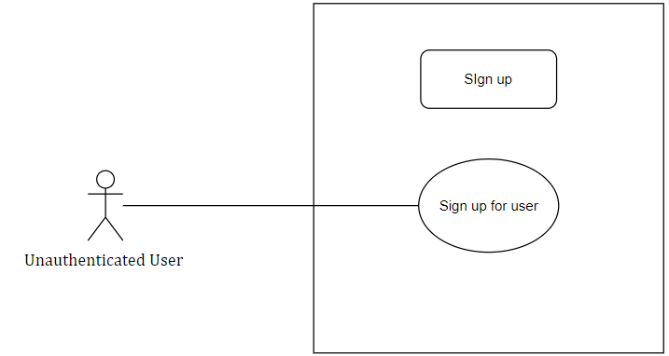

|  |  |  |  |  |  |
| --- | --- | --- | --- | --- | --- |
| ID and Name: | **UC-02. Sign up for user** | | | | |
| Created By: | HuyNQT | |  | |  |
| Primary Actor: | Unauthenticated User | |  | |  |
| Trigger: | The actor sign up for user account | | | | |
| Description: | This feature allows users to create DIMS account | | | | |
| Preconditions: | User has an email | | | | |
| Post-conditions: | **Success**: User will be redirected to login screen of the application  **Failure**: System inform: “Create Account Failed” | | | | |
| Normal Flow: | Step | Actor Action | | System Response | |
| 1 | Actor taps “Sign up”/ “Đăng ký” | | System redirects to sign up screen with name, email phone number and password fields | |
| 2 | Actor fills name, email, and password | |  | |
| 3 | Actor taps “Sign up” / “Đăng ký” button | | - System check the account input information was already stored in Database  - If the sign-up information is valid, the system redirects to Sign in screen and notify “Verify Code sent to your email, please activate”/ “Đã gửi code xác thực qua email của bạn, xin hãy xác thực sau khi sign in” | |
| Alternative Flows: | N/A | | | | |
| Exceptions: | N/A | | | | |
| Priority: | High | | | | |
| Frequency of Use: | High | | | | |
| Business Rules: | BR-0007,BR-0008 | | | | |
| Other Information: | N/A | | | | |
| Assumptions: | Internet Connection is available | | | | |

* + 1. **Sign up for hotel manager**

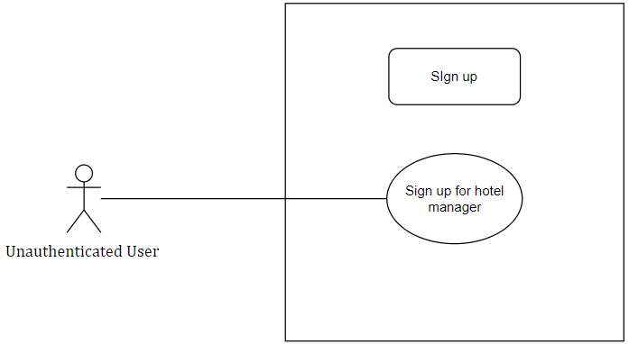

|  |  |  |  |  |  |
| --- | --- | --- | --- | --- | --- |
| ID and Name: | **UC-02. Sign up for hotel manager** | | | | |
| Created By: | HuyNQT | |  | |  |
| Primary Actor: | Unauthenticated User | |  | |  |
| Trigger: | The actor sign up for hotel manager account | | | | |
| Description: | This feature allows users to create DIMS account | | | | |
| Preconditions: | User has an email | | | | |
| Post-conditions: | **Success**: User will be redirected to login screen of the application  **Failure**: System inform: “Create Account Failed” | | | | |
| Normal Flow: | Step | Actor Action | | System Response | |
| 1 | Actor taps “Sign up”/ “Đăng ký” | | System redirects to sign up screen with email password fields | |
| 2 | Actor fills name, email, and password | |  | |
| 3 | Actor taps “Sign up” / “Đăng ký” button | | - System check the account input information was already stored in Database  - If the sign-up information is valid, the system redirects to Sign in screen | |
| Alternative Flows: | N/A | | | | |
| Exceptions: | N/A | | | | |
| Priority: | High | | | | |
| Frequency of Use: | High | | | | |
| Business Rules: | BR-0007,BR-0008 | | | | |
| Other Information: | N/A | | | | |
| Assumptions: | Internet Connection is available | | | | |

* + 1. **Forgot password**

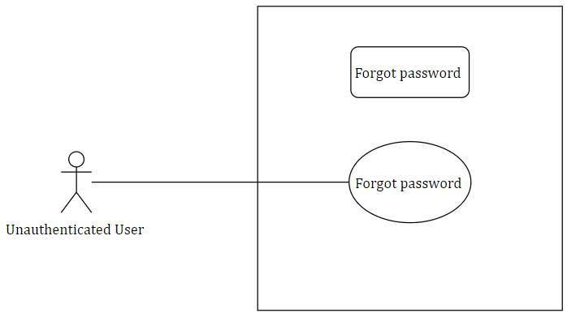

|  |  |  |  |  |  |
| --- | --- | --- | --- | --- | --- |
| ID and Name: | **UC-04. Forgot password** | | | | |
| Created By: | HuyNQT | |  | |  |
| Primary Actor: | Unauthenticated User | |  | |  |
| Trigger: | The actor forgot their password | | | | |
| Description: | This feature allows users to get new password with they know their email | | | | |
| Preconditions: | User already create a account | | | | |
| Post-conditions: | **Success**: User will be able to get a new password  **Failure**: System sends error message | | | | |
| Normal Flow: | Step | Actor Action | | System Response | |
| 1 | Actor request new password | | System send verify code to email | |
| 2 | Actor types verify code. | | - Firebase check if verify code is valid or not.  [Exception1] | |
| Alternative Flows: | N/A | | | | |
| Exceptions: | No | Cause | | System Response | |
| 1 | The verify code is invalid. | | The system informs “The Verify Code is invalid, please enter again” / “Mã xác thực của bạn không chính xác, xin hãy nhập lại”. | |
| Priority: | High | | | | |
| Frequency of Use: | High | | | | |
| Business Rules: | BR-0006 | | | | |
| Other Information: | N/A | | | | |
| Assumptions: | Internet Connection is available. | | | | |

* + 1. **View hotel list available**

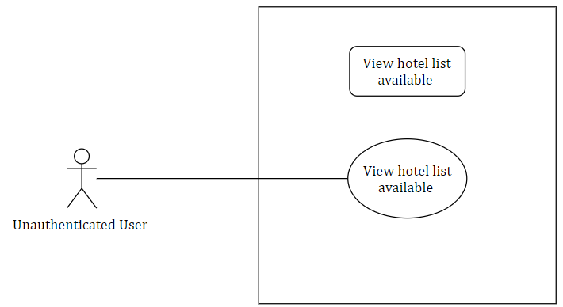

|  |  |  |  |  |  |
| --- | --- | --- | --- | --- | --- |
| ID and Name: | **UC-05. View hotel list available** | | | | |
| Created By: | HuyNQT | |  | |  |
| Primary Actor: | Unauthenticated User | |  | |  |
| Trigger: | The actor sent reset password request. | | | | |
| Description: | This feature allows users to change passwords. | | | | |
| Preconditions: | User already has Biiké account. | | | | |
| Post-conditions: | **Success**: User will be redirected to main page of the application and use the new password. | | | | |
| Normal Flow: | Step | Actor Action | | System Response | |
| 1 | Actor taps “Reset Password” / “Đổi mật khẩu” button. | | System sent verify code to email. | |
| 2 | Actor verify email. | | Redirect to new password enter screen. | |
| 3 | Actor fill new password. | |  | |
| 4 | Actor tap “Save Password”/ “Lưu Mật Khẩu”. | | Redirect to main page of application. | |
| Alternative Flows: | N/A | | | | |
| Exceptions: | N/A | | | | |
| Priority: | High | | | | |
| Frequency of Use: | High | | | | |
| Business Rules: | BR-0015 | | | | |
| Other Information: | N/A | | | | |
| Assumptions: | Internet Connection is available. | | | | |

* + 1. **View hotel detail**

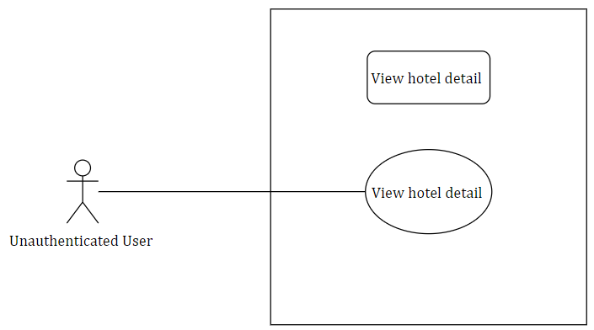

|  |  |  |  |  |  |
| --- | --- | --- | --- | --- | --- |
| ID and Name: | **UC-06.View hotel detail** | | | | |
| Created By: | HuyNQT | |  | |  |
| Primary Actor: | Unauthenticated User | |  | |  |
| Trigger: | The actor sends logout request. | | | | |
| Description: | This feature allows users to log out of application. | | | | |
| Preconditions: | User already login to application. | | | | |
| Post-conditions: | **Success**: User will be redirected to sign-up screen of the application. | | | | |
| Normal Flow: | Step | Actor Action | | System Response | |
| 1 | Actor tap “Log out” / “Đăng xuất”. | | System redirects to login screen and delete user session. | |
| Alternative Flows: | N/A | | | | |
| Exceptions: | N/A | | | | |
| Priority: | High | | | | |
| Frequency of Use: | High | | | | |
| Business Rules: | BR-0015 | | | | |
| Other Information: | N/A | | | | |
| Assumptions: | Internet Connection is available. | | | | |

* + 1. **View request**

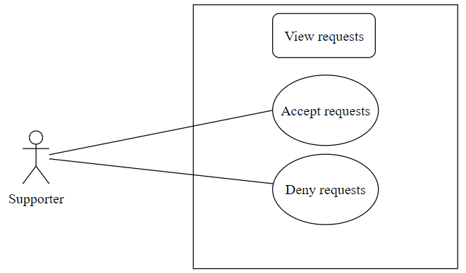

|  |  |  |  |  |  |
| --- | --- | --- | --- | --- | --- |
| ID and Name: | **UC-07. View request** | | | | |
| Created By: | HuyNQT | |  | |  |
| Primary Actor: | Supporter | |  | |  |
| Trigger: | The actor wants to view their profile. | | | | |
| Description: | This feature allows users to view their profile information. | | | | |
| Preconditions: | User has login to Biiké application. | | | | |
| Post-conditions: | **Success**: User will be redirected to view profile screen. | | | | |
| Normal Flow: | Step | Actor Action | | System Response | |
| 1 | Actor tap “View Profile”/ “Xem thông tin cá nhân”. | | System redirects to view profile screen. | |
| Alternative Flows: | N/A | | | | |
| Exceptions: | N/a | | | | |
| Priority: | High | | | | |
| Frequency of Use: | High | | | | |
| Business Rules: | BR-0001,BR-0002,BR-0022 | | | | |
| Other Information: | N/A | | | | |
| Assumptions: | Internet Connection is available | | | | |

* + 1. **Send mail**

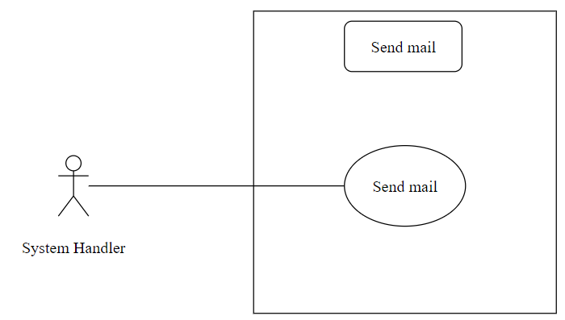

|  |  |  |  |  |  |
| --- | --- | --- | --- | --- | --- |
| ID and Name: | **UC-08. Send mail** | | | | |
| Created By: | HuyNQT | |  | |  |
| Primary Actor: | System Handler | |  | |  |
| Trigger: | The actor sends update profile request. | | | | |
| Description: | This feature allows users to change their profile information. | | | | |
| Preconditions: | User already login to Biiké application. | | | | |
| Post-conditions: | **Success**: User new information will be saved and redirect user to view profile screen.  **Failure**: System informs “Something went wrong, please try again later”. | | | | |
| Normal Flow: | Step | Actor Action | | System Response | |
| 1 | Actor tap “Update Profile” / “Cập nhật thông tin” button. | |  | |
| 2 | Actor enter update fields. | |  | |
| 3 | Actor tap “Save” / “Lưu” Button. | | - System check if the update information is valid or not.  - Success: Saved new information to Database and redirect to view profile screen.  - Failure: System show error message if something gone wrong under server. | |
| Alternative Flows: | N/A | | | | |
| Exceptions: | N/A | | | | |
| Priority: | High | | | | |
| Frequency of Use: | High | | | | |
| Business Rules: | N/A | | | | |
| Other Information: | N/A | | | | |
| Assumptions: | Internet Connection is available | | | | |

* + 1. **Create qr**

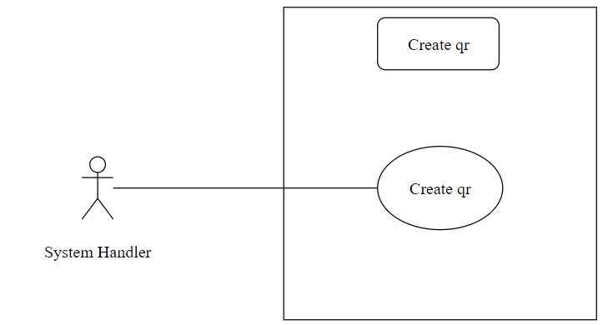

|  |  |  |  |  |
| --- | --- | --- | --- | --- |
| ID and Name: | **UC-09. Create qr** | | | |
| Created By: | HuyNQT | |  |  |
| Primary Actor: | System Handler | |  |  |
| Trigger: | User sends a request to choose a role | | | |
| Description: | This feature allows users to use the application’s service with selected mode | | | |
| Preconditions: | User has logged in to Biiké application. | | | |
| Post-conditions: | **Success**: User will be redirected to home page of the application with selected role  **Failure**: System shows error message | | | |
| Normal Flow: | Step | Actor Action | | System Response |
| 1 | User taps “Biker” / “Chở ké” or “Keer” / “Đi ké” mode | | [Alternative 2] |
| 2 | User tap “Next” icon button [Exception 1] | | System redirects to home page with selected mode that user chose [Alternative 1] [Exception 1] [Exception 2] |
| Alternative Flows: | N/A | | | |
| Exceptions: | No | | Cause | System Response |
| 1 | | User does not select a mode | System shows error message: “You must choose a role to use our service” |
| 2 | |  | System shows error message: “There are some errors, please try again later or contact Biiké development team for support” when the Azure server return error response |
| Priority: | High | | | |
| Frequency of Use: | High | | | |
| Business Rules: | N/A | | | |
| Other Information: | N/A | | | |
| Assumptions: | Internet Connection is available. | | | |

* + 1. **Log out**

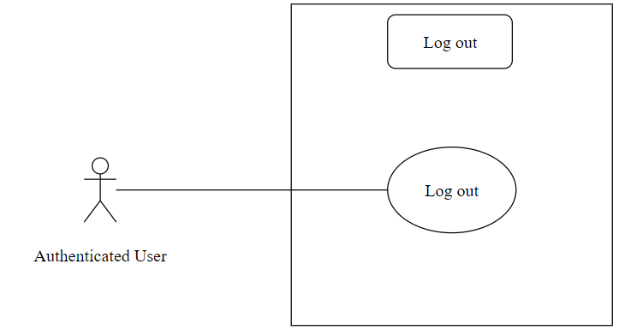

|  |  |  |  |  |  |
| --- | --- | --- | --- | --- | --- |
| ID and Name: | **UC-10. Log out** | | | | |
| Created By: | HuyNQT | |  | |  |
| Primary Actor: | Authenticated User | |  | |  |
| Trigger: | The actor wants to view top Bikers of the Biiké community. | | | | |
| Description: | This feature allows users to view top Bikers in the current month. | | | | |
| Preconditions: | User has logged in to Biiké application. | | | | |
| Post-conditions: | **Success**: User will be able to view list top Bikers and their contribute work for the community along with their rewards. | | | | |
| Normal Flow: | Step | Actor Action | | System Response | |
| 1 | Actor tap “Top Bikers” button | | System redirects to Top Bikers List Screen | |
| Alternative Flows: | N/A | | | | |
| Exceptions: | N/A | | | | |
| Priority: | High | | | | |
| Frequency of Use: | High | | | | |
| Business Rules: | BR-0001,BR-0002 | | | | |
| Other Information: | N/A | | | | |
| Assumptions: | Internet Connection is available | | | | |

* + 1. **View profile**

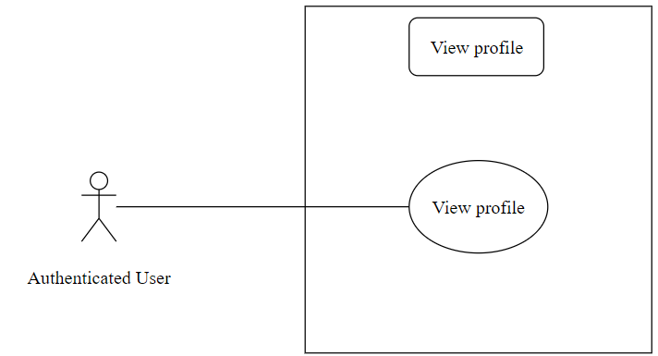

|  |  |  |  |  |  |
| --- | --- | --- | --- | --- | --- |
| ID and Name: | **UC-11. View profile** | | | | |
| Created By: | HuyNQT | |  | |  |
| Primary Actor: | Authenticated User | |  | |  |
| Trigger: | The actor received notification from system. | | | | |
| Description: | This feature allows users to view notification information. | | | | |
| Preconditions: | User has logged into Biiké application. | | | | |
| Post-conditions: | **Success**: Redirect to view Notification Screen  **Fail**: System sends error message | | | | |
| Normal Flow: | Step | Actor Action | | System Response | |
| 1 | Actor tap “Notification” / “Thông báo” button | | System redirects to view notification screen | |
|  | 2 | Actor click on a notification | | System redirects to view notification details screen | |
| Alternative Flows: | N/A | | | | |
| Exceptions: | N/A | | | | |
| Priority: | High | | | | |
| Frequency of Use: | High | | | | |
| Business Rules: | BR-0001,BR-0002 | | | | |
| Other Information: | N/A | | | | |
| Assumptions: | Internet Connection is available. | | | | |

* + 1. **Update profile**

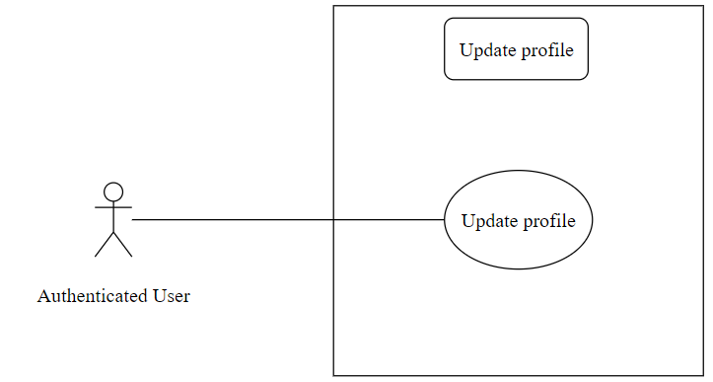

|  |  |  |  |  |  |
| --- | --- | --- | --- | --- | --- |
| ID and Name: | **UC-12. Update profile** | | | | |
| Created By: | HuyNQT | |  | |  |
| Primary Actor: | Customer | |  | |  |
| Trigger: | View Available Voucher List | | | | |
| Description: | This feature allows users to view list available vouchers | | | | |
| Preconditions: | User has logged into Biiké application | | | | |
| Post-conditions: | **Success**: User will be redirected to view available vouchers screen  **Failure**: System shows error message | | | | |
| Normal Flow: | Step | Actor Action | | System Response | |
| 1 | Actor tap “Voucher” button | | System redirects to Voucher lists screen | |
| Alternative Flows: | N/A | | | | |
| Exceptions: | N/A | | | | |
| Priority: | High | | | | |
| Frequency of Use: | High | | | | |
| Business Rules: | BR-0001,BR-0002 | | | | |
| Other Information: | N/A | | | | |
| Assumptions: | Internet Connection is available | | | | |

* + 1. **Booking rooms**

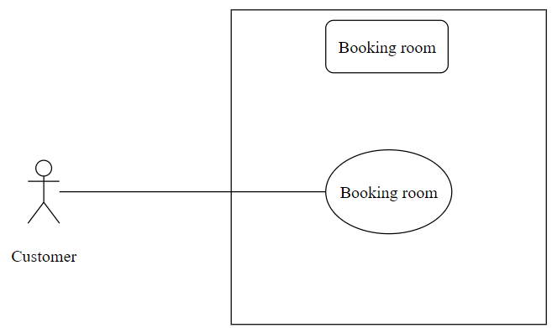

|  |  |  |  |  |  |
| --- | --- | --- | --- | --- | --- |
| ID and Name: | **UC-13. Booking rooms** | | | | |
| Created By: | HuyNQT | |  | |  |
| Primary Actor: | Customer | |  | |  |
| Trigger: | The actor sends view voucher details request | | | | |
| Description: | This feature allows users to view voucher details | | | | |
| Preconditions: | User has logged into Biiké application | | | | |
| Post-conditions: | **Success**: User will be redirected to view voucher details screen | | | | |
| Normal Flow: | Step | Actor Action | | System Response | |
| 1 | Actor tap voucher card or “View” / “Xem” button | | System redirects to voucher details screen | |
| Alternative Flows: | N/A | | | | |
| Exceptions: | N/A | | | | |
| Priority: | High | | | | |
| Frequency of Use: | High | | | | |
| Business Rules: | BR-0001,BR-0002 | | | | |
| Other Information: | N/A | | | | |
| Assumptions: | Internet Connection is available | | | | |

* + 1. **View booking history**

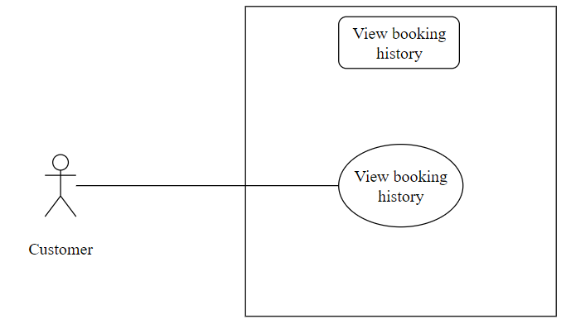

|  |  |  |  |  |  |
| --- | --- | --- | --- | --- | --- |
| ID and Name: | **UC-14. View booking history** | | | | |
| Created By: | HuyNQT | |  | |  |
| Primary Actor: | Customer | |  | |  |
| Trigger: | The actor send redeem voucher request | | | | |
| Description: | This feature allows users to exchange their points for vouchers | | | | |
| Preconditions: | User has logged into Biiké application | | | | |
| Post-conditions: | **Success**: User will have the vouchers on “Exchanged” tab and able to use the voucher, user point will be minus as the voucher amount of point  **Failure**: System informs “Cannot exchange this voucher” / “Bạn không thể đổi voucher này” | | | | |
| Normal Flow: | Step | Actor Action | | System Response | |
| 1 | Actor tap “Redeem Voucher”/ “Đổi voucher” button | | System checks if actor point If enough to exchange the voucher  Not enough points: Exception  Enough point: voucher redeem successfully, redirect to view available vouchers screen | |
| Alternative Flows: | N/A | | | | |
| Exceptions: | No | Cause | | System Response | |
| 1 | The actor’s points are not enough to exchange voucher | | The system informs “User doesn’t have enough point” / “Người dùng không đủ điểm để đổi!” | |
| Priority: | High | | | | |
| Frequency of Use: | High | | | | |
| Business Rules: | BR-0001,BR-0002 | | | | |
| Other Information: | N/A | | | | |
| Assumptions: | Internet Connection is available | | | | |

* + 1. **View Booking detail**

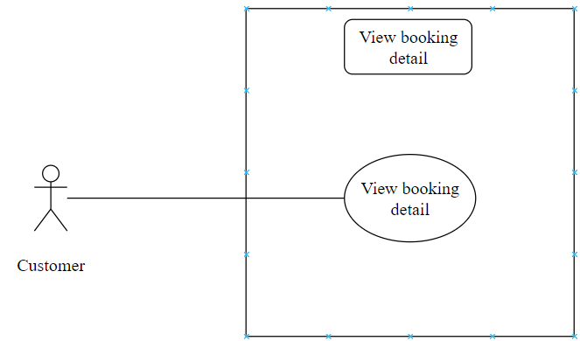

|  |  |  |  |  |  |
| --- | --- | --- | --- | --- | --- |
| ID and Name: | **UC-15. View Booking detail** | | | | |
| Created By: | HuyNQT | |  | |  |
| Primary Actor: | Customer | |  | |  |
| Trigger: | The actor sends view my voucher details request | | | | |
| Description: | This feature allows users to view their voucher details include vouchers information, expired date | | | | |
| Preconditions: | User has logged into Biiké application | | | | |
| Post-conditions: | **Success**: User will be redirected to view my voucher details screen  **Failure**: System shows error message | | | | |
| Normal Flow: | Step | Actor Action | | System Response | |
| 1 | Actor taps “Exchanged” / “Đã đổi” tab on appbar | | System redirects to Exchanged tab | |
| Alternative Flows: | N/A | | | | |
| Exceptions: | N/A | | | | |
| Priority: | High | | | | |
| Frequency of Use: | High | | | | |
| Business Rules: | BR-0001,BR-0002 | | | | |
| Other Information: | N/A | | | | |
| Assumptions: | Internet Connection is available | | | | |

* + 1. **View qr**

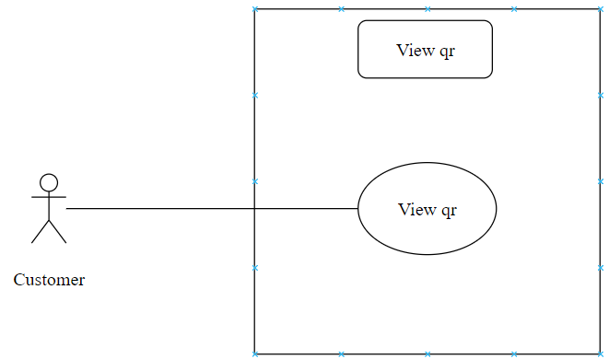

|  |  |  |  |  |  |
| --- | --- | --- | --- | --- | --- |
| ID and Name: | **UC-16. View qr** | | | | |
| Created By: | HuyNQT | |  | |  |
| Primary Actor: | Customer | |  | |  |
| Trigger: | The actor sends view my voucher list request | | | | |
| Description: | This feature allows users to view their voucher list includes their list of redeemed vouchers | | | | |
| Preconditions: | User has logged into Biiké application | | | | |
| Post-conditions: | **Success**: User will be redirected to view my voucher list screen  **Failure**: System shows error message | | | | |
| Normal Flow: | Step | Actor Action | | System Response | |
| 1 | Actor tap voucher card on “Exchanged” or “Expired/Used” tab | | System redirects to Your voucher details screen | |
| Alternative Flows: | N/A | | | | |
| Exceptions: | N/A | | | | |
| Priority: | High | | | | |
| Frequency of Use: | High | | | | |
| Business Rules: | BR-0001,BR-0002,BR-0017,BR-0019 | | | | |
| Other Information: | N/A | | | | |
| Assumptions: | Internet Connection is available | | | | |

* + 1. **Write feedback**

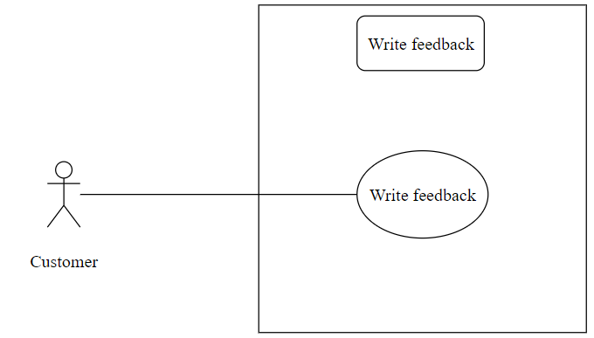

|  |  |  |  |  |  |
| --- | --- | --- | --- | --- | --- |
| ID and Name: | **UC-17. Write feedback** | | | | |
| Created By: | HuyNQT | |  | |  |
| Primary Actor: | Customer | |  | |  |
| Trigger: | The actor click on advertisement banner on home screen | | | | |
| Description: | This feature redirect users to custom url from company sponsored the ads and count every click on | | | | |
| Preconditions: | User has logged into Biiké application | | | | |
| Post-conditions: | **Success**: User will be redirected to custom url of the ads through browser  **Failure**: System shows error message | | | | |
| Normal Flow: | Step | Actor Action | | System Response | |
| 1 | Actor tap Advertisement banner on main page | | System redirects to advertisement url | |
| Alternative Flows: | N/A | | | | |
| Exceptions: | N/A | | | | |
| Priority: | High | | | | |
| Frequency of Use: | High | | | | |
| Business Rules: | BR-0001,BR-0002 | | | | |
| Other Information: | N/A | | | | |
| Assumptions: | Internet Connection is available | | | | |

* + 1. **View budget**

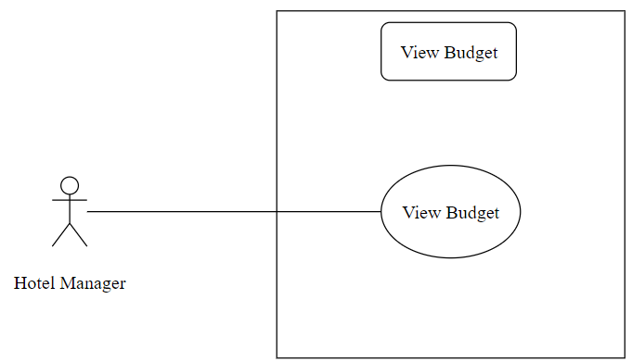

|  |  |  |  |  |  |
| --- | --- | --- | --- | --- | --- |
| ID and Name: | **UC-18. View budget** | | | | |
| Created By: | HuyNQT | |  | |  |
| Primary Actor: | Hotel Manager | |  | |  |
| Trigger: | The actor sends view point details request | | | | |
| Description: | This feature allows users to view their total points, their point expired date and their point transaction history | | | | |
| Preconditions: | User has logged into Biiké application | | | | |
| Post-conditions: | **Success**: User will be redirected to view point details screen.  **Failure**: System shows error message | | | | |
| Normal Flow: | Step | Actor Action | | System Response | |
| 1 | Actor taps on their point number in profile page | | System redirects to View Point Details screen | |
| Alternative Flows: | N/A | | | | |
| Exceptions | N/A | | | | |
| Priority: | High | | | | |
| Frequency of Use: | High | | | | |
| Business Rules: | BR-0009,BR-0011 | | | | |
| Other Information: | N/A | | | | |
| Assumptions: | Internet Connection is available | | | | |

* + 1. **Checkin users**

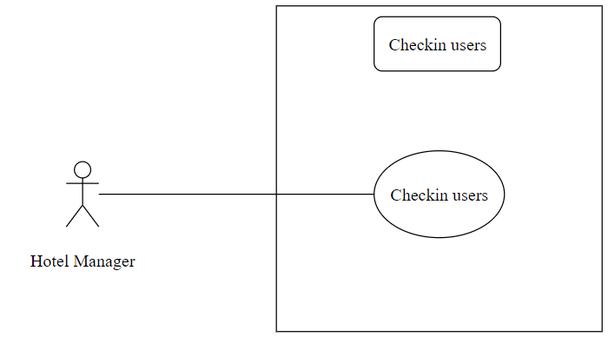

|  |  |  |  |  |  |
| --- | --- | --- | --- | --- | --- |
| ID and Name: | **UC-19. Checkin users** | | | | |
| Created By: | HuyNQT | |  | |  |
| Primary Actor: | Hotel Manager | |  | |  |
| Trigger: | The actor sends View S.O.S List request | | | | |
| Description: | This feature allows users to vie list of S.O.S options | | | | |
| Preconditions: | User has logged into Biiké application | | | | |
| Post-conditions: | **Success**: User will be redirected to S.O.S list screen  **Failure**: System shows error message | | | | |
| Normal Flow: | Step | Actor Action | | System Response | |
| 1 | Actor tap “View S.O.S List” / “Xem danh sách S.O.S” button | | System redirects to S.O.S List screen | |
| Alternative Flows: | N/A | | | | |
| Exceptions: | N/A | | | | |
| Priority: | High | | | | |
| Frequency of Use: | High | | | | |
| Business Rules: | BR-0009,BR-0021,BR-0028,BR-0030,BR-0031,BR-0017,BR-0019,  BR-0024,BR-0025 | | | | |
| Other Information: | N/A | | | | |
| Assumptions: | Internet Connection is available | | | | |

* + 1. **Checkout users**

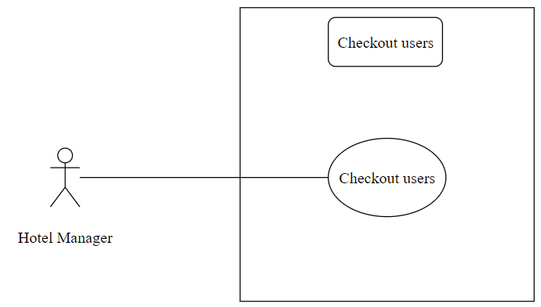

|  |  |  |  |  |  |
| --- | --- | --- | --- | --- | --- |
| ID and Name: | **UC-20. Checkout users** | | | | |
| Created By: | HuyNQT | |  | |  |
| Primary Actor: | Hotel Manager | |  | |  |
| Trigger: | The actor sends add S.O.S number request | | | | |
| Description: | This feature allows users to add S.O.S number into their emergency list | | | | |
| Preconditions: | User has logged into Biiké application | | | | |
| Post-conditions: | **Success**: User will be redirected to add S.O.S number screen  **Failure**: System shows error message | | | | |
| Normal Flow: | Step | Actor Action | | System Response | |
| 1 | User taps on plus icon | | System redirects to add S.O.S number screen | |
| 2 | User inputs fields | |  | |
| 3 | User taps “Save” / “Lưu” button | | System redirects to view S.O.S list page [Exception 1] [Exception 2] | |
| Alternative Flows: | N/A | | | | |
| Exceptions: | No | Cause | | System Response | |
| 1 | User enters invalid phone number | | System shows error message “Invalid phone number” | |
| 2 |  | | System shows error message: “There are some errors, please try again later or contact Biiké development team for support” when the Azure server return error response | |
| Priority: | High | | | | |
| Frequency of Use: | High | | | | |
| Business Rules: | BR-0009,BR-0029,BR-0026 | | | | |
| Other Information: | N/A | | | | |
| Assumptions: | Internet Connection is available | | | | |

* + 1. **Manage hotel**

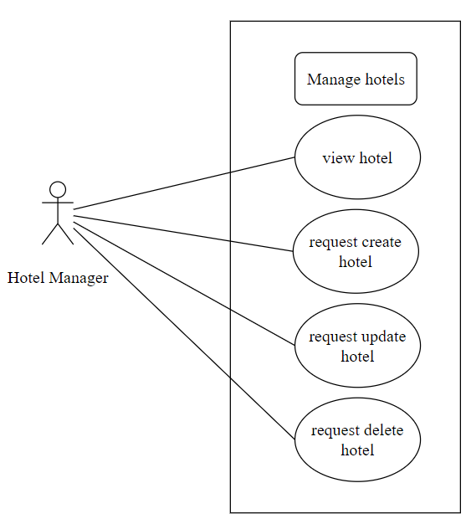

|  |  |  |  |  |  |
| --- | --- | --- | --- | --- | --- |
| ID and Name: | **UC-21. Manage hotel** | | | | |
| Created By: | HuyNQT | |  | |  |
| Primary Actor: | Hotel Manager | |  | |  |
| Trigger: | The actor sends Edit S.O.S number | | | | |
| Description: | This feature allows users to change their S.O.S number information | | | | |
| Preconditions: | User has logged into Biiké application | | | | |
| Post-conditions: | **Success**: User S.O.S number will be updated  **Failure**: System shows error message | | | | |
| Normal Flow: | Step | Actor Action | | System Response | |
| 1 | Actor taps on a S.O.S number | | System redirects to update S.O.S Number screen | |
| 2 | Actor enter new S.O.S number | |  | |
| 3 | Actor tap “Save” / “Lưu” button | | System will store the new S.O.S Number to Database | |
| Alternative Flows: | N/A | | | | |
| Exceptions: | N/A | | | | |
| Priority: | High | | | | |
| Frequency of Use: | High | | | | |
| Business Rules: | BR-0009,BR-0021,BR-0020,BR-0022 | | | | |
| Other Information: | N/A | | | | |
| Assumptions: | Internet Connection is available | | | | |

* + 1. **Manage categories**

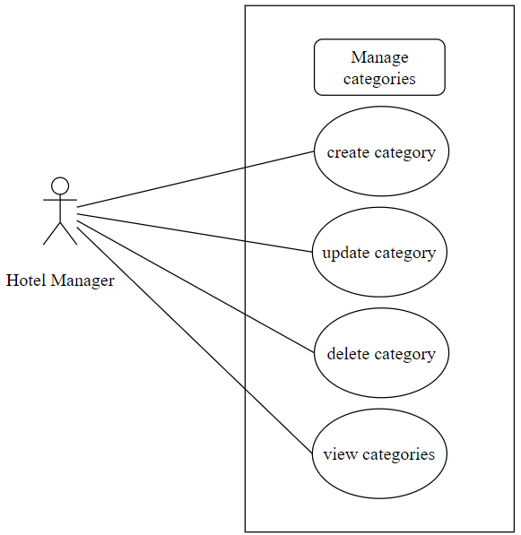

|  |  |  |  |  |  |
| --- | --- | --- | --- | --- | --- |
| ID and Name: | **UC-22. Manage categories** | | | | |
| Created By: | HuyNQT | |  | |  |
| Primary Actor: | Hotel Manager | |  | |  |
| Trigger: | The actor sends Delete S.O.S number | | | | |
| Description: | This feature allows users to delete their S.O.S Number | | | | |
| Preconditions: | User has logged into Biiké application | | | | |
| Post-conditions: | **Success**: User S.O.S Number will be deleted  **Failure**: System shows error message | | | | |
| Normal Flow: | Step | Actor Action | | System Response | |
| 1 | Actor taps on delete icon | | S.O.S Number is deleted | |
| Alternative Flows: | N/A | | | | |
| Exceptions: | N/A | | | | |
| Priority: | High | | | | |
| Frequency of Use: | High | | | | |
| Business Rules: | BR-0009,BR-0021 | | | | |
| Other Information: | N/A | | | | |
| Assumptions: | Internet Connection is available | | | | |

* + 1. **Manage special prices**

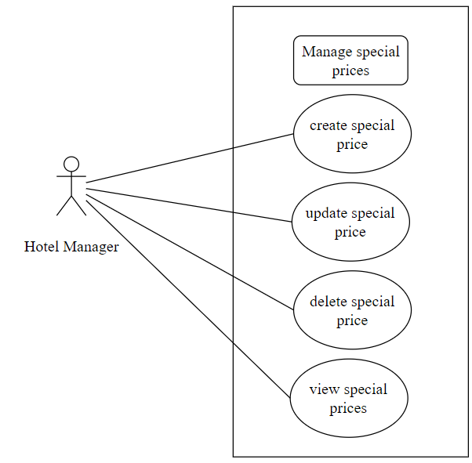

|  |  |  |  |  |  |
| --- | --- | --- | --- | --- | --- |
| ID and Name: | **UC-23. Manage special prices** | | | | |
| Created By: | HuyNQT | |  | |  |
| Primary Actor: | Hotel Manager | |  | |  |
| Trigger: | The actor sends Change Language request | | | | |
| Description: | This feature allows users to change the current language to their understandable language | | | | |
| Preconditions: | User has logged into Biiké account | | | | |
| Post-conditions: | **Success**: Biiké application will changed to the language that Actor chose | | | | |
| Normal Flow: | Step | Actor Action | | System Response | |
| 1 | Actor tap “Change Language” / “Đổi ngôn ngữ” button | | System checks the current language that Actor using  VN: System will change the application to ENG  ENG: System will change the application to VN | |
| Alternative Flows: | N/A | | | | |
| Exceptions: | N/A | | | | |
| Priority: | High | | | | |
| Frequency of Use: | High | | | | |
| Business Rules: | BR-0009,BR-0021,BR-0027 | | | | |
| Other Information: | N/A | | | | |
| Assumptions: | Internet Connection is available | | | | |

* + 1. **Manage vouchers**

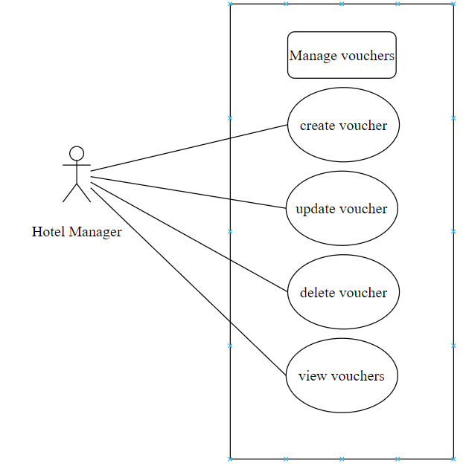

|  |  |  |  |  |  |
| --- | --- | --- | --- | --- | --- |
| ID and Name: | **UC-24. Manage vouchers** | | | | |
| Created By: | HuyNQT | |  | |  |
| Primary Actor: | Hotel Manager | |  | |  |
| Trigger: | The actor sends view address book request | | | | |
| Description: | This feature allows users to view their address deatail | | | | |
| Preconditions: | User has logged into Biiké application | | | | |
| Post-conditions: | **Success**: User will be redirected to View Address details screen  **Failure**: System shows error message | | | | |
| Normal Flow: | Step | Actor Action | | System Response | |
| 1 | Actor taps “View Address Book” button | | Redirect to Address Book screen | |
| Alternative Flows: | N/A | | | | |
| Exceptions: | N/A | | | | |
| Priority: | High | | | | |
| Frequency of Use: | High | | | | |
| Business Rules: | BR-0009,BR-0021,BR-0016 | | | | |
| Other Information: | N/A | | | | |
| Assumptions: | Internet Connection is available | | | | |

* + 1. **Manage rooms**

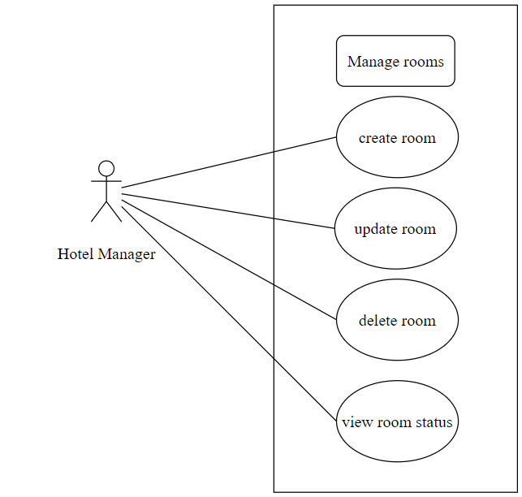

|  |  |  |  |  |  |
| --- | --- | --- | --- | --- | --- |
| ID and Name: | **UC-25. Manage rooms** | | | | |
| Created By: | HuyNQT | |  | |  |
| Primary Actor: | Hotel Manager | |  | |  |
| Trigger: | The actor sends Edit Address | | | | |
| Description: | This feature allows users to change their address information | | | | |
| Preconditions: | User has logged into Biiké application | | | | |
| Post-conditions: | **Success**: User Address is updated  **Failure**: System shows error message | | | | |
| Normal Flow: | Step | Actor Action | | System Response | |
| 1 | Actor tap on a address card | | System redirects to update Address Book screen | |
| 2 | Actor enter new address or note or name | |  | |
| 3 | Actor tap “Save” / “Lưu” button | | System will store the new address to Database | |
| Alternative Flows: | N/A | | | | |
| Exceptions: | N/A | | | | |
| Priority: | High | | | | |
| Frequency of Use: | High | | | | |
| Business Rules: | BR-0009,BR-0021,BR-0026, | | | | |
| Other Information: | N/A | | | | |
| Assumptions: | Internet Connection is available | | | | |

* + 1. **Manage menus**

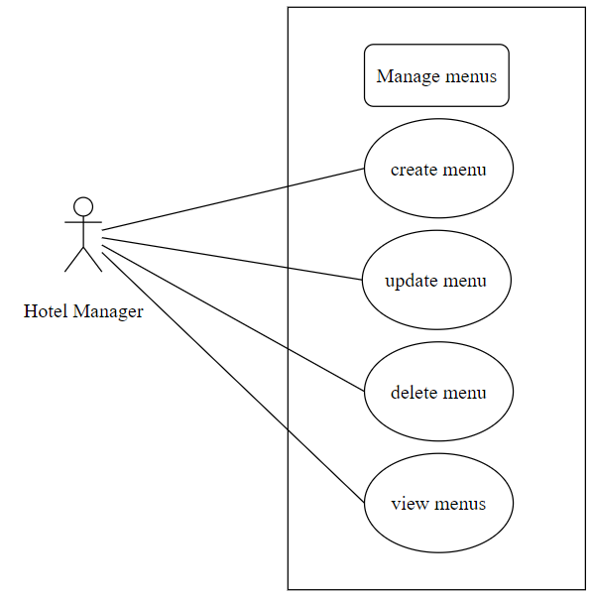

|  |  |  |  |  |  |  |
| --- | --- | --- | --- | --- | --- | --- |
| ID and Name: | **UC-63. Manage menus** | | | | | |
| Created By: | HuyNQT | |  | |  | |
| Primary Actor: | Hotel Manager | |  | |  | |
| Trigger: | Biker sends a request to view Ride Now station | | | | | |
| Description: | This feature allows Hotel manager to create , update ,delete with menu | | | | | |
| Preconditions: | Hotel manager has logged into DIMS application | | | | | |
| Post-conditions: | **Success**: System shows a success message  **Failure**: System shows error message | | | | | |
| Normal Flow: | Step | Actor Action | | System Response | | |
| 1 | User Click the icon corresponding to the function | | System shows a pop-up which success or fail [Exception 1] | | |
| Alternative Flows: | N/A | | | | | |
| Exceptions: | No | | Cause | | | System Response |
| 1 | |  | | | System shows error message: “Something went wrong” or “Action success” |
| Priority: | High | | | | | |
| Frequency of Use: | High | | | | | |
| Business Rules: | BR-0021, BR-0009 | | | | | |
| Other Information: | N/A | | | | | |
| Assumptions: | Internet Connection is available | | | | | |

1. Functional Requirements
   1. **System Functional Overview**
2. **Screen Flow**

* **User Screen Flow**

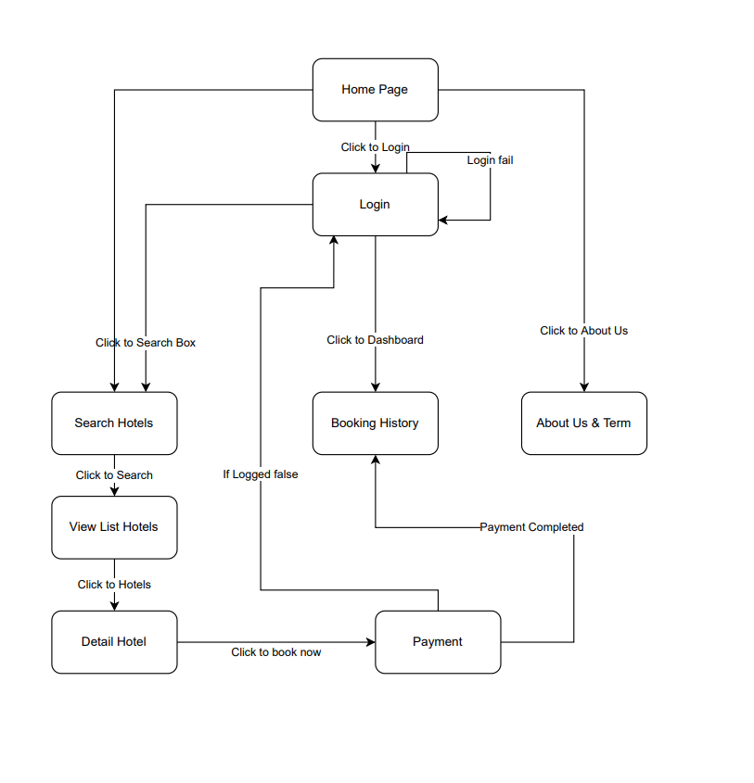

Figure 1. Web User Screen Flow

* **Partner Screen Flow**

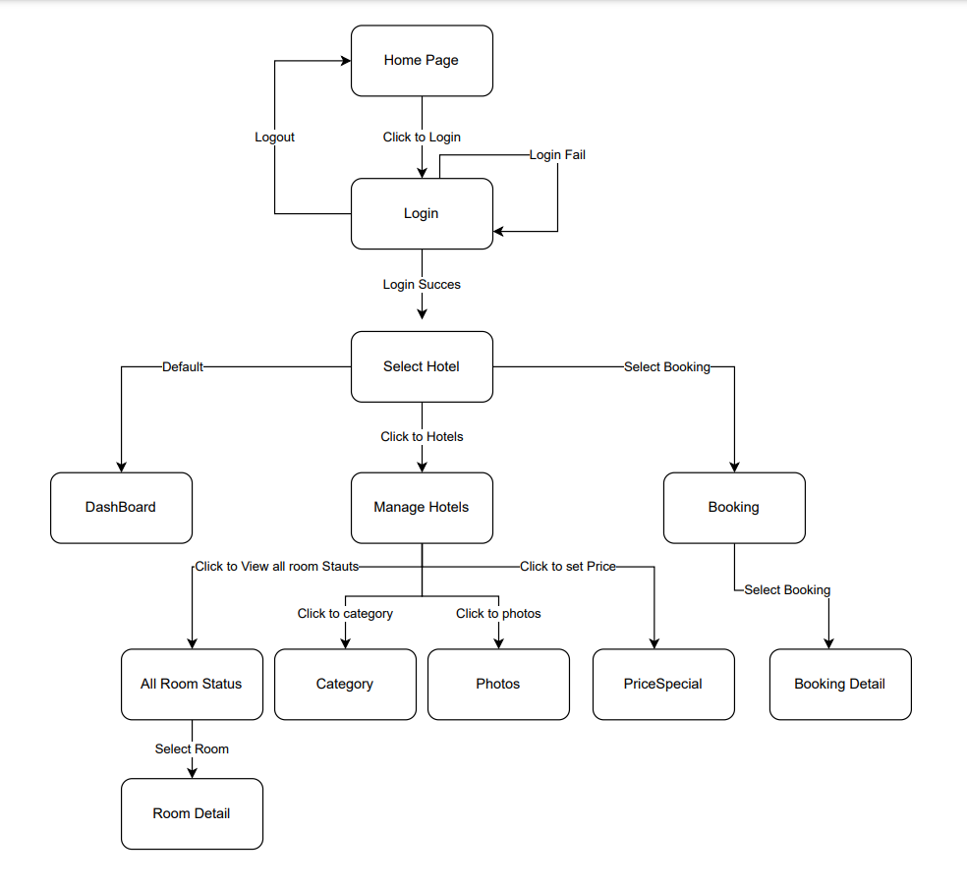

Figure 2. Web Partner Screen Flow

* **Mobile App Partner Screen Flow**

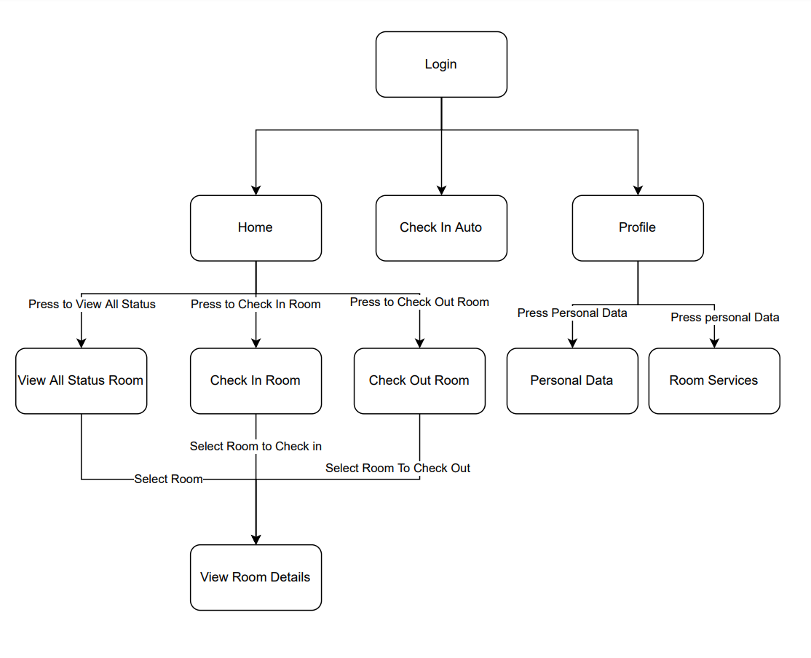

Figure 4. Mobile App Partner Screen Flow

1. **Screen Details**

* **Mobile App Partner Screen Details**

|  |  |  |  |
| --- | --- | --- | --- |
| **Id** | **Feature** | **Screen** | **Description** |
| 1 | Login | Login | Contains email and password fields |
| 2 | Forgot Password | Login | Contains email fields |
| 3 | Forgot Password Submit | Login | Contains password , confirm password , code active fields |
| 4 | View terms of use | Terms of use | Contains term of use |
| 5 | View privacy policy | Privacy policy | Contains privacy policy |
| 6 | View Home | Home | Contains tab navigation , Title Say Hi , and Content of Screen |
| 7 | View All Status Room | View Status Room | List All Room of that hotel , 2 button sort by floor or category , Room have color green is have CheckIn , color black is available , red is not clean , orange is booked at this day, Button select multiple rooms to check in multi rooms. The green room has a flag on the top right of the same color as the other room, they check in in groups |
| 8 | View Check In Room | View Check In Room | List All Room of that hotel have color black and red , 2 button sort by floor or category |
| 9 | View Check Out Room | View Check Out Room | List All Room of that hotel have color green , 2 button sort by floor or category |
| 10 | View Detail Rooms ( Select Black Room) | View Room Detail | Room default not info , with button Check In room at bottom |
| 11 | View Detail Rooms ( Select Green Room) | View Room Detail | Room with info of the booking , room Price , List customer , List used Item , button Check Out Room at bottom |
| 12 | View Detail Rooms ( Select Green Room) add Customer List | View Room Detail | Room with info of the booking , room Price , List customer , List used Item , button Check Out Room at bottom , Room with info of the booking change to camera screen |
| 13 | View Detail Rooms ( Select Green Room) add Used item | View Room Detail | Room with info of the booking , room Price , List customer , List used Item , button Check Out Room at bottom , Modal list Used Item |
| 14 | View Detail Rooms ( Select Red Room) | View Status Room | Modal confirm clean room contain 2 button confim and cancel |
| 15 | Check In Auto Screen | Check In Auto Screen | Contains tutorial about step to check in auto , button check in auto |
| 16 | Check In Auto Screen (Select Check In – Step 1) | Check In Auto Screen | Open Camera Screen , icon go back |
| 17 | Check In Auto Screen (Select Check In –Step 2) | Check In Auto Screen | Open list customer , icon go back , icon submit |
| 18 | View Profile | Profile | Contains user information with buttons to manage address book, S.O.S number, ban list, app settings |
| 19 | View fullscreen map | View fullscreen map | Full map with 2 stations: departure station and destination station |
| 20 | View Help center | Help center | List of action for help user in trip: share location, send location to SMS number, view nearest hospital, police station, gas station, mechanic shop |
| 21 | View Partner profile | Partner profile | Contains partner avatar, name, and phone number with buttons: call, message, report, and block |
| 22 | Block/Report partner | Block/Report partner | Contains an area text for reason report and block button |
| 23 | Feedback trip | Trip feedback | Contains trip star, area text for feedback, criteria feedback and submit button |
| 24 | View Point | Point | Contains amount of point, button to top up point and voucher |
| 25 | Top up point | Top up | Contains information when top up, a field to input number of points, amount of money and submit button to forward to MOMO wallet |
| 26 | View Voucher | Voucher | Contains list of vouchers, dropdown box to choose category, Near me button. |
| 27 | View Voucher detail | Voucher detail | Contains voucher information with title, brand, point to redeem, terms, description, button to redeem voucher |
| 28 | Manage bike | Manage bike | Contains a card with some bike information |
| 29 | Add bike | Add bike | Contains text fields to input bike information and take relative picture |
| 30 | Take a picture | Take a picture | Use camera on phone to take picture |
| 31 | Address book | Address book | Contain list of address user add |
| 32 | Add/Edit address | Add/Edit address | Contains address name, address detail, note and toggle to set default address |
| 33 | View S.O.S number | S.O.S number | Contains list of S.O.S numbers |
| 34 | Add/Edit S.O.S number | Add/Edit S.O.S number | Contains name and phone number |
| 35 | Edit profile | Edit profile | Contains fields to edit profile information |
| 36 | View App settings | App settings | Contains some action for user to set up the app |
| 37 | Ban list | Ban list | Contains list of users that have been blocked and can unblock |

* **Web Admin Screen Details**

|  |  |  |  |
| --- | --- | --- | --- |
| **Id** | **Feature** | **Screen** | **Description** |
| 1 | Login | Login | Contains email and password fields |
| 2 | View Dashboard | Dashboard | Contains report fields such as: total user, total trips, total new users, total saved km, selected rate of station, total saved gas, trip status rate by pie chart, points, voucher and ads, total number of exchanged vouchers. Admin can download voucher |
| 3 | View Trip | Trip | Contains list of trip, admin can view trip details |
| 4 | View Wallet transaction | Wallet transaction | Contains list of transaction, admin can view transaction |
| 5 | Manage Station | Station | Contains station list for admin to view, update, inactive or active |
| 6 | Manage Route | Route | Contains route list for admin to view, update, inactive or active |
| 7 | Manage Area | Area | Contains area list for admin to view |
| 8 | Manage User | Biker & Keer | Contains user list, admin can click on user to view user details, lock, and unlock users |
| 9 | Manage Bike | Bike | Contains list of Bike, admin can view and verify Bike |
| 10 | Manage Feedback | Feedback | Contains feedback list of user, admin can view feedback details |
| 11 | Manage Notification | Notification | Admin can send notification about incoming vouchers to users |
| 12 | Manage Advertisement | Advertisement | Contains Ads list for admin to view, update, delete, restore and add |
| 13 | Manage Voucher | Voucher | Contains voucher list for admin to view, update, delete, restore and add |
| 14 | Manage Voucher Category | Voucher Category | Contains voucher category for admin to view, delete, restore and add |
| 15 | View Admin | Admin | Contains area list for admin to view |

1. **Screen Authorization**

* Only Admin can login and view Web Admin. Admin cannot log in to Mobile App. Screen Authorization below only list Mobile Screen List
* **Mobile App Screen Authorization**

|  |  |  |
| --- | --- | --- |
| **Screen** | **Keer** | **Biker** |
| Login | x | x |
| Sign up | x | x |
| Choose mode | x | x |
| Terms of use | x | x |
| Privacy policy | x | x |
| Keer's Home | x |  |
| Create trip | x |  |
| Schedule trip | x |  |
| Biker Home |  | x |
| Ride Now |  | x |
| Ride Now Station |  | x |
| Top Bikers | x | x |
| Activity | x | x |
| History | x | x |
| Trip details | x | x |
| Notification | x | x |
| Notification details | x | x |
| Profile | x | x |
| View fullscreen map | x | x |
| Help center | x | x |
| Partner profile | x | x |
| Block/Report partner | x | x |
| Trip feedback | x | x |
| Point | x | x |
| Top up | x | x |
| Voucher | x | x |
| Voucher detail | x | x |
| Manage bike | x | x |
| Add bike | x |  |
| Take a picture | x |  |
| Address book | x | x |
| Add/Edit address | x | x |
| S.O.S number | x | x |
| Add/Edit S.O.S number | x | x |
| Edit profile | x | x |
| App settings | x | x |
| Ban list | x | x |

1. **Non-Screen Functions**

N/A

1. **Entity Relationship Diagram**

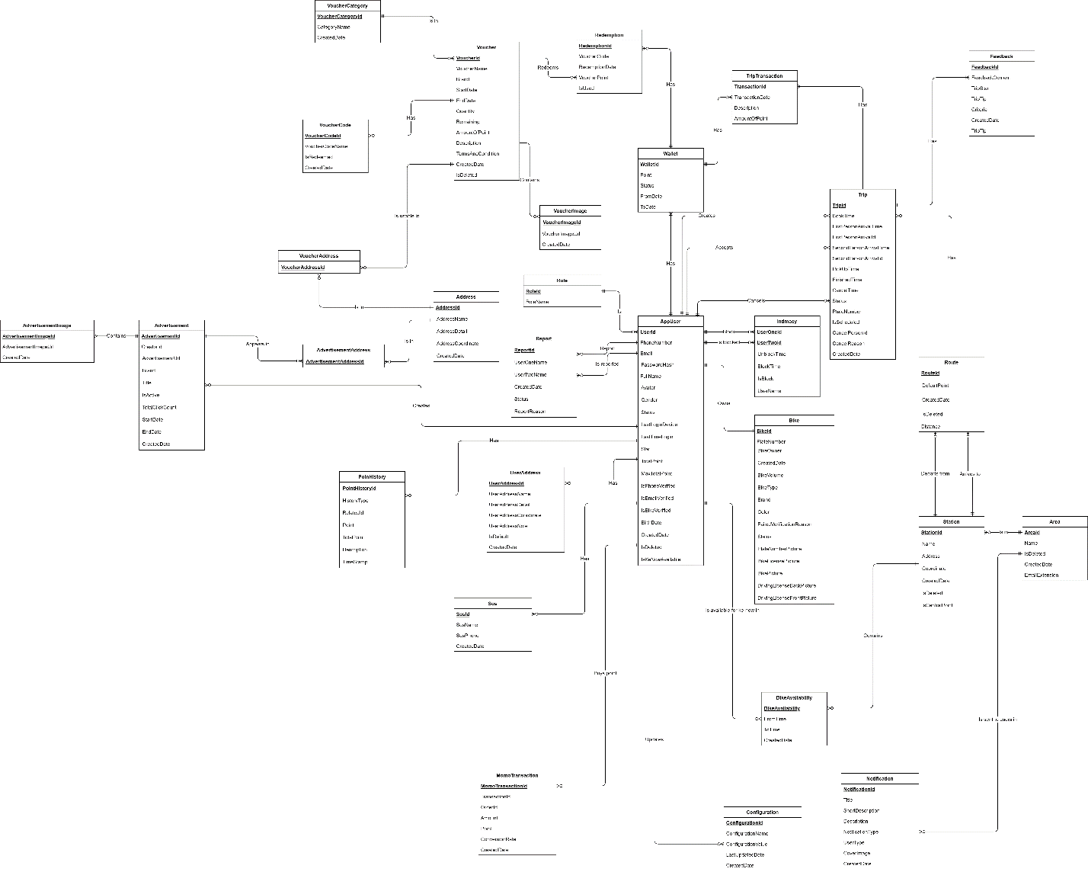

Figure 5. Entity Relationship Diagram

1. Non-Functional Requirements
   1. **External Interfaces**
2. **User Interfaces**
   * The UI shall support Vietnamese/English
   * The authenticated users UI must be fully shown in mobile app
3. **Communications Interfaces**
   * Authentication Service: The system can be integrated with Firebase Authentication framework
   * The system can send email to users to verify FPT email
   * The system can call API through data transferred by HTTP
   1. **Quality Attributes**
4. **Usability**
   * All text, label and message should be uniformly written in Vietnamese / English
   * The application should be friendly and easy for users to use without training
   * The web application for admin should require no more than 2 days of training to use
5. **Reliability**
   * N/A
6. **Security**
   * Biiké users is divided into 3 roles: Biker, Keer and Admin
   * All input data are validated before saving to the database
   * Each role only access to a group of functions
   * The system always checks authentication and authorization before doing any features
7. Software Design Description
8. Overall Description
   1. **Assumptions**

This system is designed basing on these following assumptions:

* Windows 10
* Chrome 96
* Microsoft Egde 96
* SQL Server 2019
* Android 8+
* End-User: FPT University Students, Biiké Manager team
* Security requirement: prevent users from cheating as much as possible
* Network communication: This system depends on networks connection

1. System Architecture Design
   1. **Overall System Architecture**

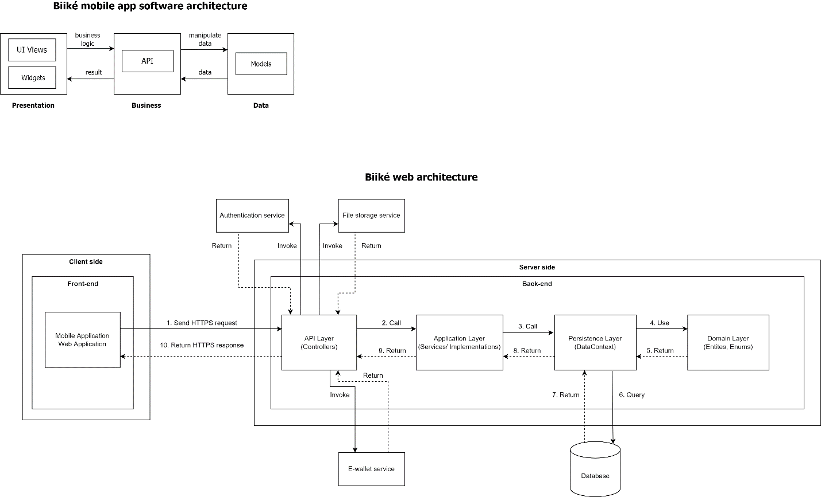

Figure 6. System Architecture Diagram

|  |  |  |
| --- | --- | --- |
| **No.** | **Name** | **Description** |
| 1. | Authentication service | It oversees authenticating 3rd party account of the user and send the result to our system |
| 2. | Email service | It handles sending emails. |
| 3. | UI | Client component to render and display data from  the server. Client component provides functions:  For admin: manage stations, routes, verify feedbacks, etc.  For biker: accept trip, manage bike, etc.  For keer: schedule trip, create Ké-now trip, etc. |
| 4. | Business logic process | It handles the business logic of the system |
| 5. | Provider/DAO | It handles reading and writing data in the system. |
| 6. | Biiké API | It handles request from mobile and web app and response from the system. |
| 7. | Database | It stores the data of the system. |

Table 16. System Architecture

* 1. **Component Diagram**

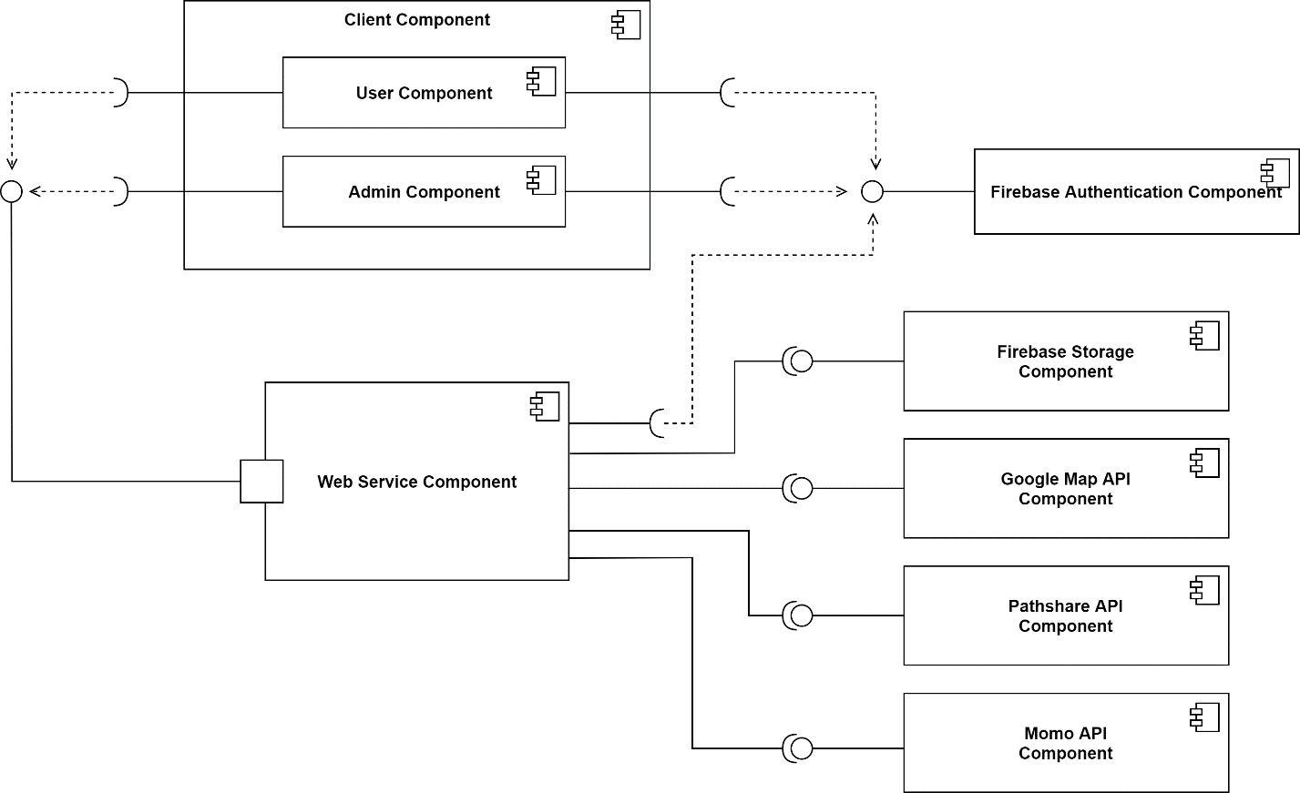

Figure 7. Component Diagram

|  |  |  |
| --- | --- | --- |
| **No.** | **Name** | **Description** |
| 1 | Firebase Authentication | User use FPT edu mail account to be authenticated in the Biiké system. This component oversees  authenticating the account of the user and send the result to our system. |
| 2 | Client component | Client component to render and display data from the server. Client component provides functions:  For admin: manage stations, routes, verify feedbacks, etc.  For biker: accept trip, manage bike, etc.  For keer: schedule trip, create Ké-now trip, etc. |
| 3 | Admin component | It provides features: manage stations, manage routes, verify feedbacks, etc. |
| 4 | User component | It provides features: create trip, accept trip, manage bike, exchange voucher, etc. |
| 5 | Firebase Storage | Store and serve user-generated content, contains photos. |
| 6 | Google Map API | Service to show the location of the Station and show the direction between 2 stations |
| 7 | Pathshare API | Service to get user real-time location via GPS |
| 8 | Momo API | Service to make in-app purchase |

Table 17. Component Diagram Description

* 1. **Package Diagram**

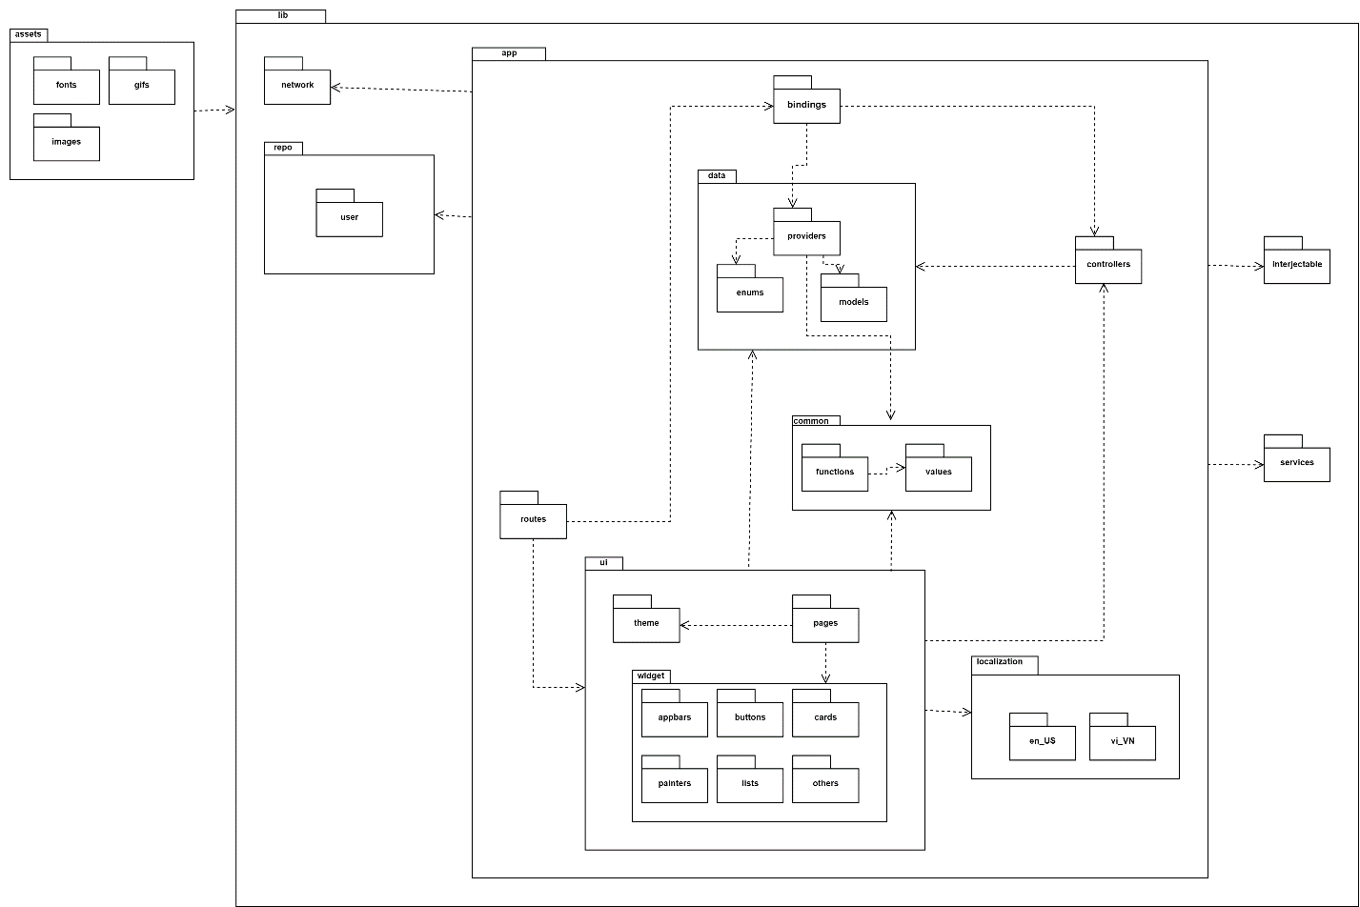

Figure 8. Package Diagram

|  |  |  |
| --- | --- | --- |
| **No** | **Package** | **Description** |
| 1 | Lib | This package contains folders of different layers in app |
| 2 | App | This package contains classes for app UI and business layers and main class |
| 3 | Bindings | This package contains classes to bind screens, providers and controllers |
| 4 | Data | This package contains folders of providers, enums and models |
| 5 | Providers | This package contains classes to send and receive HTTP requests from API |
| 6 | Enums | This package contains classes for enum data |
| 7 | Models | This package contains classes to map objects to/from json from API |
| 8 | Bindings | This package contains classes to bind ui, controllers, providers |
| 9 | Common | This package contains folders of common values and functions |
| 10 | Functions | This package contains classes for common functions |
| 11 | Values | This package contains classes for common values |
| 12 | Localizations | This package contains classes for switching language |
| 13 | en_US | This package contains English translations of the app |
| 14 | vi_VN | This package contains Vietnamese translations of the app |
| 15 | Services | This package contains classes for using outside services like Firebase, … |
| 16 | UI | This package contains folders for UI implementation |
| 17 | Theme | This package contains classes for main theme of the app |
| 18 | Pages | This package contains classes for screen UI |
| 19 | Widget | This package contains classes for widgets using in screen |
| 20 | Appbars | This package contains classes for appbar design |
| 21 | Buttons | This package contains classes for buttons in screen |
| 22 | Cards | This package contains classes for cards in screen |
| 23 | Painters | This package contains classes for drawing shapes in screen |
| 24 | Lists | This package contains classes for listview in screen |
| 25 | Others | This package contains classes for others widgets in screen |
| 26 | Routes | This package contains classes for navigation data between screens |
| 27 | Assets | This package contains assets using in UI |
| 28 | Fonts | This package contains fonts using in app |
| 29 | Gifs | This package contains gifs using in app |
| 30 | Images | This package contains images using in app |
| 31 | Network | This package contains classes for config networks and for login/logout REST client |
| 32 | Repos | This package contains user folder |
| 33 | User | This package contains classes for user behavior |

Table 18. Package Diagram Description

1. Activity Diagram

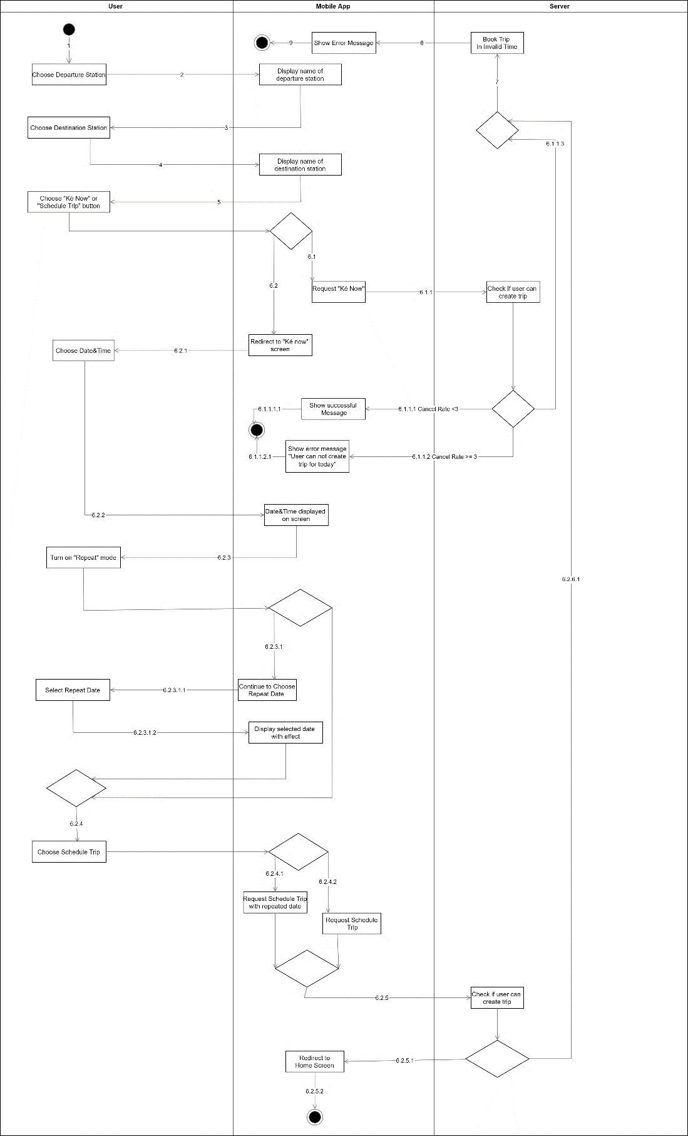

Figure 9. Activity Diagram - Create trip

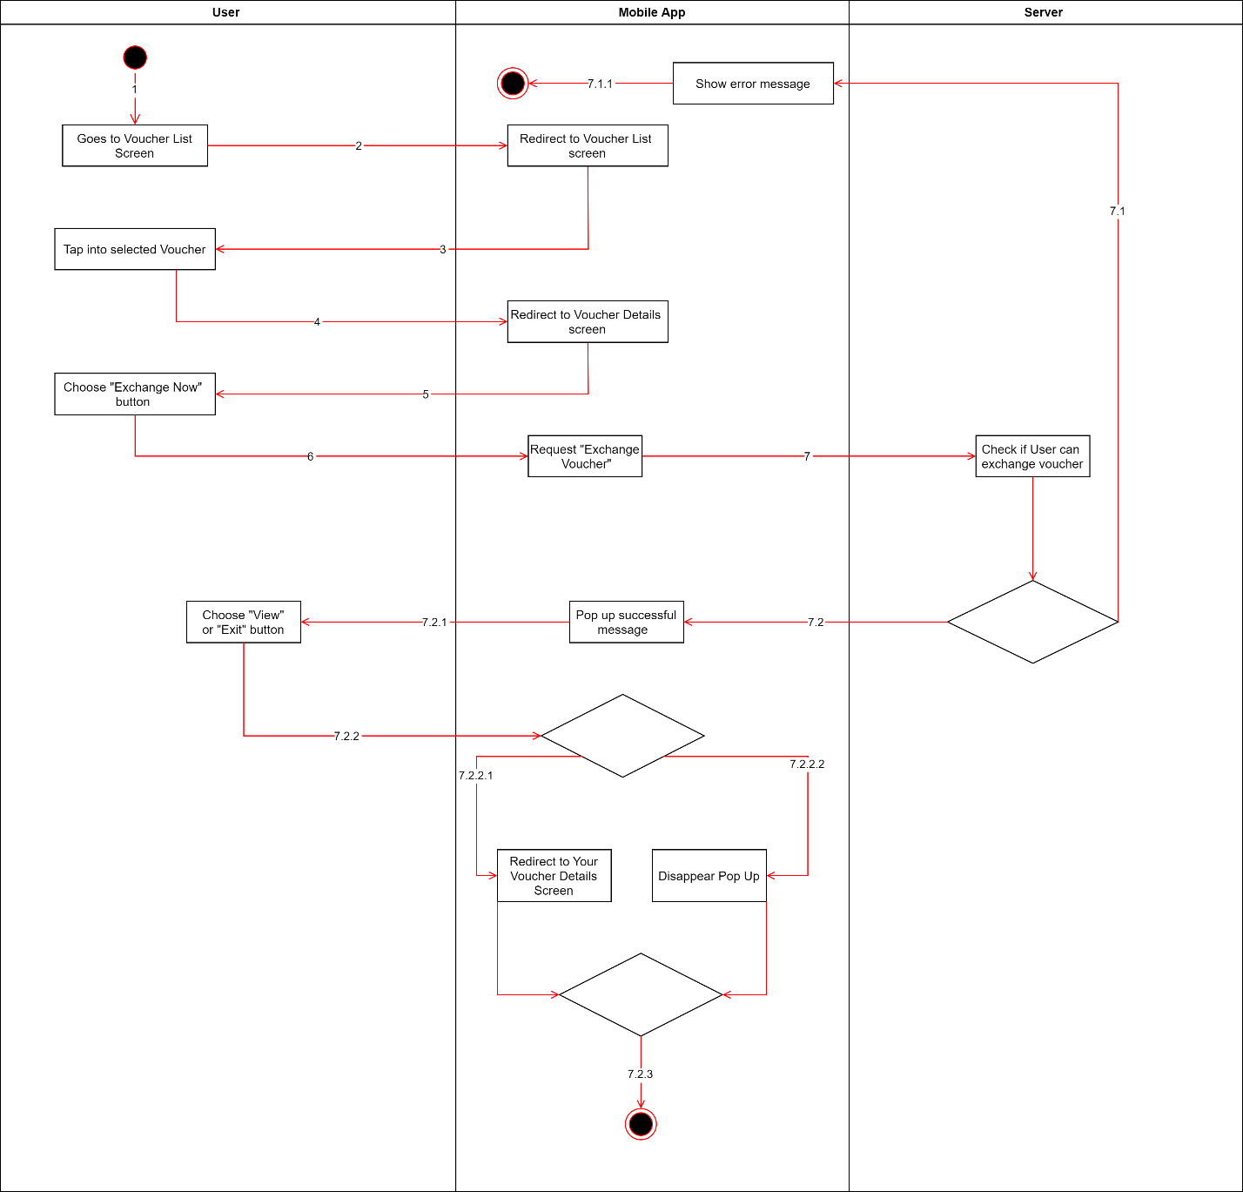

Figure 10. Activity Diagram - Redeem voucher

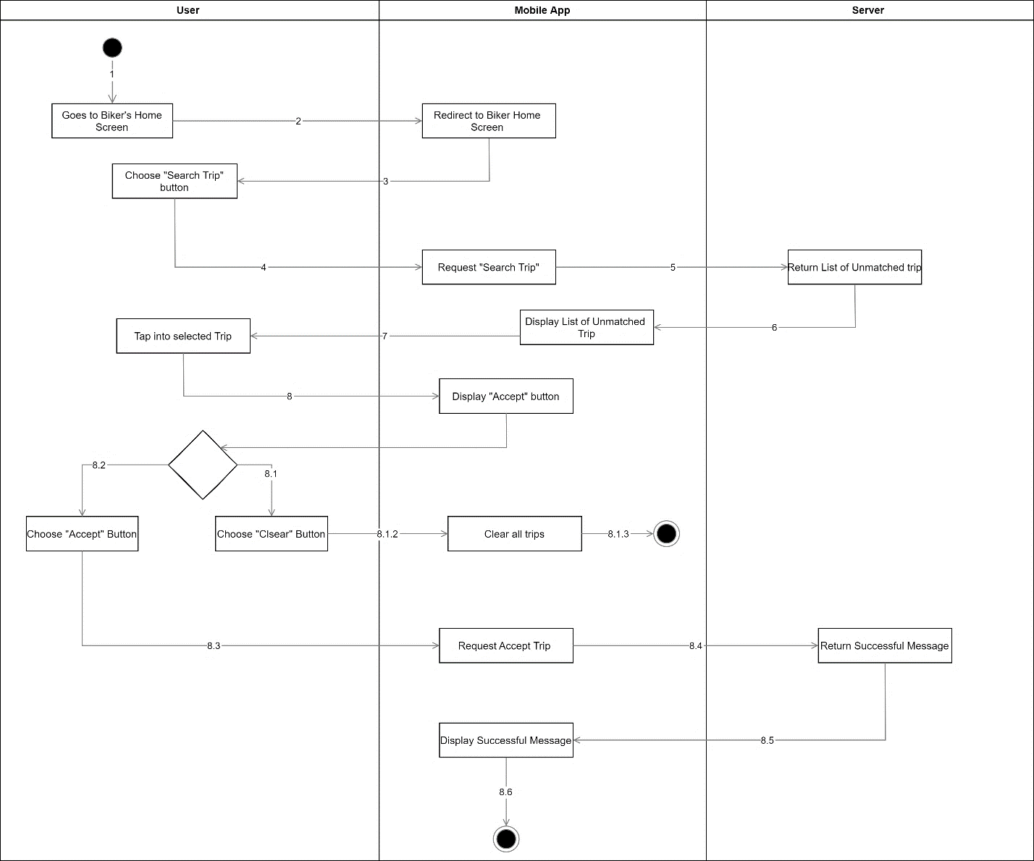

Figure 11. Activity Diagram - Accept a trip

1. System Detailed Design
   1. **Class Diagram**

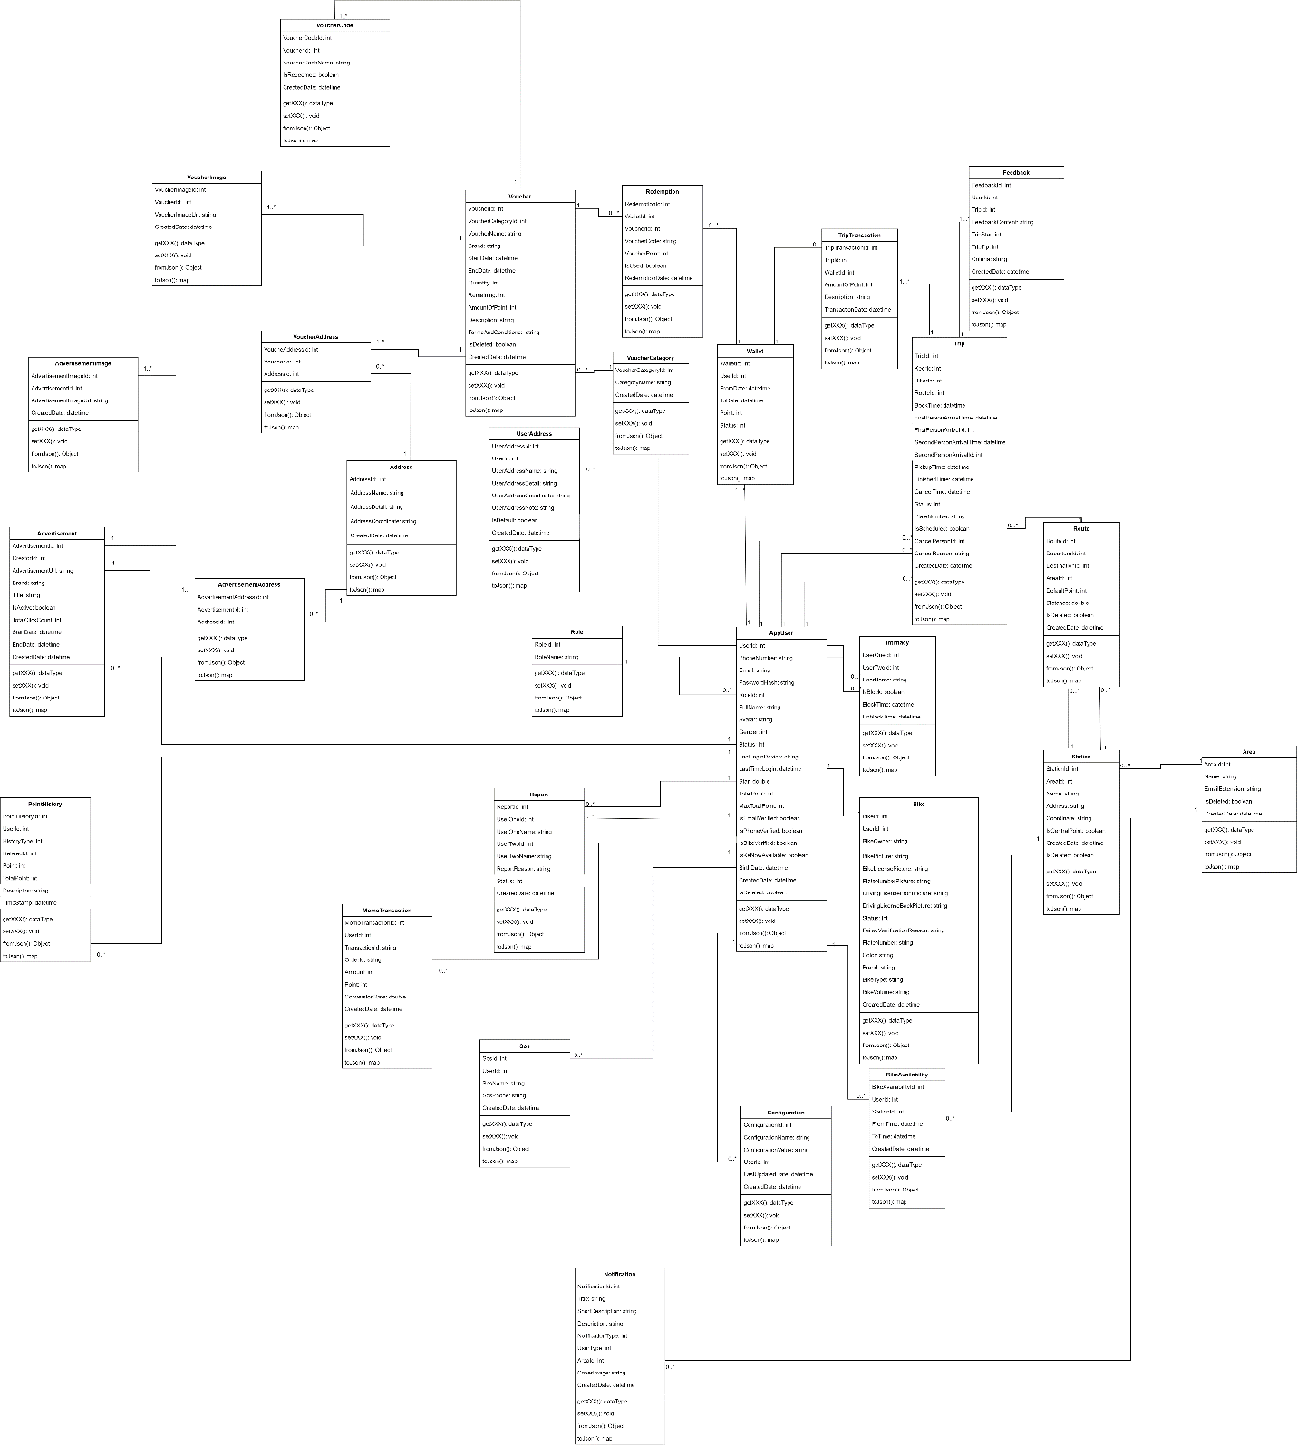

Figure 12. Class Diagram

* 1. **Class Specification**
     1. **AppUser Class**

|  |  |  |  |  |
| --- | --- | --- | --- | --- |
| **No** | **Attribute** | **Data Type** | **Visibility** | **Description** |
| 1 | UserId | Int | Private | Unique define of user |
| 2 | PhoneNumber | String | Private | Unique phone number of users |
| 3 | Email | String | Private | Unique user’s contact email |
| 4 | PasswordHash | String | Private | User password to Biiké app |
| 5 | RoleId | Int | Private | Identifier for user’s role when using Biiké |
| 6 | FullName | String | Private | User’s full name |
| 7 | Avatar | String | Private | User’s Biiké avatar |
| 8 | Gender | Int | Private | User’s Gender |
| 9 | Status | Int | Private | User’s Status |
| 10 | LastLoginDevice | String | Private | Last login device user |
| 11 | LastTimeLogin | DateTime | Private | Last time user login |
| 12 | Star | Double | Private | User Biiké star |
| 13 | TotalPoint | Int | Private | User’s total point |
| 14 | MaxTotalPoint | Int | Private | Total max point of user |
| 15 | isEmailVerify | Boolean | Private | If user’s email is verified or not |
| 16 | isPhoneVerify | Boolean | Private | If user’s phone number is verified |
| 17 | Birthday | Datetime | Private | User’s birthday |
| 18 | createdDate | Datetime | Private | User’s created date |
| 19 | isDeleted | Boolean | Private | If user is deleted |
| 20 | IsKeNowAvailable | Boolean | Private | If user’s kenow is available or not |
| 21 | IsBikeVerified | Boolean | Private | If bike is verified or not |

Table 19. AppUser Class Attribute

|  |  |  |  |  |
| --- | --- | --- | --- | --- |
| **No** | **Method** | **Return Type** | **Accessibility** | **Description** |
| 1 | getXXX | DataType | Public | To get attribute value |
| 2 | setXXX | Void | Public | Set value of attribute |
| 3 | fromJson | Object | Public | Convert Json to Object |
| 4 | toJson | Map | Public | Convert Object to Json |

Table 20. AppUser Class Method

* + 1. **Bike Class**

|  |  |  |  |  |
| --- | --- | --- | --- | --- |
| **No** | **Attribute** | **Data Type** | **Visibility** | **Description** |
| 1 | UserId | Int | Private | Unique define of user |
| 2 | BikeId | Int | Private | Unique define of user’s bike |
| 3 | BikeOwner | String | Private | Bike’s owner name |
| 4 | BikePicture | String | Private | Bike’s picture |
| 5 | BikeLisencePicture | String | Private | Bike’s license picture |
| 6 | PlateNumberPicture | String | Private | Number plate picture |
| 7 | Status | Int | Private | Bike’s status |
| 8 | FailedVerrificationreason | String | Private | Reason why the bike is failed to verify |
| 9 | PlateNumber | String | Private | Number Plate of Bike |
| 10 | Color | String | Private | Bike’s color |
| 11 | Brand | String | Private | Brand of bike |
| 12 | BikeType | String | Private | Type of Bike |
| 13 | BikeVolume | String | Private | Volume of Bike |
| 14 | CreatedDate | Datetime | Private | Time Created bike in Biiké application |
| 15 | DrivingLicenseFrontPicture | String | Private | Front picture of biker’s license |
| 16 | DrivingLicenseBackPicture | String | Private | Back picture of biker’s license |

Table 21. Bike Class Attribute

|  |  |  |  |  |
| --- | --- | --- | --- | --- |
| **No** | **Method** | **Return Type** | **Accessibility** | **Description** |
| 1 | getXXX | DataType | Public | To get attribute value |
| 2 | setXXX | Void | Public | Set value of attribute |
| 3 | fromJson | Object | Public | Convert Json to Object |
| 4 | toJson | Map | Public | Convert Object to Json |

Table 22. Bike Class Method

* + 1. **User Address Class**

|  |  |  |  |  |
| --- | --- | --- | --- | --- |
| **No** | **Attribute** | **Data Type** | **Visibility** | **Description** |
| 1 | UserId | Int | Private | Unique define of user |
| 2 | UserAddressId | Int | Private | Unique Define of user address |
| 3 | UserAddressName | String | Private | Name of user’s address in Biiké application |
| 4 | UserAddressDetails | String | Private | Information about user’s address |
| 5 | UserAddressCoordinate | String | Private | Coordinate of user’s address |
| 6 | UserAddressNote | String | Private | Note of User |
| 7 | IsDefault | Boolean | Private | If user address is default address or not |
| 8 | CreatedDate | Datetime | Private | Date user address created |

Table 23. UserAddress Class Attribute

|  |  |  |  |  |
| --- | --- | --- | --- | --- |
| **No** | **Method** | **Return Type** | **Accessibility** | **Description** |
| 1 | getXXX | DataType | Public | To get attribute value |
| 2 | setXXX | Void | Public | Set value of attribute |
| 3 | fromJson | Object | Public | Convert Json to Object |
| 4 | toJson | Map | Public | Convert Object to Json |

Table 24. UserAddress Class Method

* + 1. **Intimacy Class**

|  |  |  |  |  |
| --- | --- | --- | --- | --- |
| **No** | **Attribute** | **Data Type** | **Visibility** | **Description** |
| 1 | UserOneId | Int | Private | Unique define of user one |
| 2 | UserTwoId | Int | Private | Unique Define of user two |
| 3 | Username | String | Private | User’s Name |
| 4 | IsBlock | Bit | Private | To check if user is block or not |
| 5 | BlockTime | Datetime | Private | Time user block |
| 6 | UnblockTime | Datetime | Private | Time users unblock other user |

Table 25. Intimacy Class Attribute

|  |  |  |  |  |
| --- | --- | --- | --- | --- |
| **No** | **Method** | **Return Type** | **Accessibility** | **Description** |
| 1 | getXXX | DataType | Public | To get attribute value |
| 2 | setXXX | Void | Public | Set value of attribute |
| 3 | fromJson | Object | Public | Convert Json to Object |
| 4 | toJson | Map | Public | Convert Object to Json |

Table 26. Intimacy Class Method

* + 1. **Report Class**

|  |  |  |  |  |
| --- | --- | --- | --- | --- |
| **No** | **Attribute** | **Data Type** | **Visibility** | **Description** |
| 1 | UserOneId | Int | Private | Unique define of user one |
| 2 | UserTwoId | Int | Private | Unique Define of user two |
| 3 | ReportId | Int | Private | Unique Define of report |
| 4 | UserOneName | String | Private | User one’s name |
| 5 | UserTwoName | String | Private | User two’s name |
| 6 | ReportReason | String | Private | Reason why user report other user |
| 7 | Status | Int | Private | Status of report |

Table 27. Report Class Attribute

|  |  |  |  |  |
| --- | --- | --- | --- | --- |
| **No** | **Method** | **Return Type** | **Accessibility** | **Description** |
| 1 | getXXX | DataType | Public | To get attribute value |
| 2 | setXXX | Void | Public | Set value of attribute |
| 3 | fromJson | Object | Public | Convert Json to Object |
| 4 | toJson | Map | Public | Convert Object to Json |

Table 28. Report Class Method

* + 1. **SoS Class**

|  |  |  |  |  |
| --- | --- | --- | --- | --- |
| **No** | **Attribute** | **Data Type** | **Visibility** | **Description** |
| 1 | SosId | Int | Private | Unique define of sos |
| 2 | UserId | Int | Private | Unique Define of user |
| 3 | SosName | String | Private | Name of Sos number will be displayed on Biiké application |
| 4 | SosPhone | String | Private | Phone Number of S.o.S person |
| 5 | CreatedDate | Datetime | Private | Date added s.o.s number |

Table 29. S.O.S Class Attribute

|  |  |  |  |  |
| --- | --- | --- | --- | --- |
| **No** | **Method** | **Return Type** | **Accessibility** | **Description** |
| 1 | getXXX | DataType | Public | To get attribute value |
| 2 | setXXX | Void | Public | Set value of attribute |
| 3 | fromJson | Object | Public | Convert Json to Object |
| 4 | toJson | Map | Public | Convert Object to Json |

Table 30. S.O.S Class Method

* + 1. **PointHistory Class**

|  |  |  |  |  |
| --- | --- | --- | --- | --- |
| **No** | **Attribute** | **Data Type** | **Visibility** | **Description** |
| 1 | PointHistoryId | Int | Private | Unique define of point history |
| 2 | UserId | Int | Private | Unique Define of user |
| 3 | HistoryType | Int | Private | Type of point history |
| 4 | RelatedId | Int | Private | Related of point history |
| 5 | Point | Int | Private | History point |
| 6 | TotalPoint | Int | Private | Total history point |
| 7 | Description | String | Private | Description of point history |
| 8 | TimeStamp | Datetime | Private | Time stamp of point history |

Table 31. Point History Class Attribute

|  |  |  |  |  |
| --- | --- | --- | --- | --- |
| **No** | **Method** | **Return Type** | **Accessibility** | **Description** |
| 1 | getXXX | DataType | Public | To get attribute value |
| 2 | setXXX | Void | Public | Set value of attribute |
| 3 | fromJson | Object | Public | Convert Json to Object |
| 4 | toJson | Map | Public | Convert Object to Json |

Table 32. Point History Class Method

* + 1. **Trip Class**

|  |  |  |  |  |
| --- | --- | --- | --- | --- |
| **No** | **Attribute** | **Data Type** | **Visibility** | **Description** |
| 1 | TripId | Int | Private | Unique define of trip |
| 2 | KeerId | Int | Private | Unique Define of keer |
| 3 | BikeId | Int | Private | Unique define of Biker’s bike |
| 4 | RouteId | Int | Private | Unique define of Route |
| 5 | BookTime | Datetime | Private | Time book trip |
| 6 | PickupTime | Datetime | Private | Time pickup of trip |
| 7 | FinishedTime | Datetime | Private | Time finished of trip |
| 8 | CancelTime | Datetime | Private | Time cancel the trip |
| 9 | Status | Int | Private | Status of trip |
| 10 | PlateNumber | String | Private | Number plate of biker’s bike |
| 11 | IsScheduled | Bit | Private | If the trip is schedule or ke now trip |
| 12 | CancelPersonId | Int | Private | Unique define of cancel person |
| 13 | CancelReason | Int | Private | Cancel reason |
| 14 | CreatedDate | Datetime | Private | Created date of trip |
| 15 | FirstPersonArrivalId | Int | Private | Unique identifier for first person arrived at pick up position |
| 16 | SecondPersonArrivalId | Int | Private | Unique identifier for second person arrived at pick up position |
| 17 | FirstPersonArrivalTime | Int | Private | Time first person arrived at pick up position |
| 18 | SecondPersonArrivalTime | Int | Private | Time second person arrived at pick up position |

Table 33. Trip Class Attribute

|  |  |  |  |  |
| --- | --- | --- | --- | --- |
| **No** | **Method** | **Return Type** | **Accessibility** | **Description** |
| 1 | getXXX | DataType | Public | To get attribute value |
| 2 | setXXX | Void | Public | Set value of attribute |
| 3 | fromJson | Object | Public | Convert Json to Object |
| 4 | toJson | Map | Public | Convert Object to Json |

Table 34. Trip Class Method

* + 1. **Route Class**

|  |  |  |  |  |
| --- | --- | --- | --- | --- |
| **No** | **Attribute** | **Data Type** | **Visibility** | **Description** |
| 1 | RouteId | Int | Private | Unique define of route |
| 2 | DepartureId | Int | Private | Unique Define of departure station |
| 3 | DestinationId | Int | Private | Destination station unique definition |
| 4 | AreaId | Int | Private | Unique define of area |
| 5 | DefaultPoint | Int | Private | Default point of route |
| 6 | CreatedDate | Datetime | Private | Date created route |
| 7 | IsDeleted | Bit | Private | If the route is deleted or not |
| 8 | Distance | Double | Private | Distance of route |

Table 35. Route Class Attribute

|  |  |  |  |  |
| --- | --- | --- | --- | --- |
| **No** | **Method** | **Return Type** | **Accessibility** | **Description** |
| 1 | getXXX | DataType | Public | To get attribute value |
| 2 | setXXX | Void | Public | Set value of attribute |
| 3 | fromJson | Object | Public | Convert Json to Object |
| 4 | toJson | Map | Public | Convert Object to Json |

Table 36. Route Class Method

* + 1. **Station Class**

|  |  |  |  |  |
| --- | --- | --- | --- | --- |
| **No** | **Attribute** | **Data Type** | **Visibility** | **Description** |
| 1 | StationId | Int | Private | Unique define of station |
| 2 | AreaId | Int | Private | Unique Define of area |
| 3 | Name | String | Private | Station’s name |
| 4 | Address | String | Private | Station’s address |
| 5 | Coordinate | String | Private | Station’s coordinate |
| 6 | IsDeleted | Bit | Private | If station is deleted or not |
| 7 | CreatedDate | Datetime | Private | Date created of station |
| 8 | IsCentralPoint | Boolean | Private | If the station is Biiké’s central point |

Table 37. Station Class Attribute

|  |  |  |  |  |
| --- | --- | --- | --- | --- |
| **No** | **Method** | **Return Type** | **Accessibility** | **Description** |
| 1 | getXXX | DataType | Public | To get attribute value |
| 2 | setXXX | Void | Public | Set value of attribute |
| 3 | fromJson | Object | Public | Convert Json to Object |
| 4 | toJson | Map | Public | Convert Object to Json |

Table 38. Station Class Method

* + 1. **Area Class**

|  |  |  |  |  |
| --- | --- | --- | --- | --- |
| **No** | **Attribute** | **Data Type** | **Visibility** | **Description** |
| 1 | AreaId | Int | Private | Unique define of area |
| 2 | Name | String | Private | Name of Area |
| 3 | IsDeleted | Bit | Private | If area is deleted or not |
| 4 | CreatedDate | Datetime | Private | Date area is created |
| 5 | EmailExtension | String | Private | Condition for user’s’s register email suffix |

Table 39. Area Class Attribute

|  |  |  |  |  |
| --- | --- | --- | --- | --- |
| **No** | **Method** | **Return Type** | **Accessibility** | **Description** |
| 1 | getXXX | DataType | Public | To get attribute value |
| 2 | setXXX | Void | Public | Set value of attribute |
| 3 | fromJson | Object | Public | Convert Json to Object |
| 4 | toJson | Map | Public | Convert Object to Json |

Table 40. Area Class Method

* + 1. **Feedback Class**

|  |  |  |  |  |
| --- | --- | --- | --- | --- |
| **No** | **Attribute** | **Data Type** | **Visibility** | **Description** |
| 1 | FeedbackId | Int | Private | Unique define of feedback |
| 2 | UserId | Int | Private | Unique Define of user |
| 3 | TripId | Int | Private | Unique define of Trip |
| 4 | FeedbackContent | String | Private | Content of feedback |
| 5 | TripStar | Int | Private | Trip star of feedback given by users |
| 6 | TripTip | Int | Private | Point the Keer tip for biker |
| 7 | Criteria | String | Private | Criteria of feedback |
| 8 | CreatedDate | Datetime | Private | Created date of feedback |

Table 41. Feedback Class Attribute

|  |  |  |  |  |
| --- | --- | --- | --- | --- |
| **No** | **Method** | **Return Type** | **Accessibility** | **Description** |
| 1 | getXXX | DataType | Public | To get attribute value |
| 2 | setXXX | Void | Public | Set value of attribute |
| 3 | fromJson | Object | Public | Convert Json to Object |
| 4 | toJson | Map | Public | Convert Object to Json |

Table 42. Feedback Class Method

* + 1. **Trip Transaction Class**

|  |  |  |  |  |
| --- | --- | --- | --- | --- |
| **No** | **Attribute** | **Data Type** | **Visibility** | **Description** |
| 1 | TripTransactionId | Int | Private | Unique define of trip transaction |
| 2 | TripId | Int | Private | Unique Define of trip |
| 3 | WalletId | Int | Private | Unique define of wallet |
| 4 | AmountOfPoint | Int | Private | The amount of point transaction |
| 5 | Description | String | Private | Trip transaction’s description |
| 6 | TransactionDate | Datetime | Private | The date the transaction was made |

Table 43. Trip Transaction Class Attribute

|  |  |  |  |  |
| --- | --- | --- | --- | --- |
| **No** | **Method** | **Return Type** | **Accessibility** | **Description** |
| 1 | getXXX | DataType | Public | To get attribute value |
| 2 | setXXX | Void | Public | Set value of attribute |
| 3 | fromJson | Object | Public | Convert Json to Object |
| 4 | toJson | Map | Public | Convert Object to Json |

Table 44. Trip Transaction Class Method

* + 1. **Wallet Class**

|  |  |  |  |  |
| --- | --- | --- | --- | --- |
| **No** | **Attribute** | **Data Type** | **Visibility** | **Description** |
| 1 | WalletId | Int | Private | Unique define of wallet |
| 2 | UserId | Int | Private | Unique Define of user |
| 3 | FromDate | Datetime | Private | From date |
| 4 | ToDate | Datetime | Private | the date wallet expired |
| 5 | Point | Int | Private | Point amount of wallet |
| 6 | Status | Int | Private | Status of wallet |

Table 45. Wallet Class Attribute

|  |  |  |  |  |
| --- | --- | --- | --- | --- |
| **No** | **Method** | **Return Type** | **Accessibility** | **Description** |
| 1 | getXXX | DataType | Public | To get attribute value |
| 2 | setXXX | Void | Public | Set value of attribute |
| 3 | fromJson | Object | Public | Convert Json to Object |
| 4 | toJson | Map | Public | Convert Object to Json |

Table 46. Wallet Class Method

* + 1. **Redemption Class**

|  |  |  |  |  |
| --- | --- | --- | --- | --- |
| **No** | **Attribute** | **Data Type** | **Visibility** | **Description** |
| 1 | RedemptionId | Int | Private | Unique define of redemption |
| 2 | WalletId | Int | Private | Unique Define of wallet |
| 3 | VoucherId | Int | Private | Unique Define of voucher |
| 4 | VoucherCode | String | Private | Code of voucher |
| 5 | IsUsed | Bit | Private | Is the voucher is used or not |
| 6 | RedemptionDate | Datetime | Private | The date the voucher was redeemed |
| 7 | VoucherPoint | Int | Private | Voucher point of redemption |

Table 47. Redemption Class Attribute

|  |  |  |  |  |
| --- | --- | --- | --- | --- |
| **No** | **Method** | **Return Type** | **Accessibility** | **Description** |
| 1 | getXXX | DataType | Public | To get attribute value |
| 2 | setXXX | Void | Public | Set value of attribute |
| 3 | fromJson | Object | Public | Convert Json to Object |
| 4 | toJson | Map | Public | Convert Object to Json |

Table 48. Redemption Class Method

* + 1. **VoucherCategory Class**

|  |  |  |  |  |
| --- | --- | --- | --- | --- |
| **No** | **Attribute** | **Data Type** | **Visibility** | **Description** |
| 1 | VoucherCategoryId | Int | Private | Unique define of voucher category |
| 2 | CategoryName | String | Private | Category Name |
| 3 | CreatedDate | Datetime | Private | Name of Sos number will be displayed on Biiké application |

Table 49. Voucher Category Class Attribute

|  |  |  |  |  |
| --- | --- | --- | --- | --- |
| **No** | **Method** | **Return Type** | **Accessibility** | **Description** |
| 1 | getXXX | DataType | Public | To get attribute value |
| 2 | setXXX | Void | Public | Set value of attribute |
| 3 | fromJson | Object | Public | Convert Json to Object |
| 4 | toJson | Map | Public | Convert Object to Json |

Table 50. Voucher Category Class Method

* + 1. **Voucher Class:**

|  |  |  |  |  |
| --- | --- | --- | --- | --- |
| **No** | **Attribute** | **Data Type** | **Visibility** | **Description** |
| 1 | VoucherCategoryId | Int | Private | Unique define of voucher category |
| 2 | VoucherName | String | Private | Voucher Name |
| 3 | CreatedDate | Datetime | Private | Name of Sos number will be displayed on Biiké application |
| 4 | VoucherId | Int | Private | Unique identifier for voucher |
| 5 | Brand | Nvarchar(max) | Private | Voucher’s brand |
| 6 | StartDate | Datetime2 | Private | Date voucher started available |
| 7 | EndDate | Datetime2 | Private | Date voucher ends |
| 8 | Quantity | Int | Private | Quantity of vouchers |
| 9 | Remaining | Int | Private | Remaining quantity of vouchers |
| 10 | AmountOfPoint | Int | Private | Amount of point meeds to exchange voucher |
| 11 | Description | Nvarchar(max) | Private | Voucher’description |
| 12 | TermsAndConditions | Nvarchar(max) | Private | Voucher’s yterms and conditions |
| 13 | IsDeleted | Boolean | Private | If voucher is deleted |

Table 51. Voucher Class Attribute

|  |  |  |  |  |
| --- | --- | --- | --- | --- |
| **No** | **Method** | **Return Type** | **Accessibility** | **Description** |
| 1 | getXXX | DataType | Public | To get attribute value |
| 2 | setXXX | Void | Public | Set value of attribute |
| 3 | fromJson | Object | Public | Convert Json to Object |
| 4 | toJson | Map | Public | Convert Object to Json |

Table 52. Voucher Class Method

* + 1. **VoucherAddress Class:**

|  |  |  |  |  |
| --- | --- | --- | --- | --- |
| **No** | **Attribute** | **Data Type** | **Visibility** | **Description** |
| 1 | VouccherAddressId | Int | Private | Unique define of voucher address |
| 2 | VoucherId | Int | Private | Unique define of voucher |
| 3 | AddressId | Int | Private | Identifier of adress |

Table 53. Voucher Address Class Attribute

|  |  |  |  |  |
| --- | --- | --- | --- | --- |
| **No** | **Method** | **Return Type** | **Accessibility** | **Description** |
| 1 | getXXX | DataType | Public | To get attribute value |
| 2 | setXXX | Void | Public | Set value of attribute |
| 3 | fromJson | Object | Public | Convert Json to Object |
| 4 | toJson | Map | Public | Convert Object to Json |

Table 54. Voucher Address Class Method

* + 1. **Address Class:**

|  |  |  |  |  |
| --- | --- | --- | --- | --- |
| **No** | **Attribute** | **Data Type** | **Visibility** | **Description** |
| 1 | AddressName | String | Private | Name of address named by user |
| 2 | AddressDetails | String | Private | Address detail information |
| 3 | AddressID | Int | Private | Unique Identifier of adress |
| 4 | AddressCoordinate | String | Private | Coordinate of adderss |
| 5 | CreatedDate | Datetime | [private | Date address was added |

Table 55. Address Class Attribute

|  |  |  |  |  |
| --- | --- | --- | --- | --- |
| **No** | **Method** | **Return Type** | **Accessibility** | **Description** |
| 1 | getXXX | DataType | Public | To get attribute value |
| 2 | setXXX | Void | Public | Set value of attribute |
| 3 | fromJson | Object | Public | Convert Json to Object |
| 4 | toJson | Map | Public | Convert Object to Json |

Table 56. Address Class Method

* + 1. **Advertisement Address Class**

|  |  |  |  |  |
| --- | --- | --- | --- | --- |
| **No** | **Attribute** | **Data Type** | **Visibility** | **Description** |
| 1 | Advertisement AddressId | Int | Private | Unique define of voucher addres |
| 2 | AdvertisementId | Int | Private | Unique define of advertisement |
| 3 | AddressID | Int | Private | Unique Identifier of adress |

Table 57. Advertisement Address Class Attribute

|  |  |  |  |  |
| --- | --- | --- | --- | --- |
| **No** | **Method** | **Return Type** | **Accessibility** | **Description** |
| 1 | getXXX | DataType | Public | To get attribute value |
| 2 | setXXX | Void | Public | Set value of attribute |
| 3 | fromJson | Object | Public | Convert Json to Object |
| 4 | toJson | Map | Public | Convert Object to Json |

Table 58. Advertisement Address Method

* + 1. **Advertisement Class:**

|  |  |  |  |  |
| --- | --- | --- | --- | --- |
| **No** | **Attribute** | **Data Type** | **Visibility** | **Description** |
| 1 | AdvertisementId | Int | Private | Unique define of advertisement |
| 2 | CreatorId | Int | Private | Unique define of creator |
| 3 | Brand | String | Private | Brand of advertisement |
| 4 | IsActive | String | Private | If this ads is still active or not |
| 5 | TotalClickCount | Int | Private | Total times ads was clicked |
| 6 | StartDate | Datetime | Private | Date ads started active |
| 7 | Title | String | Private | Title of advertisement |
| 8 | EndDate | String | Private | Date ads ends |
| 9 | CreatedDate | Datetime | Private | Date ads was created |

Table 59. Advertisement Class Attribute

|  |  |  |  |  |
| --- | --- | --- | --- | --- |
| **No** | **Method** | **Return Type** | **Accessibility** | **Description** |
| 1 | getXXX | DataType | Public | To get attribute value |
| 2 | setXXX | Void | Public | Set value of attribute |
| 3 | fromJson | Object | Public | Convert Json to Object |
| 4 | toJson | Map | Public | Convert Object to Json |

Table 60. Advertisement Class Method

* + 1. **VoucherImage Class:**

|  |  |  |  |  |
| --- | --- | --- | --- | --- |
| **No** | **Attribute** | **Data Type** | **Visibility** | **Description** |
| 1 | VoucherImageId | Int | Private | Unique define of voucher image |
| 2 | VoucherId | Int | Private | Unique define of voucher |
| 3 | VoucherImageUrl | String | Private | Url of voucher’s image |
| 4 | CreatedDate | Datetime | Private | Date voucher image was added |

Table 61. Voucher Image Class Attribute

|  |  |  |  |  |
| --- | --- | --- | --- | --- |
| **No** | **Method** | **Return Type** | **Accessibility** | **Description** |
| 1 | getXXX | DataType | Public | To get attribute value |
| 2 | setXXX | Void | Public | Set value of attribute |
| 3 | fromJson | Object | Public | Convert Json to Object |
| 4 | toJson | Map | Public | Convert Object to Json |

Table 62. Voucher Image Class Method

* + 1. **Voucher Code Class**

|  |  |  |  |  |
| --- | --- | --- | --- | --- |
| **No** | **Attribute** | **Data Type** | **Visibility** | **Description** |
| 1 | VoucherCodeId | Int | Private | Unique define of vouchercode |
| 2 | VoucherId | Int | Private | Unique define of voucher |
| 3 | VoucherCodeName | String | Private | Name of voucher code |
| 4 | CreatedDate | Datetime | Private | Date voucher code was added |
| 5 | IsRedeemed | Boolean | Private | If voucher code is redeemed or not |

Table 63. Voucher Code Class Attribute

|  |  |  |  |  |
| --- | --- | --- | --- | --- |
| **No** | **Method** | **Return Type** | **Accessibility** | **Description** |
| 1 | getXXX | DataType | Public | To get attribute value |
| 2 | setXXX | Void | Public | Set value of attribute |
| 3 | fromJson | Object | Public | Convert Json to Object |
| 4 | toJson | Map | Public | Convert Object to Json |

Table 64. Voucher Code Class Method

* + 1. **Momo Transaction Class**

|  |  |  |  |  |
| --- | --- | --- | --- | --- |
| **No** | **Attribute** | **Data Type** | **Visibility** | **Description** |
| 1 | MomoTransactionId | Int | Private | Unique define of momo transaction |
| 2 | UserId | Int | Private | Unique define of user |
| 3 | TransactionId | String | Private | Unique define of transaction |
| 4 | OrderId | String | Private | Unique identifier of order |
| 5 | Amount | Int | Private | Amount of transaction order |
| 6 | Point | Int | Private | Point of transaction exchange |
| 7 | ConversionRate | Double | Private | Conversion rate from VND currency to Biiké point |
| 8 | CreatedDate | Datetime | Private | Date momo transaction was made |

Table 65. Momo Transaction Class

|  |  |  |  |  |
| --- | --- | --- | --- | --- |
| **No** | **Method** | **Return Type** | **Accessibility** | **Description** |
| 1 | getXXX | DataType | Public | To get attribute value |
| 2 | setXXX | Void | Public | Set value of attribute |
| 3 | fromJson | Object | Public | Convert Json to Object |
| 4 | toJson | Map | Public | Convert Object to Json |

Table 66. Momo Transaction Method

* + 1. **Role Class**

|  |  |  |  |  |
| --- | --- | --- | --- | --- |
| **No** | **Attribute** | **Data Type** | **Visibility** | **Description** |
| 1 | RoleId | Int | Private | Unique define of role |
| 2 | RoleName | String | Private | Name of role |

Table 67. Role Class Attribute

|  |  |  |  |  |
| --- | --- | --- | --- | --- |
| **No** | **Method** | **Return Type** | **Accessibility** | **Description** |
| 1 | getXXX | DataType | Public | To get attribute value |
| 2 | setXXX | Void | Public | Set value of attribute |
| 3 | fromJson | Object | Public | Convert Json to Object |
| 4 | toJson | Map | Public | Convert Object to Json |

Table 68. Role Class Method

* + 1. **Notification Class**

|  |  |  |  |  |
| --- | --- | --- | --- | --- |
| **No** | **Attribute** | **Data Type** | **Visibility** | **Description** |
| 1 | NotificationId | Int | Private | Unique define of notification |
| 2 | Title | String | Private | Title of notification |
| 3 | ShortDescription | String | Private | Notification’s short description |
| 4 | NotificationType | Int | Private | Type of notification |
| 5 | UserType | Int | Private | Type of user that notification will be sent to |
| 6 | AreaId | Int | Private | Unique define of area |
| 7 | CoverImage | String | Private | Cover image of notification |
| 8 | CreatedDate | Datetime | Private | Date notification was created |
| 9 | Description | String | Private | Description of notification |

Table 69. Notification Class Attribute

|  |  |  |  |  |
| --- | --- | --- | --- | --- |
| **No** | **Method** | **Return Type** | **Accessibility** | **Description** |
| 1 | getXXX | DataType | Public | To get attribute value |
| 2 | setXXX | Void | Public | Set value of attribute |
| 3 | fromJson | Object | Public | Convert Json to Object |
| 4 | toJson | Map | Public | Convert Object to Json |

Table 70. Notification Class Method

* + 1. **Configuration Class:**

|  |  |  |  |  |
| --- | --- | --- | --- | --- |
| **No** | **Attribute** | **Data Type** | **Visibility** | **Description** |
| 1 | ConfigurationId | Int | Private | Unique define of configuration |
| 2 | ConfigurationName | String | Private | Name of configuration |
| 3 | ConfigurationValue | String | Private | Value of configuration |
| 4 | UserId | Int | Private | Unique identifier for user |
| 5 | LastUpdateDate | Datetime | Private | Date of last time update configuration |
| 6 | CreatedDate | Datetime | Private | Date configuration was created |

Table 71. Configuration Class Attribute

|  |  |  |  |  |
| --- | --- | --- | --- | --- |
| **No** | **Method** | **Return Type** | **Accessibility** | **Description** |
| 1 | getXXX | DataType | Public | To get attribute value |
| 2 | setXXX | Void | Public | Set value of attribute |
| 3 | fromJson | Object | Public | Convert Json to Object |
| 4 | toJson | Map | Public | Convert Object to Json |

Table 72. Configuration Class Method

* + 1. **BikeAvailability Class:**

|  |  |  |  |  |
| --- | --- | --- | --- | --- |
| **No** | **Attribute** | **Data Type** | **Visibility** | **Description** |
| 1 | BikeAvailabilityId | Int | Private | Unique define of bike availability |
| 2 | UserId | Int | Private | Unique define of user |
| 3 | StationId | Int | Private | Unique define of station |
| 4 | FromTime | Datetime | Private | Time bike avilability started |
| 5 | ToTime | Datetime | Private | Time bike availability ends |
| 6 | CreatedDate | Datetime | Private | Date bike availability was created |

|  |  |  |  |  |
| --- | --- | --- | --- | --- |
| **No** | **Method** | **Return Type** | **Accessibility** | **Description** |
| 1 | getXXX | DataType | Public | To get attribute value |
| 2 | setXXX | Void | Public | Set value of attribute |
| 3 | fromJson | Object | Public | Convert Json to Object |
| 4 | toJson | Map | Public | Convert Object to Json |

* + 1. **AdvertisementImage Class**

|  |  |  |  |  |
| --- | --- | --- | --- | --- |
| **No** | **Attribute** | **Data Type** | **Visibility** | **Description** |
| 1 | AdvertisementImageId | Int | Private | Unique define of advertisment image |
| 2 | AdvertisementId | Int | Private | Unique define of advertisement |
| 3 | AdvertisementImageUrl | String | Private | Url of ads image |
| 4 | CreatedDate | Datetime | Private | Date ads image was ads was added |

|  |  |  |  |  |
| --- | --- | --- | --- | --- |
| **No** | **Method** | **Return Type** | **Accessibility** | **Description** |
| 1 | getXXX | DataType | Public | To get attribute value |
| 2 | setXXX | Void | Public | Set value of attribute |
| 3 | fromJson | Object | Public | Convert Json to Object |
| 4 | toJson | Map | Public | Convert Object to Json |

* 1. **State Machine Diagrams**

**Trip’s States**

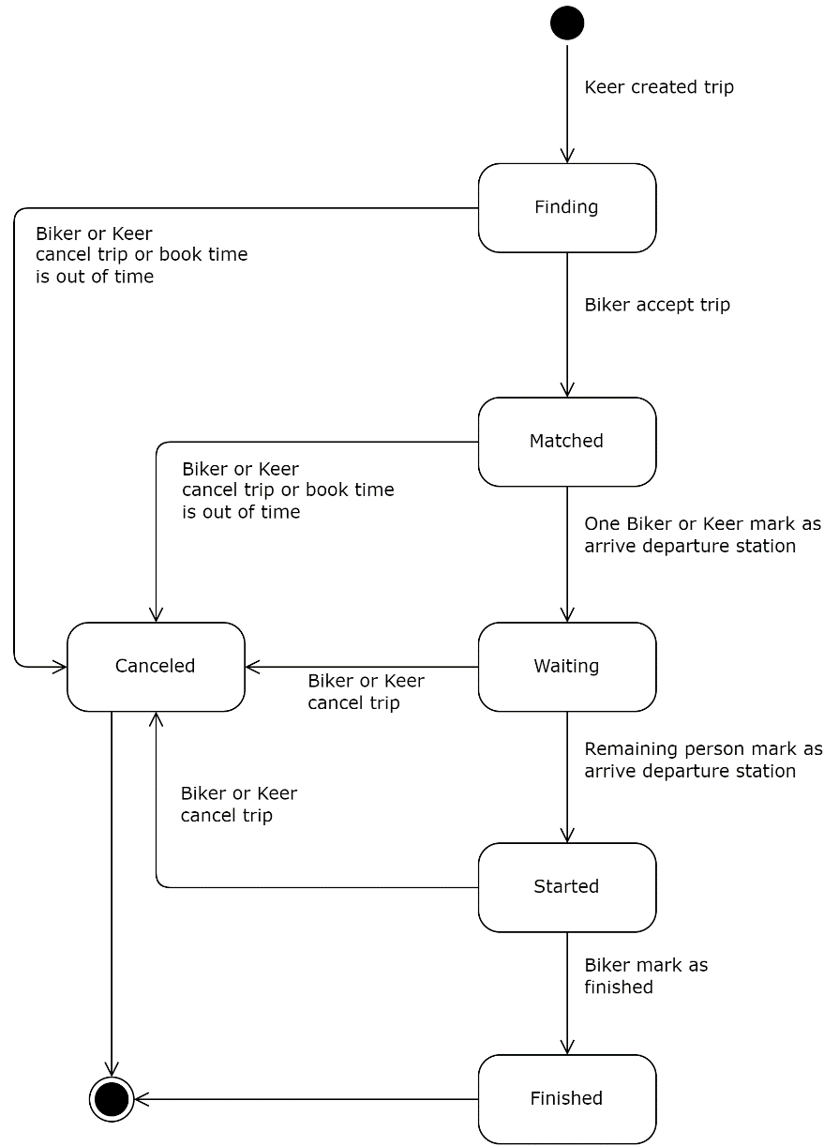

Figure 13. Trip's States

* 1. **Sequence Diagram**

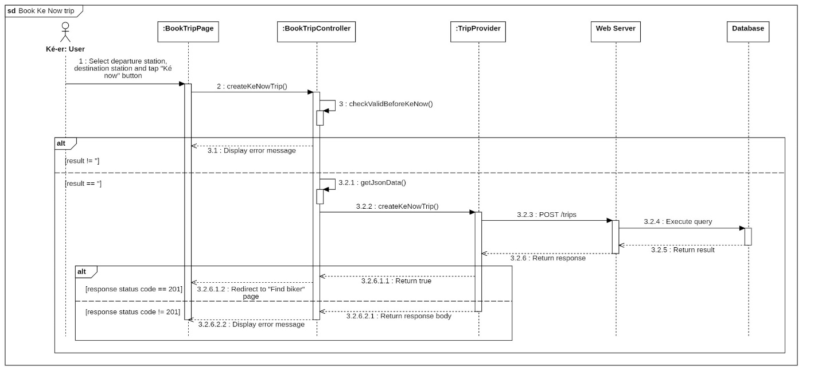

Figure 14. Create Trip Now Sequence Diagram

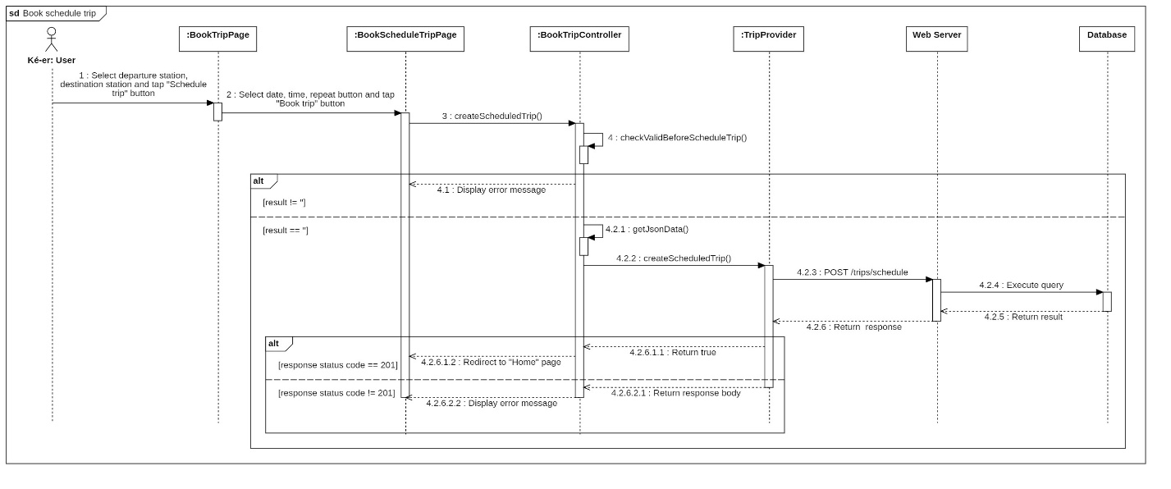

Figure 15. Create Schedule Trip Sequence Diagram

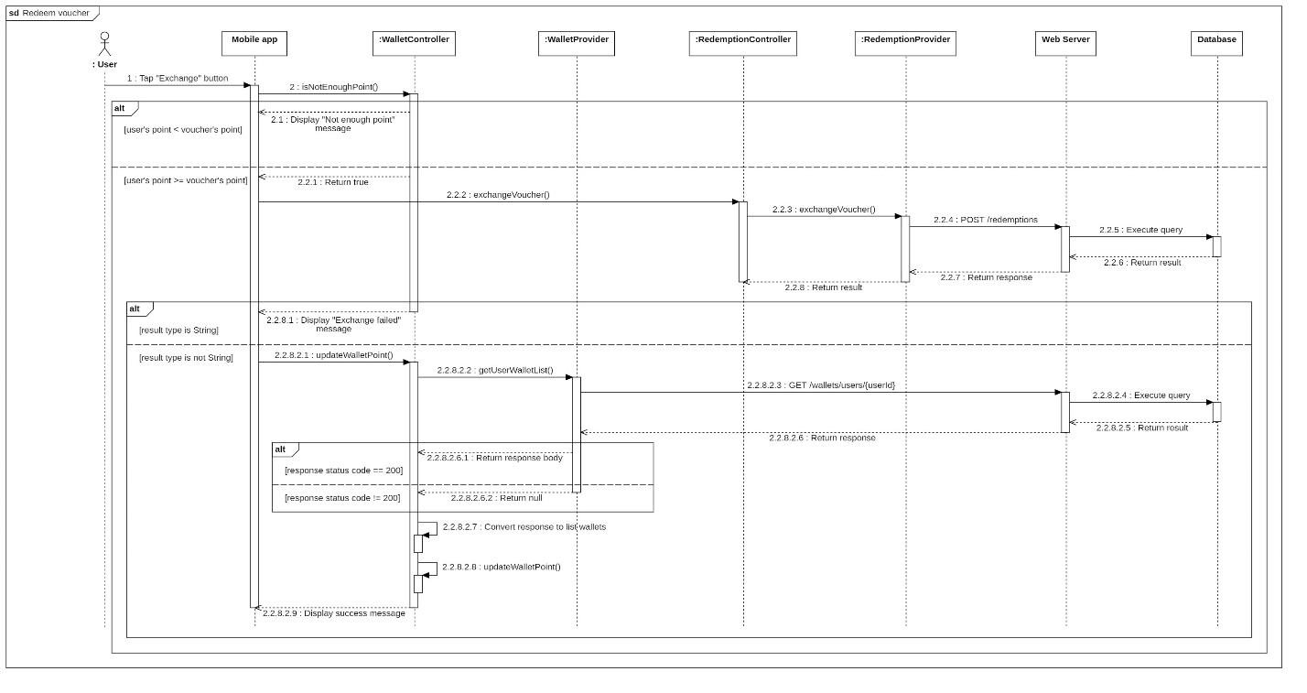

Figure 16. Redeem Voucher Sequence Diagram

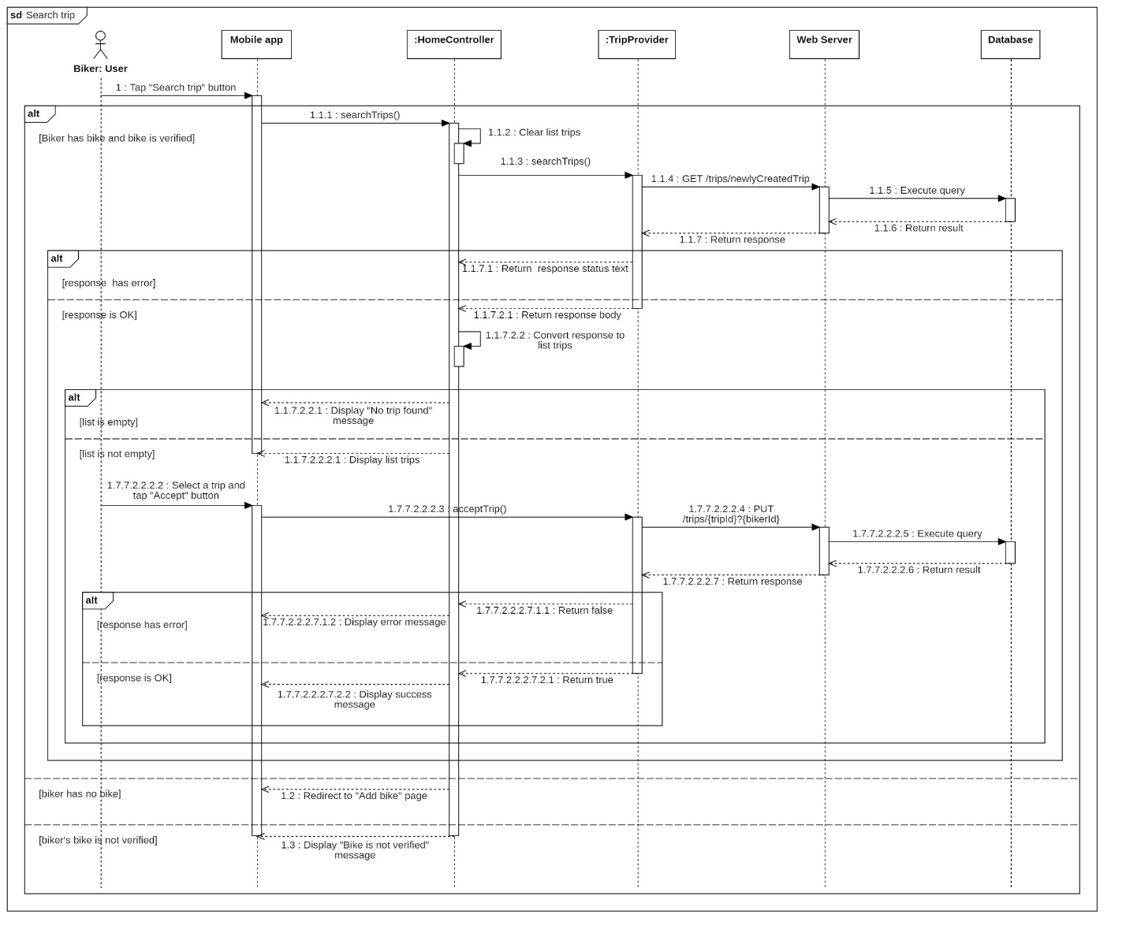

Figure 17. Search Trip Sequence Diagram

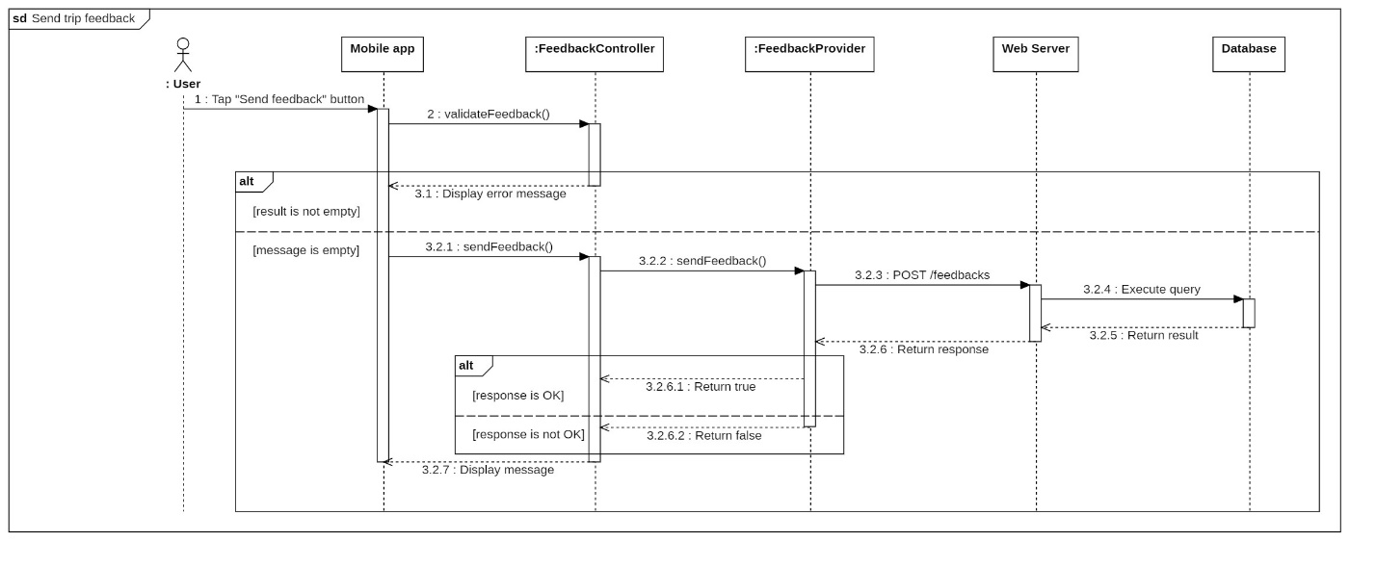

Figure 18. Send Trip Feedback Sequence Diagram

1. Data and Database Design
   1. **Database Design**

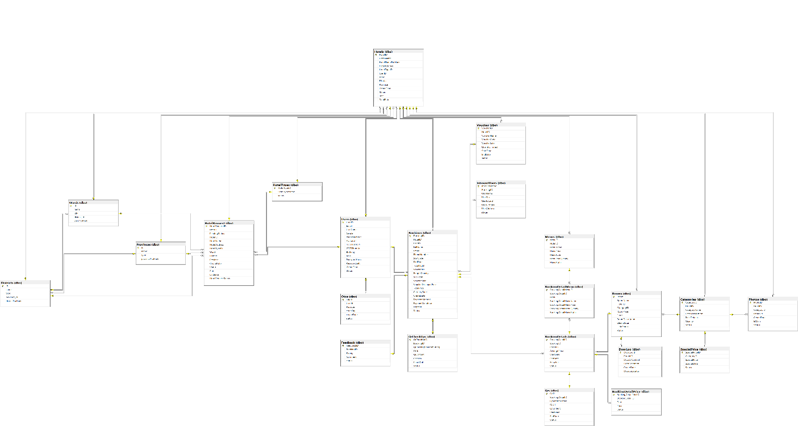

Figure 19. Physical Diagram

* 1. **Data File Design**
     1. **App User Table**

|  |  |  |  |  |  |
| --- | --- | --- | --- | --- | --- |
| **Field name** | **Type** | **Description** | **Unique** | **Not Null** | **PK/FK** |
| UserId | Int | Unique Identifier for user | Yes | Yes | PK |
| PhoneNumber | NVarchar(450) | Unique user’s phone numbers | Yes | Yes | No |
| UserEmail | Varchar(450) | User’s fpt’s contact email | Yes | Yes | No |
| RoleId | Int | Identifier for role | No | Yes | No |
| Gender | Int | User’s gender | No | No | No |
| Status | Int | User’s status | No | Yes | No |
| PasswordHash | Nvarchar(250) | User’s Biiké account password | No | Yes | No |
| CreatedDate | Datetime2 | Date user created Biiké account | No | Yes | No |
| IsDeleted | bit | If user’s account is deleted | No | Yes | No |
| FullName | NVarchar(max) | User’s full name | No | Yes | No |
| LastLoginDevice | NVarchar(Max) | User’s last login device name | No | No | No |
| LastTimeLogin | Datetime2 | Last time user login into Biiké application | No | No | No |
| Star | Float | User’s Biiké Star | No | Yes | No |
| TotalPoint | Int | User’s total point in Biiké | No | Yes | No |
| MaxTotalPoint | Int | User’s max total point | No | Yes | No |
| IsEmailVerify | Bit | If user’s email is verified or not | No | Yes | No |
| IsPhoneVerify | Bit | If user’s phone numbers is verified | No | Yes | No |
| IsKeNowAvailable | Bit | If user’s ke now mode is available | No | Yes | No |
| Is_bike_verify | Bit | If user’s bike is verified | No | Yes | No |
| Birthday | Datetime2 | User’s date of birth | No | No | No |

Table 73. App User Table

* + 1. **Bike Table**

|  |  |  |  |  |  |
| --- | --- | --- | --- | --- | --- |
| **Field name** | **Type** | **Description** | **Unique** | **Not Null** | **PK/FK** |
| BikeId | Int | Unique Identifier for bike | Yes | Yes | PK |
| UserId | Int | Unique Identifier for user | Yes | Yes | FK |
| PlateNumber | Varchar(45) | Identifier for biker’s bike | Yes | Yes | No |
| Color | Varchar(max) | Color of bike | No | Yes | No |
| IsDeleted | Bit | If Bike is deleted or not | No | Yes | No |
| BikeOwnver | Nvarchar(max) | Bike’s owner information | No | Yes | No |
| BikePicture | Nvarchar(max) | Bike’s picture | No | Yes | No |
| CreatedDate | Datetime2 | Date biker created bike | No | Yes | No |
| BikeLisencePicture | Nvarchar(max) | Picture of bike license | No | Yes | No |
| PlateNumberPicture | Nvarchar(max) | Picture of plate number | No | Yes | No |
| Status | Int | Status of bike | No | Yes | No |
| FailedVerificationReason | Nvarchar(max) | Reason the bike is failed to verified | No | No | No |
| Brand | Nvarchar(max) | Brand of bike | No | Yes | No |
| BikeType | Nvarchar(max) | Type of bike | No | Yes | No |
| BikeVolume | Nvarchar(max) | Volume of bike | No | Yes | No |

Table 74. Bike Table

* + 1. **Intimacy Table**

|  |  |  |  |  |  |
| --- | --- | --- | --- | --- | --- |
| **Field name** | **Type** | **Description** | **Unique** | **Not Null** | **PK/FK** |
| UserOneId | Int | Unique Identifier for user 1 | Yes | Yes | FK, PK |
| UserTwoId | Int | Unique Identifier for user 2 | Yes | Yes | FK, PK |
| UserName | Nvarchar(max) | Identifier name for user | No | Yes | No |
| Is_block | Bit | If user is block or not | No | Yes | No |
| UnblockTime | Datetime2 | Date user unblock other user | No | No | No |
| BlockTime | Datetime2 | Date user block other user | No | Yes | No |

Table 75. Intimacy Table

* + 1. **Wallet Table**

|  |  |  |  |  |  |
| --- | --- | --- | --- | --- | --- |
| **Field name** | **Type** | **Description** | **Unique** | **Not Null** | **PK/FK** |
| WalletId | Int | Unique Identifier for wallet | Yes | Yes | PK |
| UserId | Int | Unique Identifier for user | Yes | Yes | FK |
| Point | Int | Point of wallet | No | Yes | No |
| Status | Int | Status of wallet | No | Yes | No |
| FromDate | Datetime2 | Date wallet started | No | Yes | No |
| ToDate | Datetime2 | Date wallet expired | No | Yes | No |
| DrivingLisenceProntPicture | Nvarchar(max) | Pront picture of biker’s lisence | No | Yes | No |
| DrivingLisenceBaPictue | Nvarchar(max) | Back picture of biker’s picture | No | Yes | no |

Table 76. Wallet Table

* + 1. **Trip**

|  |  |  |  |  |  |
| --- | --- | --- | --- | --- | --- |
| **Field name** | **Type** | **Description** | **Unique** | **Not Null** | **PK/FK** |
| TripId | Int | Unique Identifier for trip | Yes | Yes | PK |
| KeerId | Int | Unique Identifier for Keer | Yes | Yes | FK |
| BikerId | Int | Unique Identifier for biker | Yes | No | FK |
| RouteId | Int | Unique Identifier for route | Yes | Yes | FK |
| BookTime | Datetime2 | Time the trip was book | No | Yes | No |
| PickUpTime | Datetime2 | Time pick up keer | No | No | No |
| FinishedTime | Datetime2 | Time the trip is finished | No | No | No |
| CancelTime | Datetime2 | Time the trip is canceled | No | No | No |
| Status | Int | Status of trip | No | Yes | No |
| PlateNumber | Nvarchar(max) | Number plate of bike | No | No | No |
| CancelPersonId | Int | Unique Identifier for cancel person | No | No | No |
| IsScheduled | Bit | If the trip is schedule or not | No | Yes | No |
| CancelReason | Nvarchar(max) | Reason cancel trip | No | No | No |
| CreatedDate | Datetime2 | Date the trip was created | No | Yes | No |
| FirstPersonArrivedId | Int | ID of first person arrived in pick up position | No | No | No |
| SencondPersonArrivedId | Int | ID of second person arrived in pick up position | No | No | No |
| FirstPersonArrivedTime | Datetime2 | Time the first person arrived in pick up location | No | No | No |
| SecondPersonArrivedTime | Datetime2 | Time the second person arrived in pick up location | No | No | no |

Table 77. Trip Tabel

* + 1. **Route Table**

|  |  |  |  |  |  |
| --- | --- | --- | --- | --- | --- |
| **Field name** | **Type** | **Description** | **Unique** | **Not Null** | **PK/FK** |
| RouteId | Int | Unique Identifier for route | Yes | Yes | PK |
| DepartureId | Int | Unique Identifier for departure station | Yes | Yes | FK |
| DestinationId | Int | Unique Identifier for destination station | Yes | Yes | FK |
| AreaId | Int | Unique Identifier for area | Yes | Yes | FK |
| DefaultPoint | Int | Default point of trip | No | Yes | No |
| IsDeleted | Bit | If the trip is deleted or not | No | Yes | No |
| Distance | Float | Distance of the route | No | Yes | No |

Table 78. Route Table

* + 1. **Station Table**

|  |  |  |  |  |  |
| --- | --- | --- | --- | --- | --- |
| **Field name** | **Type** | **Description** | **Unique** | **Not Null** | **PK/FK** |
| StationId | Int | Unique Identifier for station | Yes | Yes | PK |
| AreaId | Int | Unique Identifier for area | Yes | Yes | FK |
| Address | Nvarchar(max) | Address of station | No | Yes | No |
| IsDeleted | Bit | Is station is deleted or not | No | Yes | No |
| Name | Nvarchar(max) | Name of station | No | Yes | No |
| Coordinate | Nvarchar(max) | Coordinate of station | No | Yes | No |
| CreatedDate | Datetime 2 | Date station was created | No | Yes | No |
| IsCentralPoint | Bit | If the position is central point of Biiké list position | No | Yes | No |

Table 79. Station Table

* + 1. **Area Table**

|  |  |  |  |  |  |
| --- | --- | --- | --- | --- | --- |
| **Field name** | **Type** | **Description** | **Unique** | **Not Null** | **PK/FK** |
| AreaId | Int | Unique Identifier for area | Yes | Yes | PK |
| Name | Nvarchar(max) | Name of area | No | Yes | No |
| IdDeleted | Bit | If area is deleted or not | No | Yes | No |
| CreatedDate | Datetime2 | Date area was created | No | Yes | No |
| EmailExtension | Nvarchar(max) | Condition for sufix of user’s rgister email | No | Yes | No |

Table 80. Area Table

* + 1. **Trip Transaction Table**

|  |  |  |  |  |  |
| --- | --- | --- | --- | --- | --- |
| **Field name** | **Type** | **Description** | **Unique** | **Not Null** | **PK/FK** |
| TripTransactionId | Int | Unique Identifier for trip transaction | Yes | Yes | PK |
| TripId | Int | Unique Identifier for trip | Yes | Yes | FK |
| WalletId | Int | Unique Identifier for wallet | Yes | Yes | FK |
| TransactionDate | Datetime2 | Date transaction was made | No | Yes | No |
| AmountOfPoint | Int | Amount point of trip | No | Yes | No |
| Description | Nvarchar(max) | Description of trip | No | Yes | No |

Table 81. Trip Transaction Table

* + 1. **Feedback Table**

|  |  |  |  |  |  |
| --- | --- | --- | --- | --- | --- |
| **Field name** | **Type** | **Description** | **Unique** | **Not Null** | **PK/FK** |
| FeedbackId | Int | Unique Identifier for feedback | Yes | Yes | PK |
| UserId | Int | Unique Identifier for user | Yes | Yes | FK |
| TripId | V | Unique Identifier for trip | Yes | Yes | FK |
| FeedbackContent | Nvarchar(max) | Feedback content | No | No | No |
| TripStar | Int | Star of trip | No | Yes | No |
| Criteria | Nvarchar(max) | Criteria for feedback | No | No | No |
| CreatedDate | Datetime2 | Date feedback was sent | No | Yes | No |
| TripTip | Int | Tip of keer to biker | No | Yes | No |

Table 82. Feedback Table

* + 1. **Redemption Table**

|  |  |  |  |  |  |
| --- | --- | --- | --- | --- | --- |
| **Field name** | **Type** | **Description** | **Unique** | **Not Null** | **PK/FK** |
| RedeemtionId | Int | Unique Identifier for redemption | Yes | Yes | PK |
| WalletId | Int | Unique Identifier for wallet | Yes | Yes | FK |
| VoucherId | Int | Unique Identifier for voucher | Yes | Yes | FK |
| VoucherCode | Varchar(max) | Code of voucher | Yes | Yes | No |
| VoucherPoint | Int | Point to exchange voucher | No | Yes | No |
| IsUsed | Bit | If voucher is used or not | No | Yes | No |
| RedemptionDate | Datetime2 | Date redemption was made | No | Yes | No |
| IsDeleted | Bit | If voucher is deleted or notq | No | Yes | No |

Table 83. Redemption Table

* + 1. **Voucher Table**

|  |  |  |  |  |  |
| --- | --- | --- | --- | --- | --- |
| **Field name** | **Type** | **Description** | **Unique** | **Not Null** | **PK/FK** |
| VoucherId | Int | Unique Identifier for voucher | Yes | Yes | PK |
| VoucherCategoryId | Int | Unique Identifier for voucher category | Yes | Yes | FK |
| VoucherName | NVarchar(max) | Name of voucher | Yes | Yes | No |
| StartDate | Datetime2 | Date voucher started available | No | Yes | No |
| EndDate | Datetime2 | Date voucher expired | No | Yes | No |
| Quantity | Int | Quantity of vouchers | No | Yes | No |
| Remaining | Int | Number voucher remaining | No | Yes | No |
| AmountPoint | Int | Amount of point to exchange voucher | No | Yes | No |
| Description | Nvarchar(max) | Description of voucher | No | Yes | No |
| TermsAndConditions | NVarchar(max) | Terms and conditions to use voucher | No | Yes | No |
| CreatedDate | Datetime2 | Date voucher was created | No | Yes | No |
| Brand | Nvarchar(max) | Brand of voucher | No | Yes | No |

Table 84. Voucher Table

* + 1. **Advertisement Table**

|  |  |  |  |  |  |
| --- | --- | --- | --- | --- | --- |
| **Field name** | **Type** | **Description** | **Unique** | **Not Null** | **PK/FK** |
| AdsId | Int | Unique Identifier for ads | Yes | Yes | PK |
| AdsUrl | Varchar(max) | url of ads | No | Yes | No |
| CreatorId | Int | Unique Identifier for creator | No | Yes | No |
| Brand | Nvarchar(max) | Brand of ads | No | Yes | No |
| Title | Nvarchar(max) | Title of ads | No | Yes | No |
| Is_Active | Bit | If advertisement is active or not | No | Yes | No |
| TotalClickCount | Int | Times ads is clicked | No | Yes | No |
| StartDate | Datetime2 | Date ads started | No | Yes | No |
| EndDate | Datetime2 | Date ads ended | No | Yes | No |
| CreatedDate | Datetime2 | Date ads created | No | Yes | No |

Table 85. Advertisement Table

* + 1. **Report Table**

|  |  |  |  |  |  |
| --- | --- | --- | --- | --- | --- |
| **Field name** | **Type** | **Description** | **Unique** | **Not Null** | **PK/FK** |
| ReportId | Int | Unique Identifier for report | Yes | Yes | PK |
| UserOneId | Int | Unique Identifier for user 1 | Yes | Yes | FK |
| UserTwoId | Int | Unique Identifier for user 2 | Yes | Yes | FK |
| UserOneName | Nvarchar(max) | Name of user 1 | No | Yes | No |
| UserTwoName | Nvarchar(max) | Name of user 2 | No | Yes | No |
| ReportReason | Nvarchar(max) | Reason why user report other user | No | Yes | No |
| CreatedDate | Datetime2 | Date report request created | No | Yes | No |

Table 86. Report Table

* + 1. **S.O.S Table**

|  |  |  |  |  |  |
| --- | --- | --- | --- | --- | --- |
| **Field name** | **Type** | **Description** | **Unique** | **Not Null** | **PK/FK** |
| SosId | Int | Unique Identifier for sos | Yes | Yes | PK |
| UserId | Int | Unique Identifier for user | Yes | Yes | FK |
| SoSName | Nvarchar(max) | Name of sos person | No | Yes | No |
| SosPhone | Nvarchar(max) | Phone of s.o.s person | No | Yes | No |
| CreatedDate | Datetime2 | Date created sos number | No | Yes | No |

Table 87. S.O.S Table

* + 1. **Point History Table**

|  |  |  |  |  |  |
| --- | --- | --- | --- | --- | --- |
| **Field name** | **Type** | **Description** | **Unique** | **Not Null** | **PK/FK** |
| PointHistoryId | Int | Unique Identifier for point history | Yes | Yes | PK |
| UserId | Int | Unique Identifier for user | Yes | Yes | FK |
| HistoryType | Int | Type of history | No | Yes | No |
| RealatedId | Int | Unique Identifier for related | No | Yes | No |
| Point | Int | Amount of point | No | Yes | No |
| Total point | Int | Total amount point | No | Yes | No |
| Description | Nvarchar(max) | Description of point history | No | Yes | No |
| TimeStamp | Datetime2 | Time stamp of point history | No | Yes | No |

Table 88. Point History Table

* + 1. **User Address Table**

|  |  |  |  |  |  |
| --- | --- | --- | --- | --- | --- |
| **Field name** | **Type** | **Description** | **Unique** | **Not Null** | **PK/FK** |
| UserAddressId | Int | Unique Identifier for user address | Yes | Yes | PK |
| UserId | Int | Unique Identifier for user | Yes | Yes | FK |
| UserAdderssName | Nvarchar(max) | Name of user’s address displayed on Biiké | No | Yes | No |
| UserAddressCordinate | Nvarchar(max) | Coordinate of user’s address | No | Yes | No |
| UserAddressNote | Nvarchar(max) | Address noted by user | No | Yes | No |
| ReportReason | Nvarchar(max) | Reason why user report other user | No | Yes | No |
| CreatedDate | Datetime2 | Date report request created | No | Yes | No |

Table 89. User Address Table

* + 1. **Address Table**

|  |  |  |  |  |  |
| --- | --- | --- | --- | --- | --- |
| **Field name** | **Type** | **Description** | **Unique** | **Not Null** | **PK/FK** |
| AdderssId | Int | Unique Identifier for address | Yes | Yes | PK |
| AddressName | Nvarchar(max) | Identifier for address | No | Yes | No |
| AddressDetails | Nvarchar(max) | Address details information | No | Yes | No |
| AddressCoordinate | Nvarchar(max) | Coordinate of address | No | Yes | No |
| CreatedDate | Datetime2 | Date address created | No | Yes | No |

Table 90. Address Table

* + 1. **Advertisement Address Table**

|  |  |  |  |  |  |
| --- | --- | --- | --- | --- | --- |
| **Field name** | **Type** | **Description** | **Unique** | **Not Null** | **PK/FK** |
| AdvertisementAddressId | Int | Unique Identifier for advertisement address | Yes | Yes | PK |
| AdvertisementId | Int | Unique Identifier for advertisement | Yes | Yes | FK |
| AddressId | Int | Unique Identifier for address | Yes | Yes | FK |

Table 91. Advertisement Address

* + 1. **Advertisement Image Table**

|  |  |  |  |  |  |
| --- | --- | --- | --- | --- | --- |
| **Field name** | **Type** | **Description** | **Unique** | **Not Null** | **PK/FK** |
| AdvertisementImageId | Int | Unique Identifier for advertisement image | Yes | Yes | PK |
| AdvertisementId | Int | Unique Identifier for advertisement | Yes | Yes | FK |
| AdvertisementImageUrl | Nvarchar(max) | Url of advertisement image | No | Yes | No |
| CreatedDate | Datetime2 | Date Image was created | No | Yes | No |

Table 92. Advertisement Image Table

* + 1. **Voucher Code Table**

|  |  |  |  |  |  |
| --- | --- | --- | --- | --- | --- |
| **Field name** | **Type** | **Description** | **Unique** | **Not Null** | **PK/FK** |
| VoucherCodeId | Int | Unique Identifier for voucher code | Yes | Yes | PK |
| VoucherId | Int | Unique Identifier for voucher | Yes | Yes | FK |
| VoucherCodeName | Nvarchar(450) | Name of voucher code | Yes | Yes | No |
| IsRedeemed | Bit | If this voucher code is redeemed | No | Yes | No |
| CreatedDate | Datetime2 | Date voucher code created | No | Yes | No |

Table 93. Voucher Code Table

* + 1. **Voucher Category Table**

|  |  |  |  |  |  |
| --- | --- | --- | --- | --- | --- |
| **Field name** | **Type** | **Description** | **Unique** | **Not Null** | **PK/FK** |
| VoucherCategoryId | Int | Unique Identifier for voucher category | Yes | Yes | PK |
| CategoryName | Nvarchar(450) | Identifier for category | Yes | Yes | No |
| CreatedDate | Datetime2 | Date voucher category created | No | Yes | No |

Table 94. Voucher Category table

* + 1. **Voucher Image Table**

|  |  |  |  |  |  |
| --- | --- | --- | --- | --- | --- |
| **Field name** | **Type** | **Description** | **Unique** | **Not Null** | **PK/FK** |
| VoucherAddressId | Int | Unique Identifier for voucher address | Yes | Yes | PK |
| VoucherId | Int | Identifier for voucher | Yes | Yes | FK |
| CreatedDate | Datetime2 | Date voucher image created | No | Yes | No |
| VoucherImageUrl | Nvarchar(max) | Url of voucher image | No | Yes | No |

Table 95. Voucher Image Table

* + 1. **Voucher Address Table**

|  |  |  |  |  |  |
| --- | --- | --- | --- | --- | --- |
| **Field name** | **Type** | **Description** | **Unique** | **Not Null** | **PK/FK** |
| VoucherAddressId | Int | Unique Identifier for voucher address | Yes | Yes | PK |
| VoucherId | Int | Identifier for voucher | Yes | Yes | FK |
| AddressId | Int | Identifier for address | Yes | Yes | FK |

Table 96. Voucher Address Table

* + 1. **Role Table**

|  |  |  |  |  |  |
| --- | --- | --- | --- | --- | --- |
| **Field name** | **Type** | **Description** | **Unique** | **Not Null** | **PK/FK** |
| RoleId | Int | Unique Identifier for role | Yes | Yes | PK |
| RoleName | Nvarchar(450) | Identifier for voucher | Yes | Yes | FK |

Table 97. Role Table

* + 1. **Notification Table**

|  |  |  |  |  |  |
| --- | --- | --- | --- | --- | --- |
| **Field name** | **Type** | **Description** | **Unique** | **Not Null** | **PK/FK** |
| NotificationId | Int | Unique Identifier notification | Yes | Yes | PK |
| AreaId | Int | Identifier for area | Yes | Yes | FK |
| Title | Int | Title of notification displayed on Biiké application | No | Yes | No |
| ShortDescription | Nvarchar(max) | Short description of notification shows on screen | No | Yes | No |
| Description | Nvarchar(max) | Full description of notification | No | Yes | No |
| NotificationType | Int | Type of notification | No | Yes | No |
| UserType | Int | Type of user | No | Yes | No |
| CoverImage | Nvarchar(max) | Image of notification | No | Yes | No |
| CreatedDate | Datetime2 | Date notification created | No | Yes | No |

Table 98. Notification Table

* + 1. **Bike Availability Table**

|  |  |  |  |  |  |
| --- | --- | --- | --- | --- | --- |
| **Field name** | **Type** | **Description** | **Unique** | **Not Null** | **PK/FK** |
| BikeAvailabilityId | Int | Unique Identifier bike availability | Yes | Yes | PK |
| UserId | Int | Identifier for user | Yes | Yes | FK |
| StationId | Int | Identifier for station | Yes | Yes | FK |
| FromTime | Datetime2 | Time biker available: from | No | Yes | No |
| ToTime | Datetime2 | Time biker available: to | No | Yes | No |
| CreatedDate | Datetime2 | Date created bike availability | No | Yes | No |

Table 99. Bike Availability Table

* + 1. **Momo Transaction Table**

|  |  |  |  |  |  |
| --- | --- | --- | --- | --- | --- |
| **Field name** | **Type** | **Description** | **Unique** | **Not Null** | **PK/FK** |
| MomoTransactionId | Int | Unique Identifier for momo transaction | Yes | Yes | PK |
| UserId | Int | Identifier for user | Yes | Yes | FK |
| TransactionId | Nvarchar(450) | Identifier for transaction | Yes | Yes | No |
| OrderId | Nvarchar(450) | Identifier for order | Yes | Yes | No |
| Amount | Int | Amount of order | No | No | No |
| Point | Int | Amount of point in transaction | No | No | No |
| ConversionRate | float | Rate convert from VND currency to Biiké point | No | No | No |
| createdDate | Datetime2 | Date created transaction | No | No | No |

Table 100. Momo Transaction Table

* + 1. **Configuration Table**

|  |  |  |  |  |  |
| --- | --- | --- | --- | --- | --- |
| **Field name** | **Type** | **Description** | **Unique** | **Not Null** | **PK/FK** |
| ConfigurationId | Int | Unique Identifier for configuration | Yes | Yes | PK |
| UserId | Int | Identifier for user | Yes | Yes | FK |
| ConfigurationName | Nvarchar(450) | Name of configuration | Yes | Yes | No |
| ConfigurationValue | Nvarchar(max) | Value of configuration | No | No | No |
| LastUpdatedDate | Datetime2 | Date configuration update last time | No | No | No |
| CreatedDate | Datetime2 | Date configuration was created | No | No | No |

Table 101. Configuration Table

1. Algorithm
   1. **Create station in an area**
      1. **Definition**

* Create station in an area is let admin create a station that is really in that area with a certain distance. Biiké need to avoid station that is not in that area.
  + 1. **Define problem**
* We use coordinates of central point and new station, check if it's distance is smaller than valid radius (Configuration Table), Biiké will accept action create station
  + 1. **Solution**
* Get new station coordinate, central point coordinate and valid radius (Configuration Table)
* Calculate the distance from new station to central point using Haversine formula:
* Set lat1 and long1 are latitude and longitude of new station.
* Set lat2 and long2 are the latitude and longitude of the central point.
* R = earth’s radius (mean radius = 6,371km)
* Δlat = lat2− lat1
* Δlong = long2− long1
* a = sin²(Δlat/2) + cos(lat1).cos(lat2).sin²(Δlong/2)
* c = 2.atan2(√a, √(1−a))
* d = R.c
* d is the distance from new station to the central point
* If the distance is less than valid radius then Biiké accept admin action.
  + 1. **Complexity**
* The complexity of this algorithm is simple.
  1. **Mark as arrived or finished trip**
     1. **Definition**
* Mark as arrived or finish is to let biker or keer confirm that they are arrive the departure station or destination station. Biiké need to avoid frauds (mark as arrived or finish at any where to get point in an invalid way).
  + 1. **Define problem**
* We use coordinates of user location and corresponding station, check if it's distance is smaller than 500m, Biiké will accept action "mark as arrived" or "finish"
  + 1. **Solution**
* Get user location and corresponding station.
* Calculate the distance from user location to station using **Haversine formula**:
  + Set lat1 and long1 are latitude and longitude of use location.
  + Set lat2 and long2 are the latitude and longitude of the station.
  + R = earth’s radius (mean radius = 6,371km)
  + Δlat = lat2− lat1
  + Δlong = long2− long1
  + a = sin²(Δlat/2) + cos(lat1).cos(lat2).sin²(Δlong/2)
  + c = 2.atan2(√a, √(1−a))
  + d = R.c
  + d is the distance from user location to the station
* If the distance is less than 500m then Biiké accept user action.
  + 1. **Complexity**
* The complexity of this algorithm is simple.

1. Software Testing Documentation
2. Overall Description
   1. **Test Model**

In Dims project, we apply Incremental testing for many purposes:

* Each Module provides a definitive role to play in the project structure
* Some function testing can start at early step of the develop process
  1. **Testing Levels:** 
     + Testing Level: System Test, User Acceptance Test
     + Testing Types: Functional Testing, User Interface Testing

1. Test Plan
   1. **Test Stages**

|  |  |  |  |
| --- | --- | --- | --- |
| **Type Of Test** | **Stage Of Test** | | |
| **Unit** | **System** | **Acceptance** |
| Function Testing |  | X |  |
| User Interface Testing |  | X |  |

* 1. **Resources**

|  |  |  |
| --- | --- | --- |
| **Worker** | **Role** | **Specific Responsibilities** |
| Hoàng Tuấn Anh | Member | Planing, verify test reseult, assign test function to members |
| Nguyễn Quốc Trường Huy | Member | Execute test and reports as planned |

* 1. **Test Milestones**

|  |  |  |
| --- | --- | --- |
| **No.** | **Deliverables** | **Due Date** |
| 1 | Test document | 2/12/2021 |

1. Test Cases & Test Reports

|  |  |
| --- | --- |
| **Testing Level** | **File Name** |
| System Test | [Dims - Test Case (Mobile App).xlsx](https://1drv.ms/x/s!ApXZS3wt9T_0o8oc-7rNI5BmObkJyg?e=qtHrHt) [Dims - Test Case (Web).xlsx](https://docs.google.com/spreadsheets/d/19MQcgMR1uJLad35HLaypVOUvO_RB_PI9/edit?usp=sharing&ouid=106680604147973051837&rtpof=true&sd=true) |
| Acceptance Test | Because everyone's home is far away from school, there was a difficulty in performing acceptance test |

1. Release Package and User Guides
2. Deliverable Package
   1. **Source Codes and Documents**

| **No.** | **Items** | **Sub-Items** | **Type** | **Version** |
| --- | --- | --- | --- | --- |
| **Code Package** | | | | |
| 1 | Mobile Module | Dims Mobie Application |  |  |
| 2 | Web Module | Dims Web Admin Application |  |  |
| 3 | Web API Module | Dims Web Api |  |  |
| **Database** | | | | |
| 1 | Initialize Database | DIMS.scrpit | | |
| **Documents** | | | | |
| 1 | Project Introduction | Report1_Project Introduction.docx |  |  |
| 2 | Project Management Plan | Report2_Project Management Plan.docx |  |  |
| 3 | Software Requirement Specification | Report3_System Requirement Specification.docx |  |  |
| 4 | Software Design Document | Report4_Software Design Document.docx |  |  |
| 5 | Test Documentation | Report5_Test Documentation.docx Report5_Test Case Document.xlsx |  |  |
| 6 | Software User Guides | Report6_Software User Guides.docx |  |  |
| 7 | Final Project Report | Report7_Final Project Report.docx Brief - Report7_Final Project Report.doc |  |  |
| 8 | Task sheet | Dims – Detail Plan.xlsx |  |  |

Table 102. Source Codes and Documents

1. Installation Guide
   1. **System Requirements**
      1. **Hardware Requirement**

* Web user Application

|  |  |  |
| --- | --- | --- |
| **PC** | **Minimum** | **Recommended** |
| Internet connection | Cable, Wi-fi (4 Mbps) | Cable, Wi-fi (8 Mbps) |
| Processor | Intel Core i3 1.4Ghz | Intel Core i7 2.5Ghz |
| Memory | 4GB RAM | 8GB RAM |
| Storage | 5GB | 10GB |
| Web Browser | Chromes (v69 or higher) | Chrome latest stable version |

* Web admin Application

|  |  |  |
| --- | --- | --- |
| **PC** | **Minimum** | **Recommended** |
| Internet connection | Cable, Wi-fi (4 Mbps) | Cable, Wi-fi (8 Mbps) |
| Processor | Intel Core i3 1.4Ghz | Intel Core i7 2.5Ghz |
| Memory | 4GB RAM | 8GB RAM |
| Storage | 5GB | 10GB |
| Web Browser | Chromes (v69 or higher) | Chrome latest stable version |

* Mobile Application

|  |  |
| --- | --- |
| **Operating System** | Android 9 or higher |
| **Processor** | Intel Atom® Processor Z2520 1.2 GHz, or faster processor |
| **Storage** | Between 1GB or higher |
| **RAM** | Minimum of 1GB, 2GB is recommend |

* + 1. **Software Requirement**

|  |  |  |
| --- | --- | --- |
| **Component** | **Name and Version** | **Description** |
| Operating System | Windows 7 SP1/8.1/10/Window Server 2016 or above (Web application)  Android 5.1 Lollipop or above (Mobile application) | Operating system for building production |
| DBMS | SQL Server 2019 | Used to manage database |
| .Net Core Runtime 3.0 Hosting bundles | 5GB | 10Gb |

Table 103. Software Requirement

* 1. **Setup Files**
* Biiké_User_App_1_1_0.apk
  1. **Installation Instruction**

Set up and install Windows10 (1903):

<https://www.microsoft.com/en-us/software-download/windows10>

#### 2.3.1 Setup environment

1. **Mobile application**
   1. Download Flutter installation bundle file: <https://docs.flutter.dev/get-started/install/windows>
   2. Extract the downloaded file to the Flutter container folder location for the Flutter SDK.

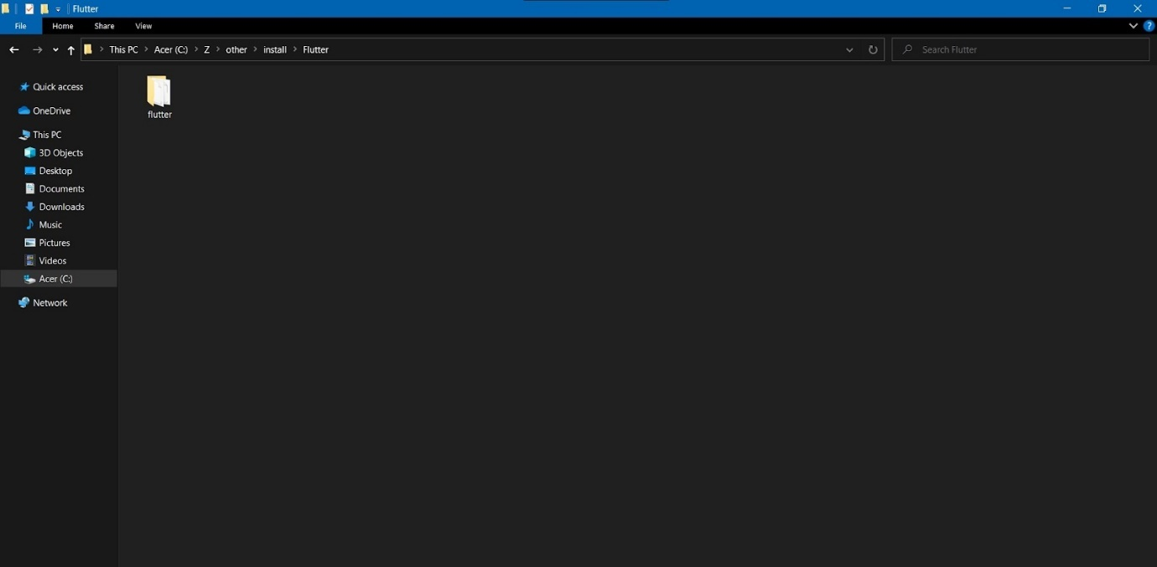

1. Setup environment variable: In Windows search bar, type “Environment variable”, and click on “Edit system environment variables”. In the popped-up window, tap on the “Environment variables” button.

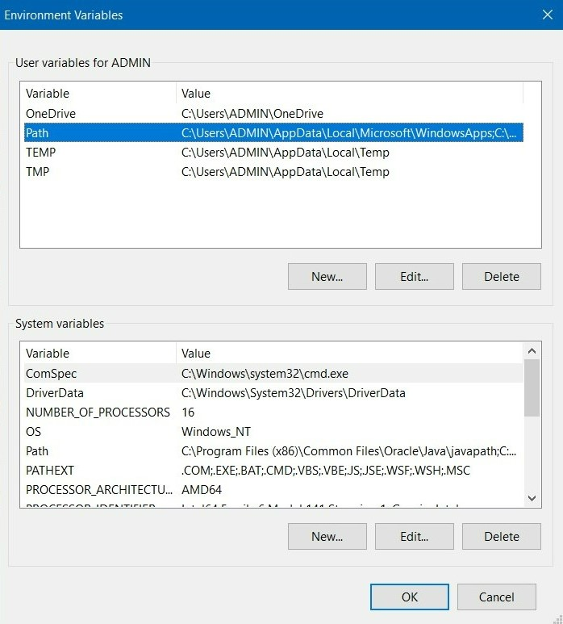

1. Tap on the “Path” variable and click on the “Edit” button. Append the full path to flutter\bin using ‘;’ as a separator from existing values of the Path variable.
2. Install Visual Studio Code: <https://code.visualstudio.com/download>

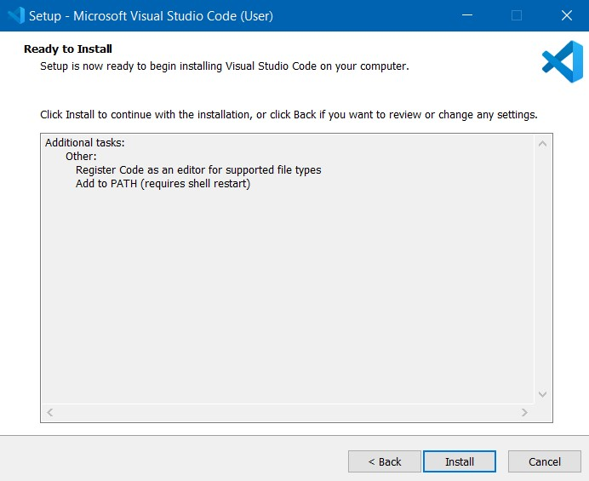

1. **Web application**
   1. Install Nodejs with the following link: <https://nodejs.org/en/>
   2. Download Nodejs installation file and click on the downloaded file to install Nodejs.

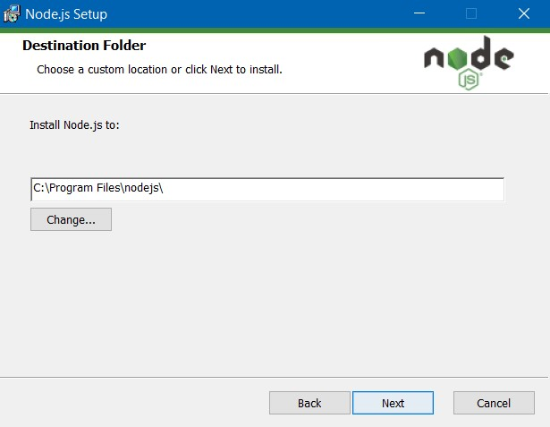

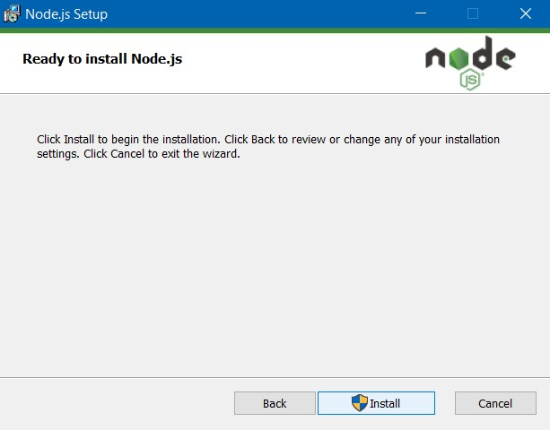

1. After the installation. turn on CMD, and type “node -v” to check Nodejs version.
2. Install Angular CLI

Open cmd and enter the command “npm install -g @angular/cli”

1. Install XAMPP

e.1) Download XAMPP via<https://www.apachefriends.org/download.html> and install

e.2) After installing, you launch XAMPP

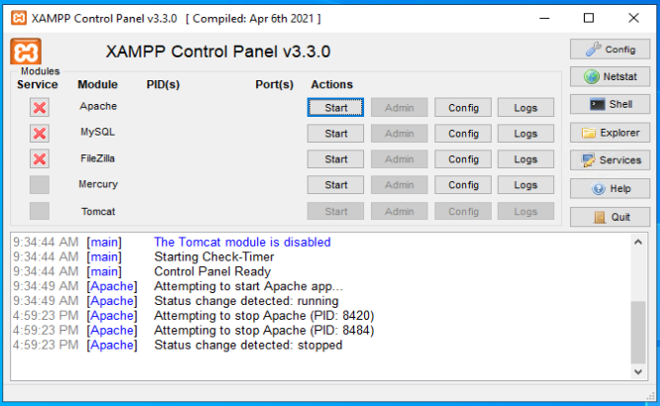

e.3) Click the Start button in Apache row

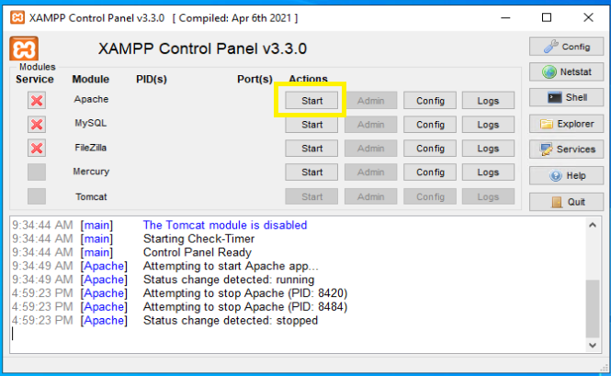

Green background around Apache marks that these modules work correctly

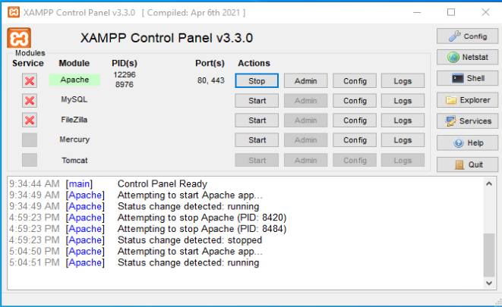

1. **Web API Application**
   1. Download and install .Net 6 runtime: <https://dotnet.microsoft.com/en-us/download/dotnet/6.0>

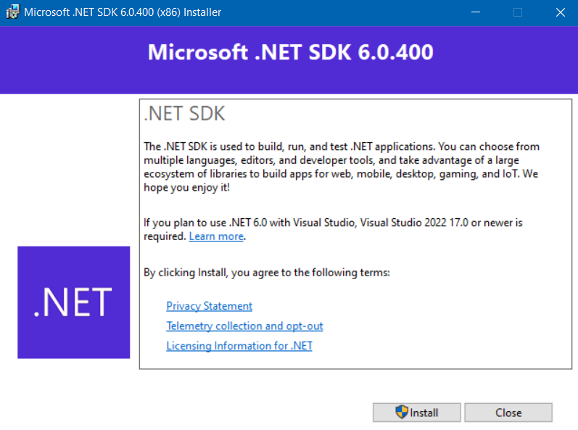

* + 1. **Setup Application**

1. Mobile application
2. Web application
   1. Go to your project folder, type “Cmd” on search bar. Enter the command     “git clone https://github.com/huynhbao/FoodManager”
   2. Enter “ng build” to create a build folder.

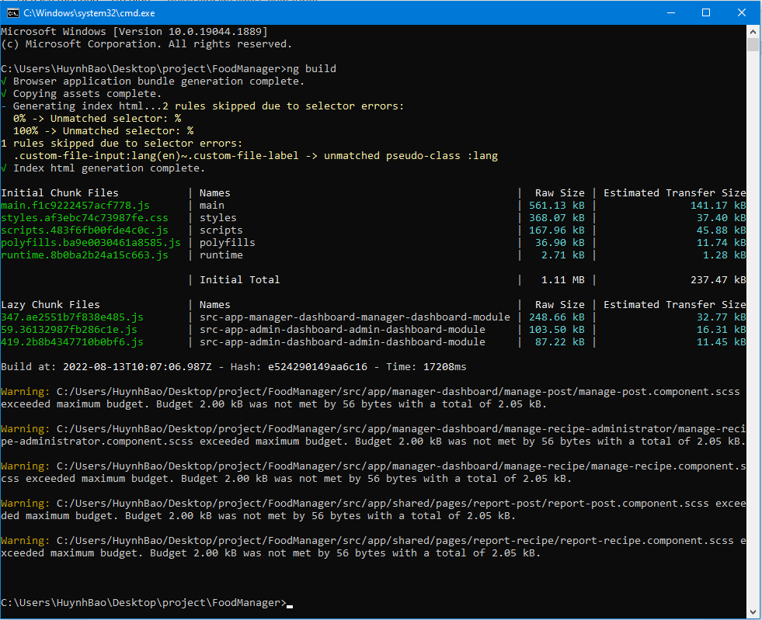

1. Go to the dist folder and copy the new folder named “food-manager” which has just been built to the “C:\xampp\htdocs” folder on the cloud server machine
2. Web API application
   1. Go to your project folder, type “Cmd” on the search bar. Enter the command     “git clone https://github.com/hienlu2010vn/FooMaApp.git”

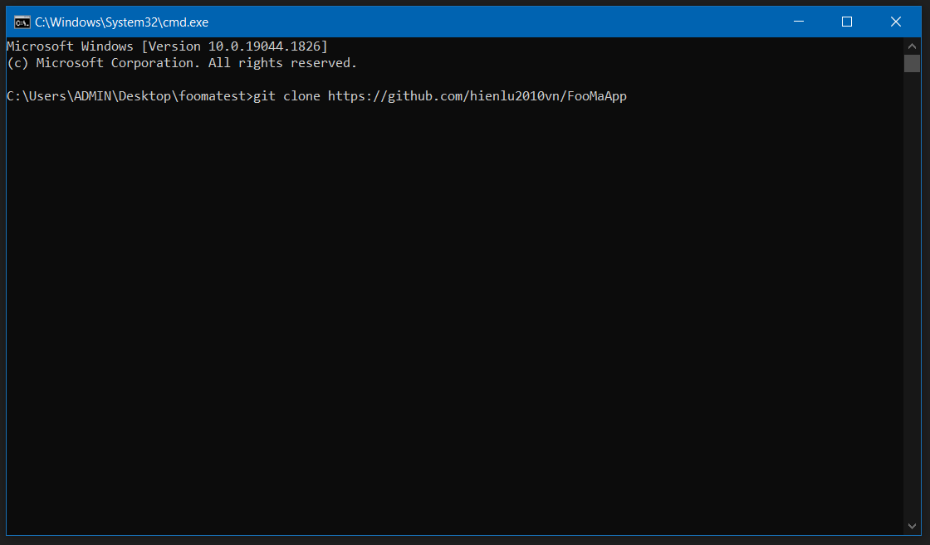

1. Enter “cd FooMaApp” to go to sollution’s folder. Type “dotnet publish -c Release -r win-x64 --output ./Publish FooMaApp.sln” to create Publish folder.

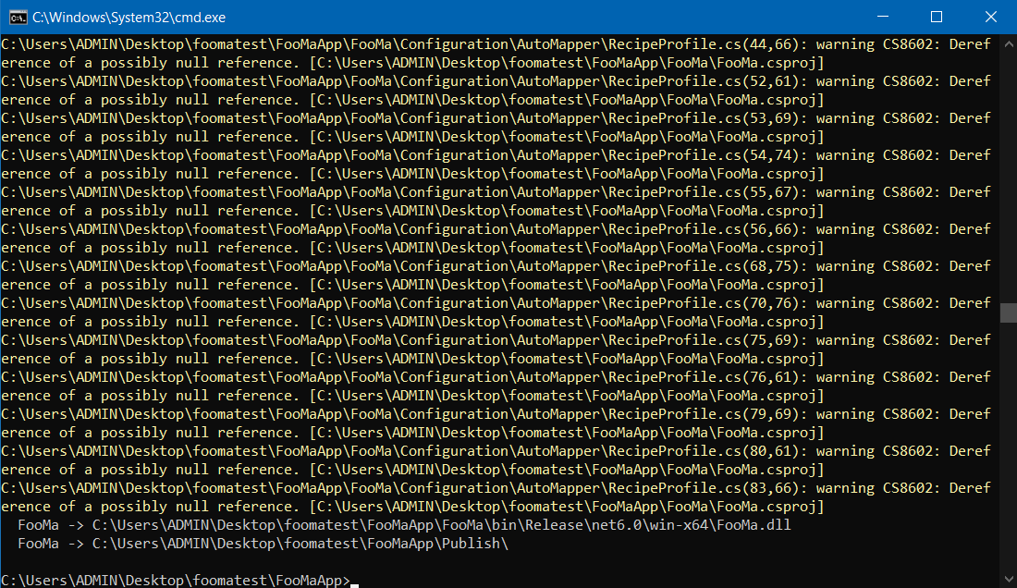

1. Copy the “Publish” folder to the “inetpub” folder on the cloud server machine.
2. User Manual
   1. **Terms and Definitions**

N/A

* 1. **System Requirement**
     1. **Hardware Requirement**

|  |  |  |  |
| --- | --- | --- | --- |
| **Type** | **Part/Component** | **Minimum** | **Recommended** |
| Computer | OS supported | Windows7 SP1 or later (64-bit), Linux | _ |
| Computer | Network | LAN | LAN and Internet |
| Computer | RAM | 4GB | >= 8GB |
| Computer | HDD | 100GB | >= 200GB |
| Computer | Ports | USB, Network | _ |
| Mobile | Camera | 2MP | - |
| ESP32 Cam | Network | Wifi 2.4 ghz, Internet | - |
| ESP32 Cam | Power | Adapter 12V 4A | >= 5A  Or 16 cell Battery AA |

Table 104. Hardware Requirements

* + 1. **Software Requirement**
* .NET Core runtime 6
* React 17.0
* Arduino 1.8
  1. **Application Usage**
     1. **Dims Web admin**

1. Manage login to system (web)

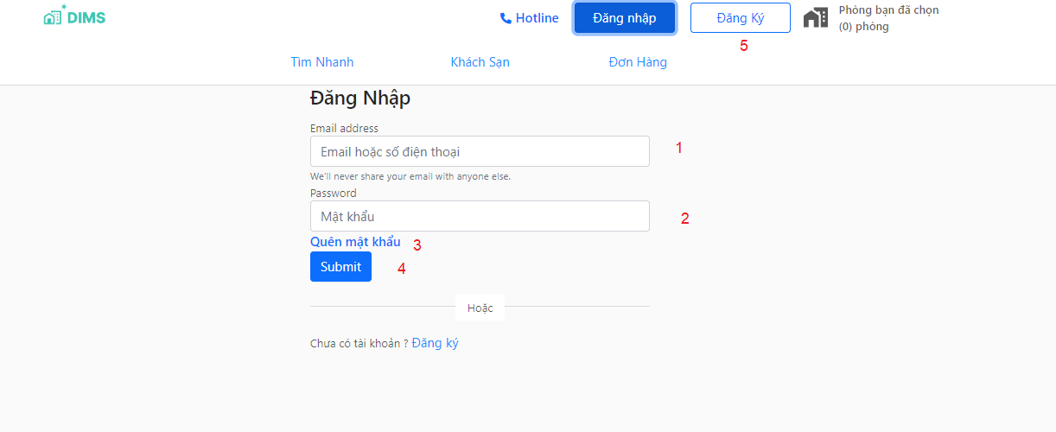

|  |  |  |  |  |
| --- | --- | --- | --- | --- |
| **No** | **Function** | **Description** | **Validation** | **Outcome** |
| 4 | Submit | Click to login | yes | If login success, the app will navigate to the “Home” screen. If login fails, the error message will be shown. |
| 3 | Forgot password | Tap to go to the “Forgot password” screen | no | Navigate to “Forgot password” screen |
| 4 | Register | Tap to go to the “register” screen | no | Navigate to “register” screen |

|  |  |  |  |  |  |  |
| --- | --- | --- | --- | --- | --- | --- |
| **No** | **Field Name** | **Description** | **Read only** | **Mandatory** | **Control type** | **Data type** |
| 1 | Email | The email of manager account | No | Yes | Text Box | String |
| 2 | Password | The password of manager account | No | Yes | Text Box | String |

1. View dashboard

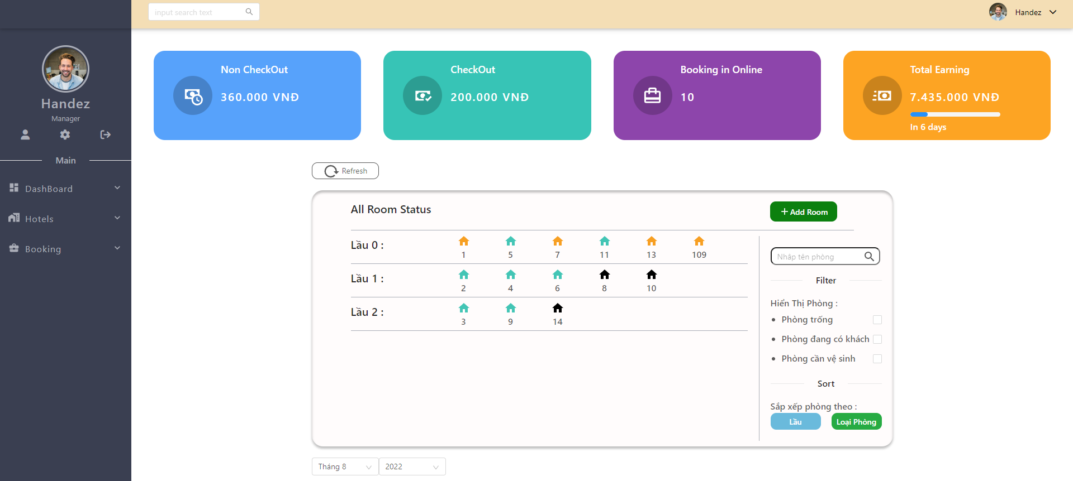

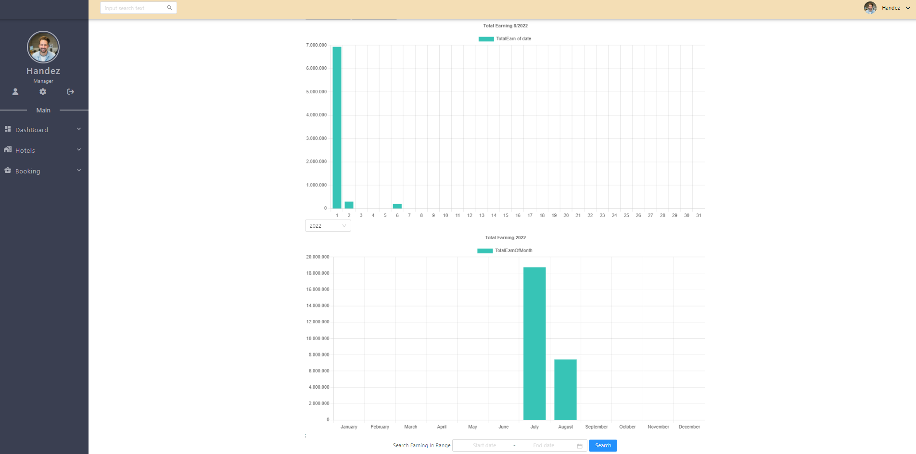

|  |  |  |  |  |
| --- | --- | --- | --- | --- |
| **No** | **Function** | **Description** | **Validation** | **Outcome** |
| 1 | View all Room Status | View the status room | No | Table include data on dashboard page |
| 2 | View detail nonCheckout | View detail nonCheckout | No | Table include data on dashboard page |
| 3 | View detail Checkout | View detail Checkout | No | Table include data on dashboard page |
| 4 | View detail total earning | View detail total earning | No | Table include data on dashboard page |

1. View total Earning nonCheckout

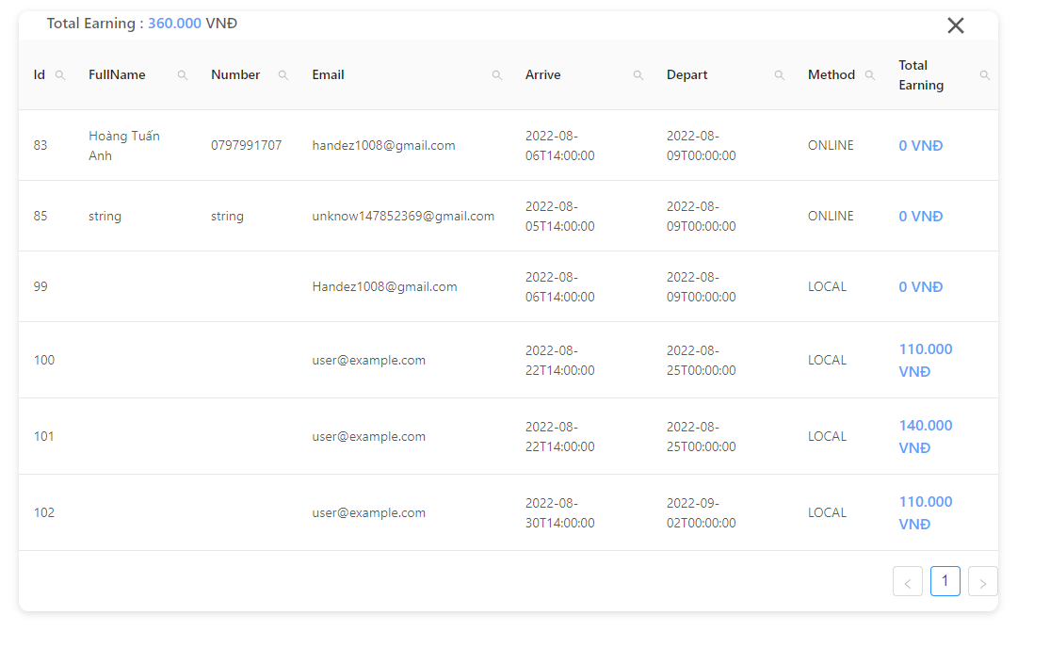

|  |  |  |  |  |
| --- | --- | --- | --- | --- |
| **No** | **Function** | **Description** | **Validation** | **Outcome** |
| 1 | View total Earning nonCheckout | Click to view invoice information | No | Open invoice pop-up |

1. View total Checkout list

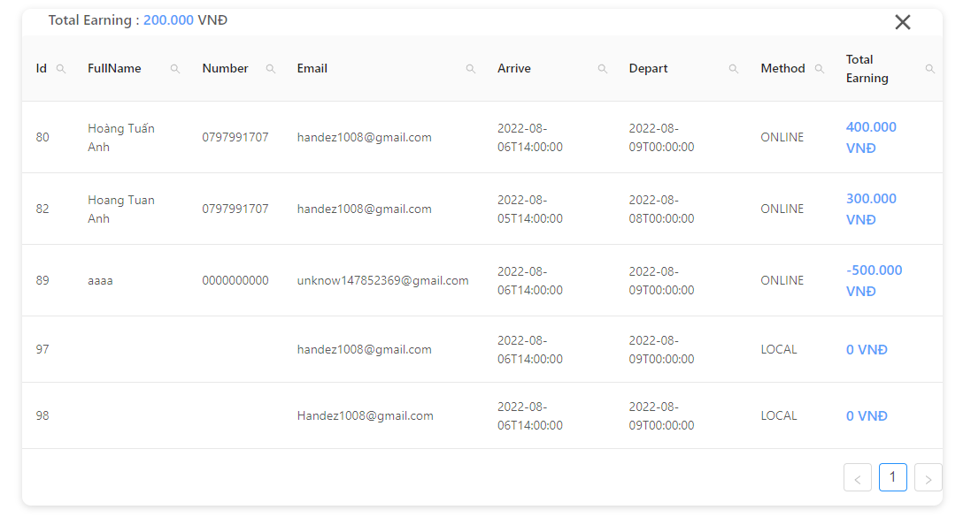

|  |  |  |  |  |
| --- | --- | --- | --- | --- |
| **No** | **Function** | **Description** | **Validation** | **Outcome** |
| 1 | View total Earning Checkout | Click to view invoice information | No | Wallet transaction information by month |

1. View total earning list

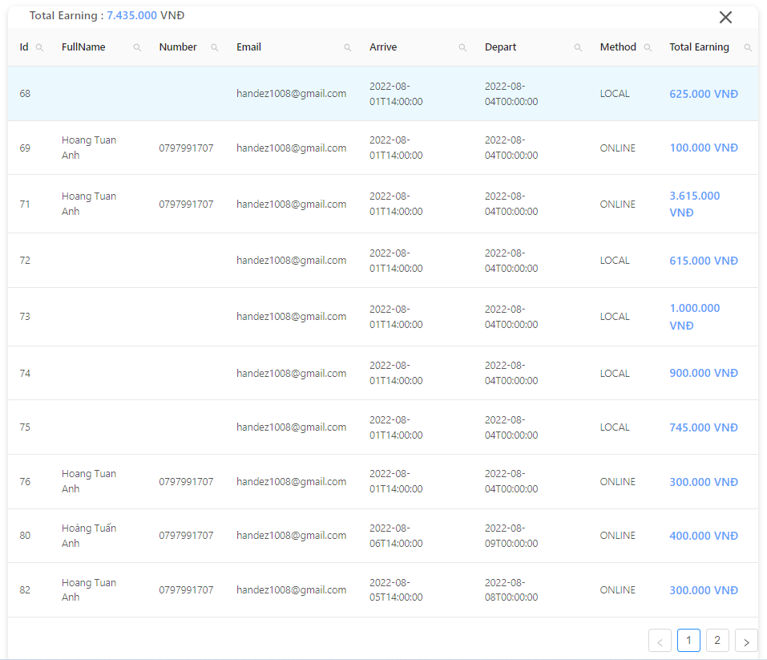

|  |  |  |  |  |
| --- | --- | --- | --- | --- |
| **No** | **Function** | **Description** | **Validation** | **Outcome** |
| 1 | View total Earning | Click to view invoice information | No | Open invoice pop-up |

1. Booking history
   1. View booking list

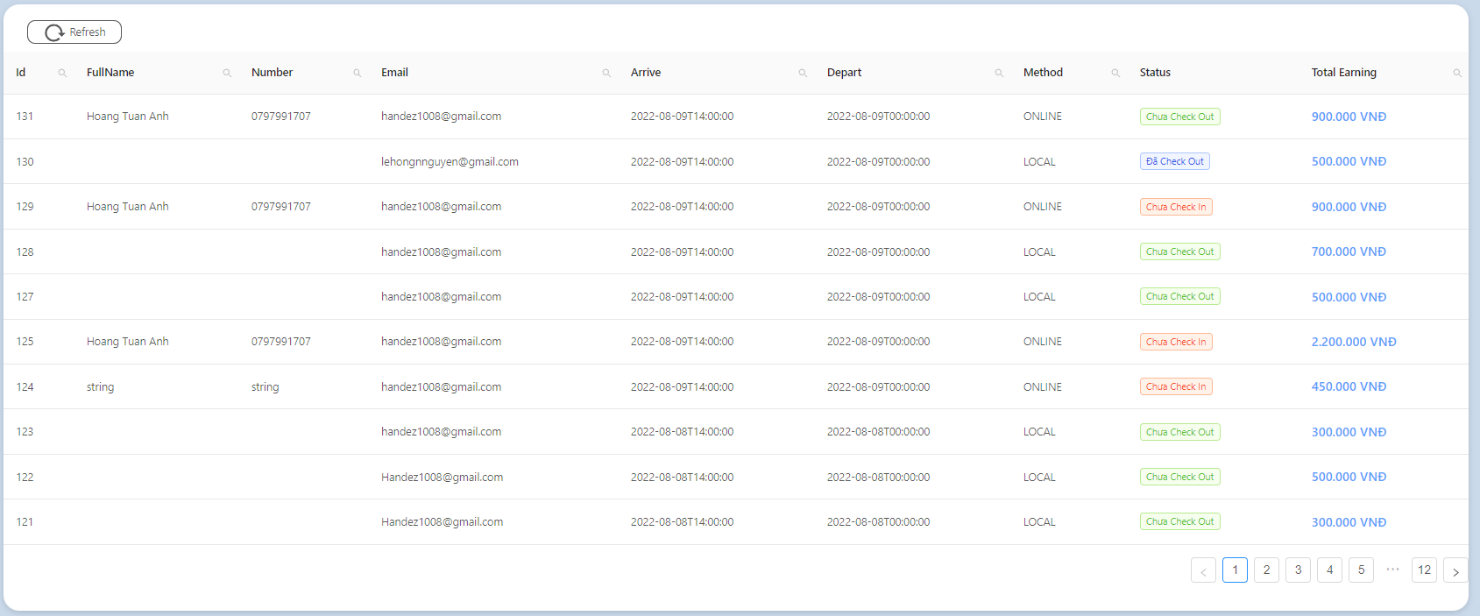

|  |  |  |  |  |
| --- | --- | --- | --- | --- |
| **No** | **Function** | **Description** | **Validation** | **Outcome** |
| 1 | View detail booking | Click to show pop-up booking details | No | Open station detail pop-up |

1. Hotel
   1. List room

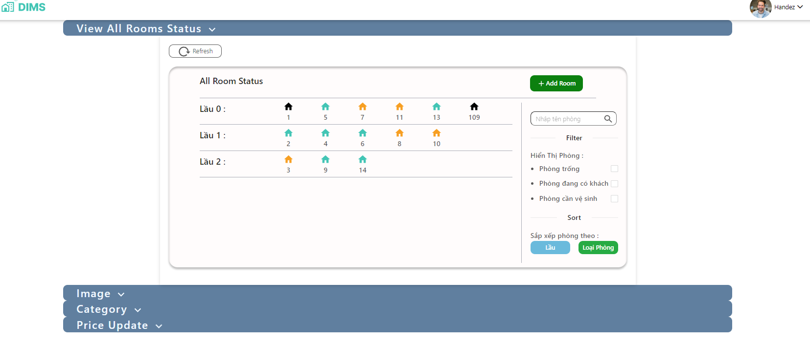

|  |  |  |  |  |
| --- | --- | --- | --- | --- |
| **No** | **Function** | **Description** | **Validation** | **Outcome** |
| 1 | Status rooms | Click to show pop-up detail room | No | Open create route pop-up |

* 1. Images

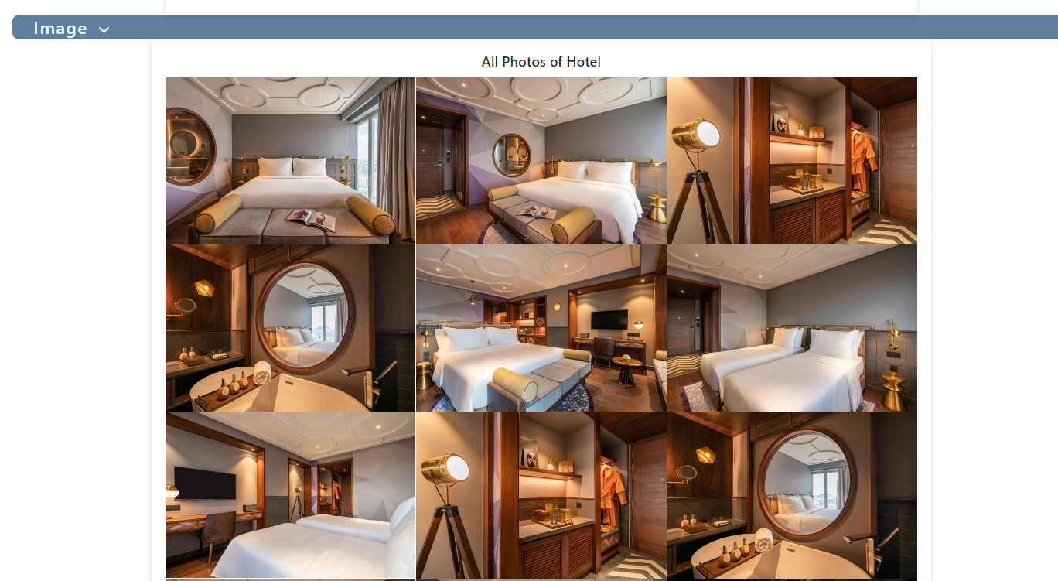

|  |  |  |  |  |  |
| --- | --- | --- | --- | --- | --- |
| **No** | **Field Name** | **Description** | **Read only** | **Mandatory** | **Control type** |
| 1 | Set mainimage | Set mainimage for hotel or motel | No | Yes | Popup |
| 2 | Delete images | Delete images in albums | No | Yes | Popup |
| 3 | Add images | Add images in albums | No | Yes | Popup |

* 1. Category

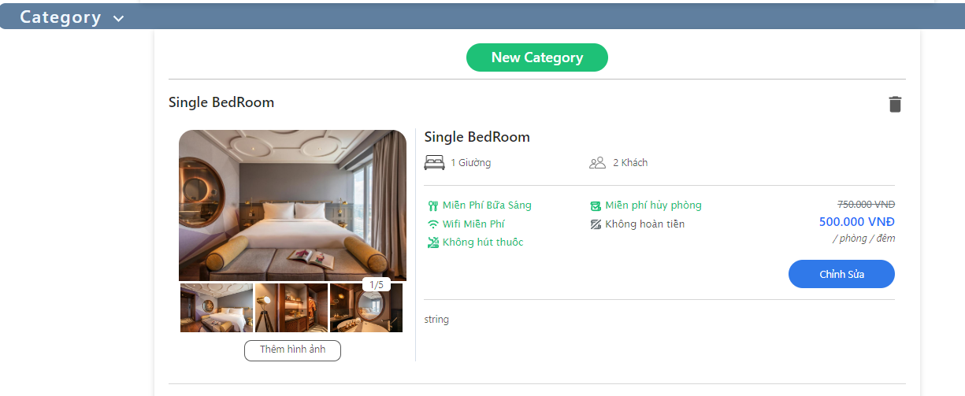

|  |  |  |  |  |  |  |
| --- | --- | --- | --- | --- | --- | --- |
| **No** | **Field Name** | **Description** | **Read only** | **Mandatory** | **Control type** | **Data type** |
| 1 | New Category | Add Category | No | Yes | Text box, Popup | String |
| 2 | Edit, Update | Edit, update type room, beds, price | No | Yes | Text box | String |
| 3 | Add images | The departure name of the route | No | Yes | Popup | String |

1. Price Update

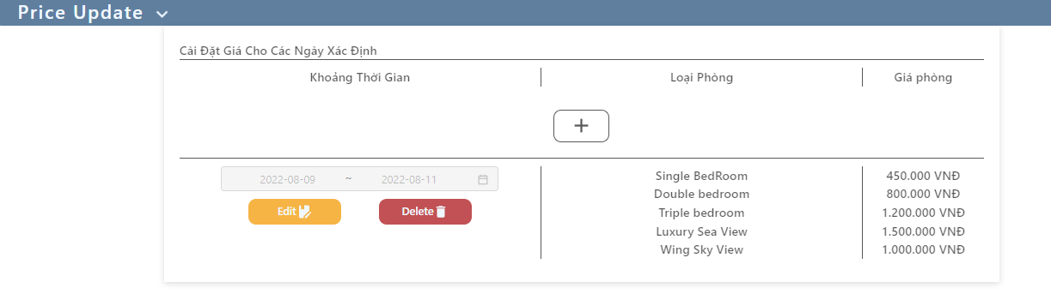

|  |  |  |  |  |  |  |
| --- | --- | --- | --- | --- | --- | --- |
| **No** | **Field Name** | **Description** | **Read only** | **Mandatory** | **Control type** | **Data type** |
| 1 | Edit, Delete | Edit, Delete type room, price | No | Yes | Text box | String |

1. Manage Hotels

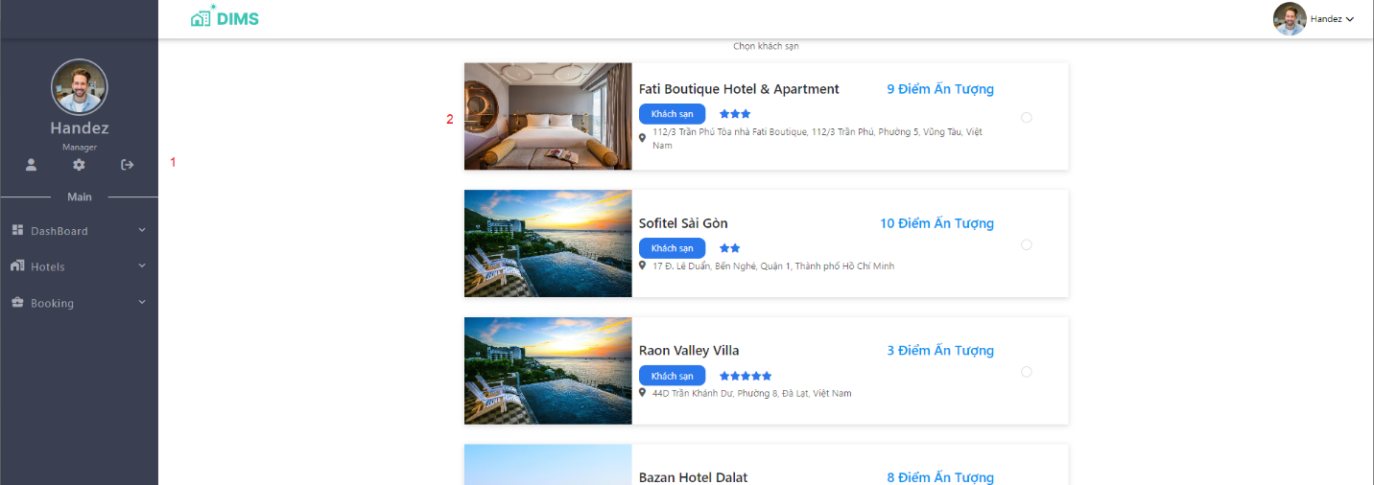

|  |  |  |  |  |
| --- | --- | --- | --- | --- |
| **No** | **Function** | **Description** | **Validation** | **Outcome** |
| 1 | logout | Click to logout account | No | Navigate to “login” screen |
| 2 | View hotel detai | Tap to go to the “hotel detail” screen | no | Navigate to “hotel detail” screen |

* + 1. **User web application**

1. User search hotel filter

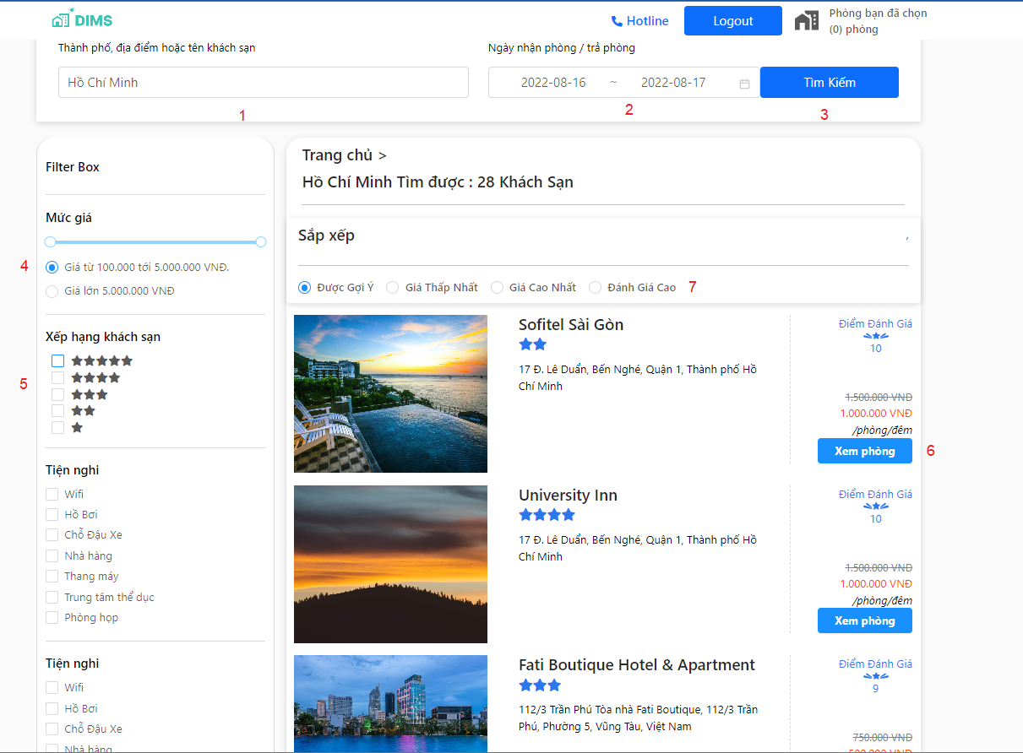

|  |  |  |  |  |  |  |
| --- | --- | --- | --- | --- | --- | --- |
| **No** | **Field Name** | **Description** | **Read only** | **Mandatory** | **Control type** | **Data type** |
| 1 | Search name field | The content to search | No | Yes | Text box | String |
| 2 | Search date field | The start date and total night stay | No | Yes | Text box | String |

|  |  |  |  |  |
| --- | --- | --- | --- | --- |
| **No** | **Function** | **Description** | **Validation** | **Outcome** |
| 3 | search | Tap to search hotel | yes | Only show hotels have one or more room |
| 4 | Price filter | Drag to choose wanted price | yes | Show hotel have the price between wanted price |
| 5 | Rate filter | Choose rating | Yes | Show hotel have the suitable rate |
| 6 | View hotel | Tap to go to view hotel detail page | No | Navigate to “view hotel detail” screen |
| 7 | Other filter | Tap to choose filter you want | No | Show suitable hotel |

1. View hotel detail

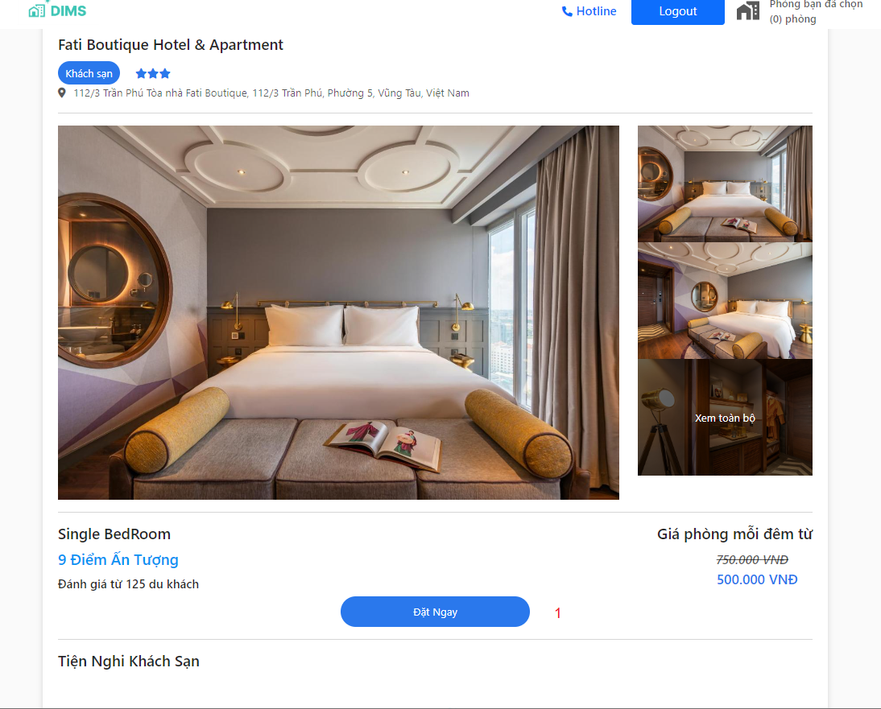

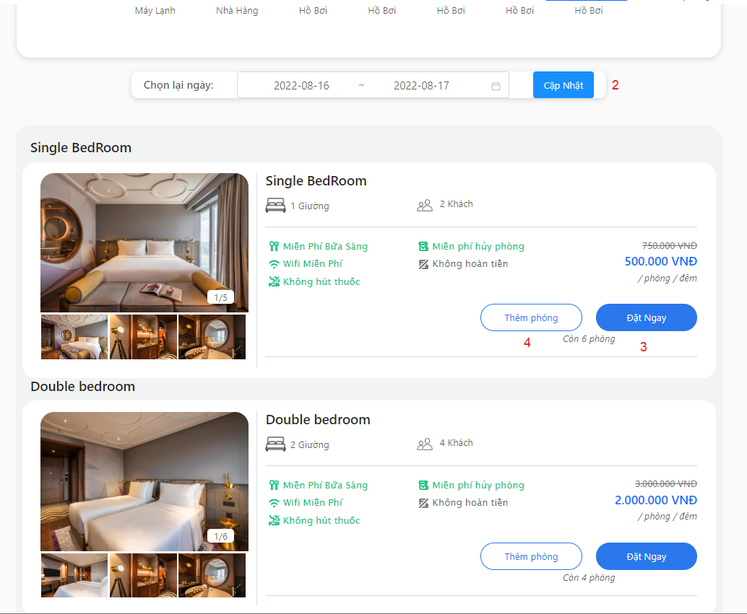

|  |  |  |  |  |
| --- | --- | --- | --- | --- |
| **No** | **Function** | **Description** | **Validation** | **Outcome** |
| 1 | Order now | Tap to go to “order now” screen | no | Navigate to “order now” screen |
| 2 | Update date search | Tap to change the date you want | No | Show list room suitable to the date |
| 3 | Order now | Tap to go to “order now” screen | no | Navigate to “order now” screen |
| 4 | Add room | Tap to add room to your cart of that hotel | yes | Your cart have room only in that hotel when change to other hotel it reset card |

1. Manage cart

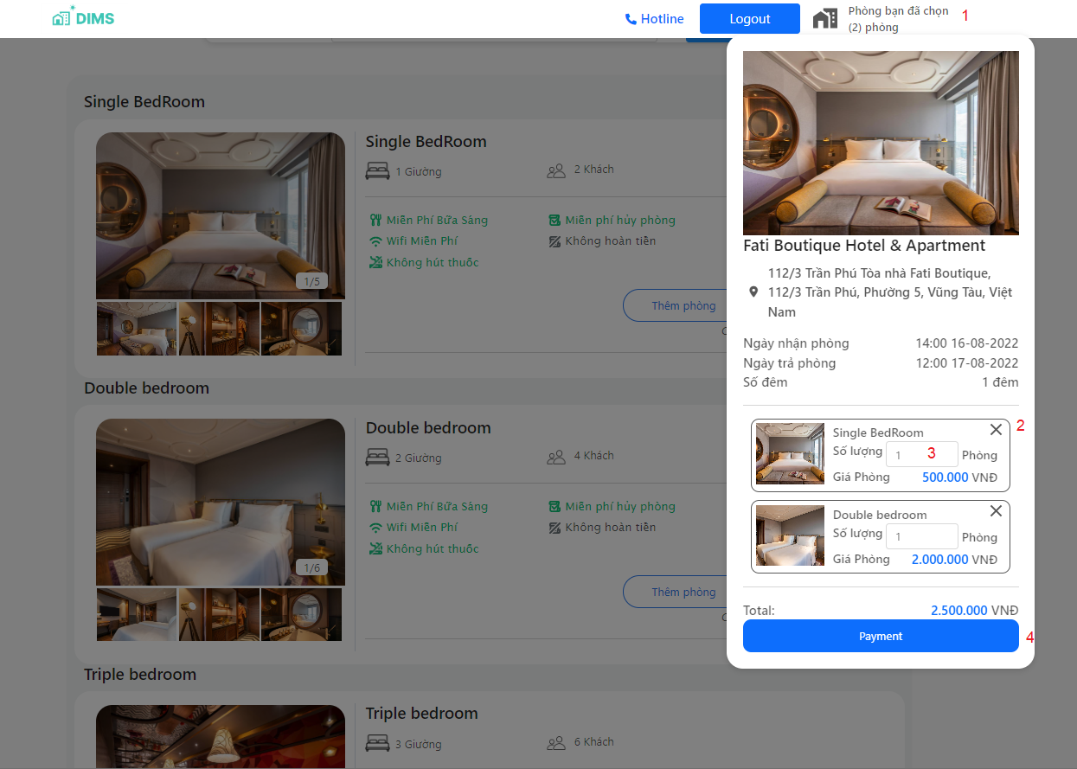

|  |  |  |  |  |  |  |
| --- | --- | --- | --- | --- | --- | --- |
| **No** | **Field Name** | **Description** | **Read only** | **Mandatory** | **Control type** | **Data type** |
| 3 | Room quantity | Room amount | No | Yes | Text box | number |

|  |  |  |  |  |
| --- | --- | --- | --- | --- |
| **No** | **Function** | **Description** | **Validation** | **Outcome** |
| 2 | Remove from cart | Delete category | No | That category deleted |
| 1 | Your cart | View cart | yes | Pop up to show the category add from that hotel |
| 4 | payment | Tap to go to payment screen | No | Navigate to “payment” screen |
| 3 | Update amount room | Tap to update amount room | Yes | Allow the amount room in range of that category |

1. Manage payment

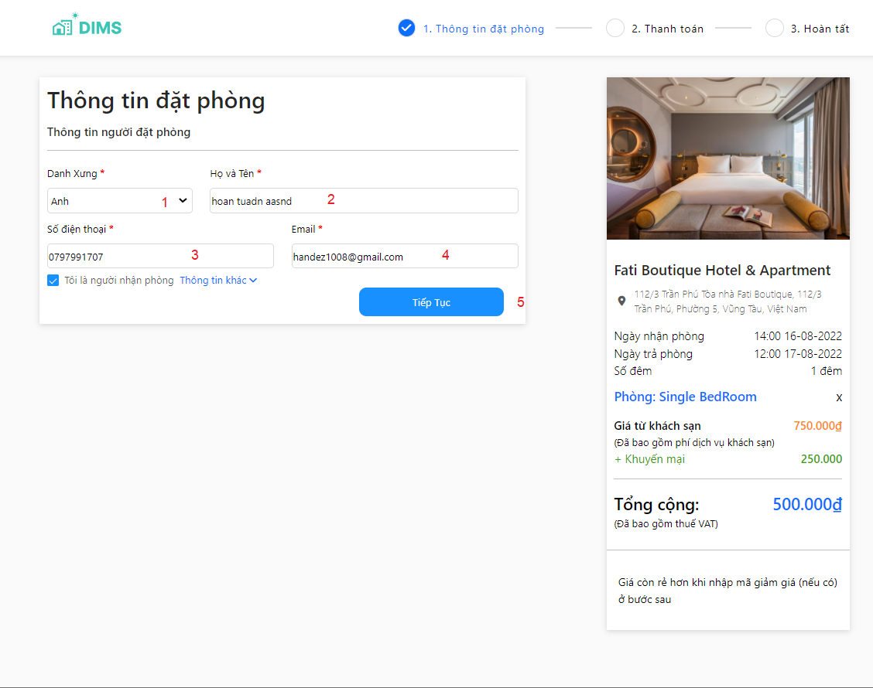

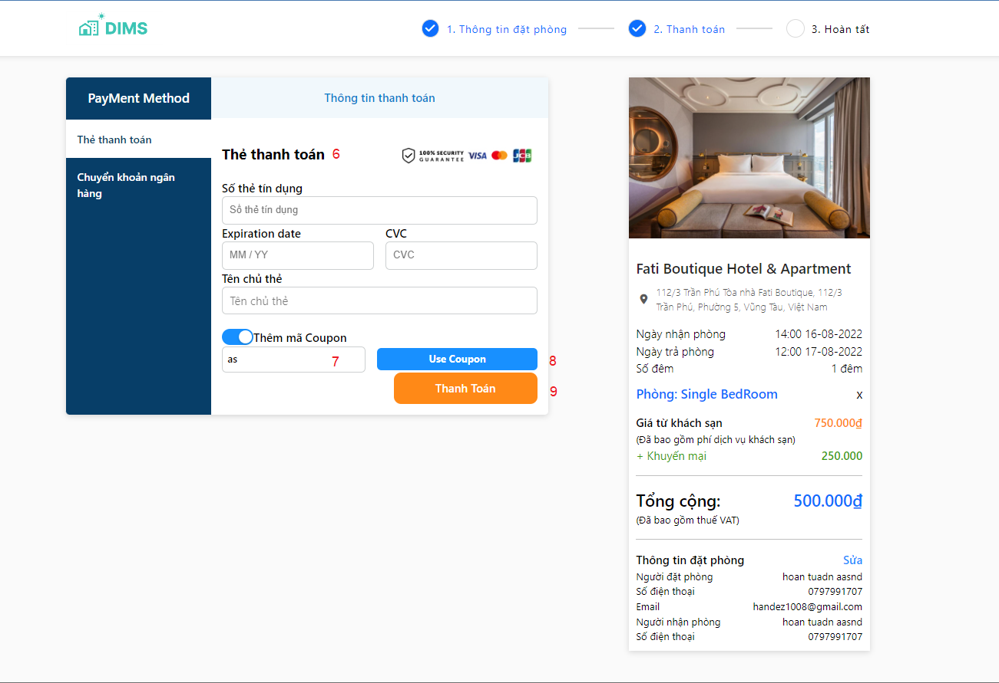

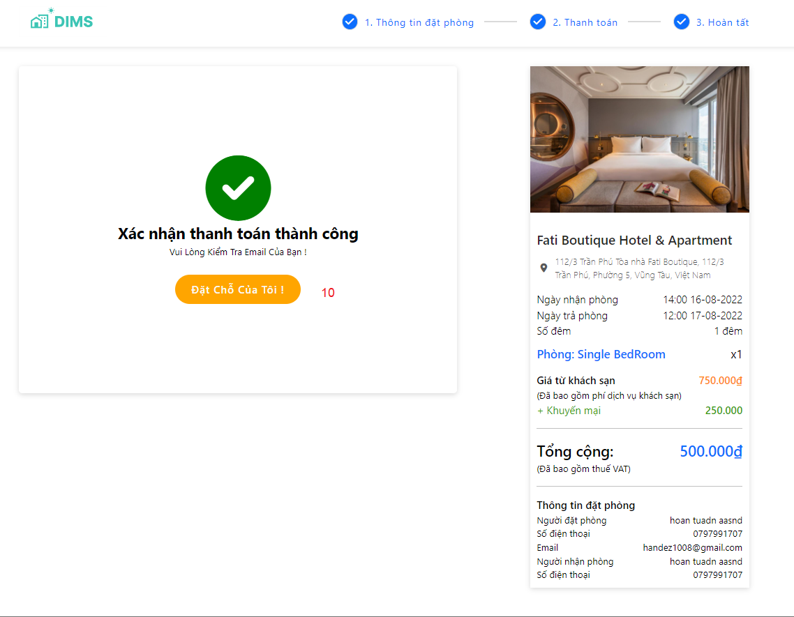

|  |  |  |  |  |  |  |
| --- | --- | --- | --- | --- | --- | --- |
| **No** | **Field Name** | **Description** | **Read only** | **Mandatory** | **Control type** | **Data type** |
| 1 | name | User name to call | No | Yes | Text box | string |
| 2 | Full name | User full name | No | Yes | Text box | string |
| 3 | phone | User phone number | No | yes | Text box | string |
| 4 | email | User email | No | yes | Text box | string |
| 6 | Card info | User card info | No | Yes | Text box | string |
| 7 | Voucher code | Voucher code | No | Yes | Text box | string |

|  |  |  |  |  |
| --- | --- | --- | --- | --- |
| **No** | **Function** | **Description** | **Validation** | **Outcome** |
| 5 | next | Tap to move to next step | No | Navigate to payment method screen |
| 8 | Use coupon | Tap to check the coupon | yes | Check if coupon still available |
| 9 | pay | Tap to begin paying progress | yes | Check the booking info if it available , the booking will be add to database and send mail .If not it will show error messeage |
| 10 | Booking history | Tap to move to booking history | no | Navigate to booking history screen |

1. Manage booking history

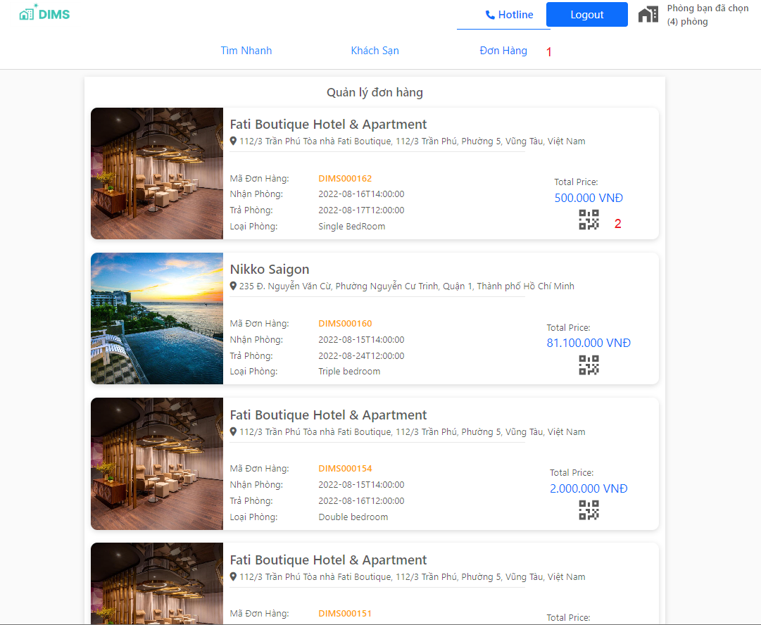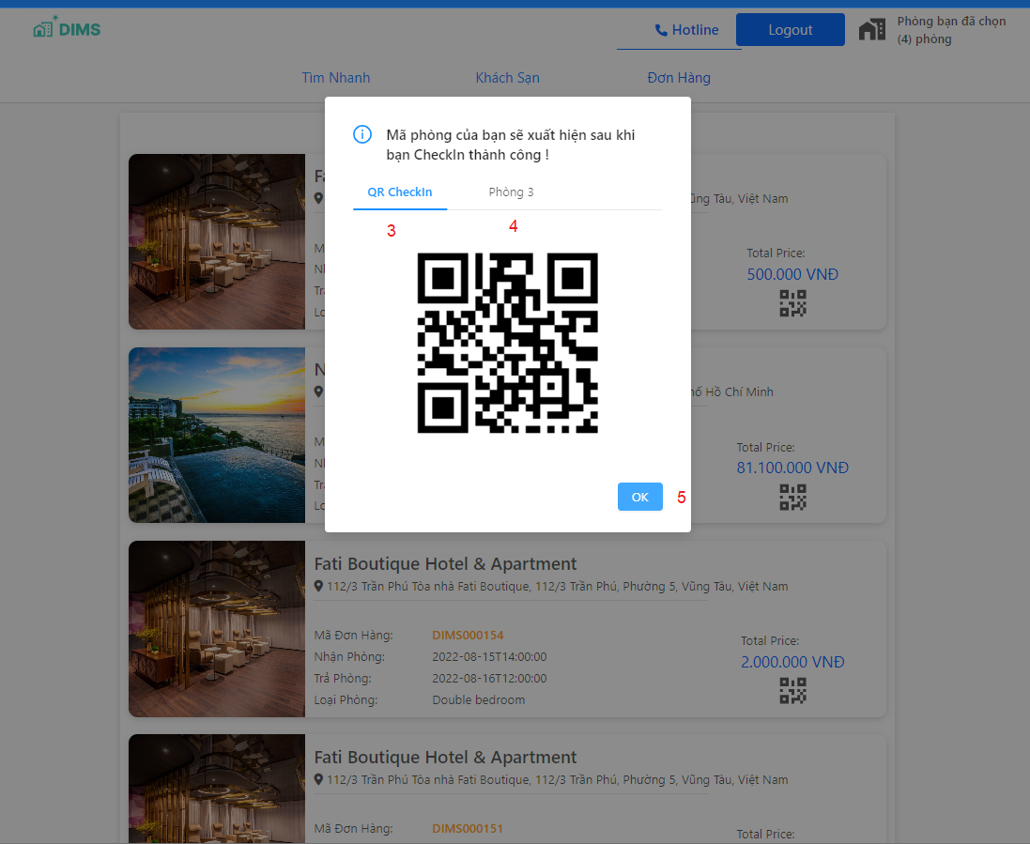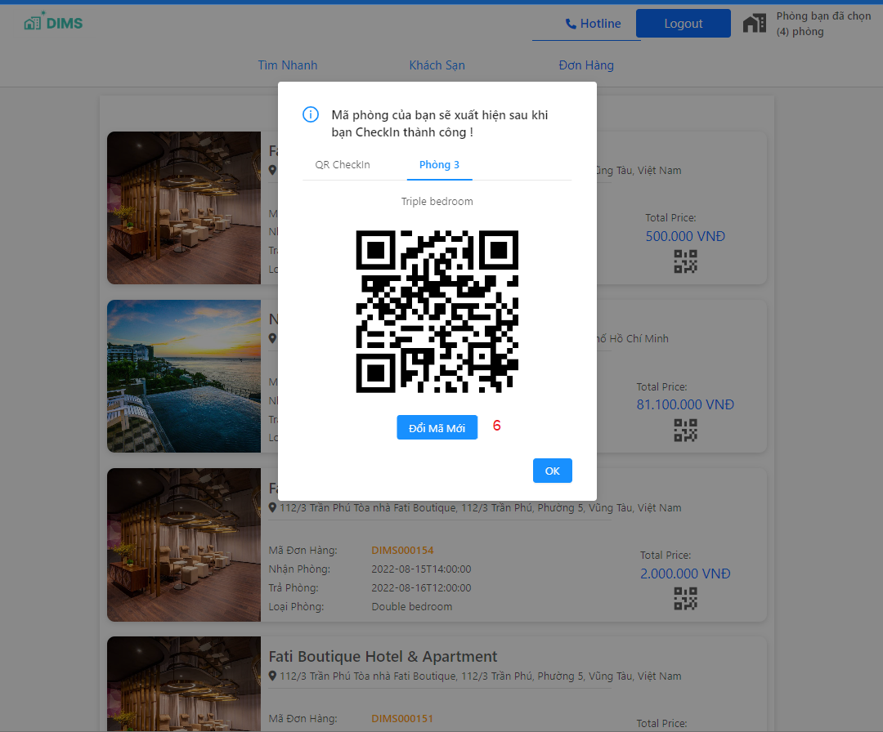

|  |  |  |  |  |
| --- | --- | --- | --- | --- |
| **No** | **Function** | **Description** | **Validation** | **Outcome** |
| 1 | Booking history | Tap to view all the booking history now and past | No | Show all the booking history of that user sort by latest date |
| 2 | View qr | Tap to see the qr checkin and qr room | no | Popup show all qr |
| 3 | Qr checkin | Tap to see the qr check in | No | Popup show qr checkin |
| 4 | Qr room | Tap next one to see other qr of your room | Yes | Only show qr room when user already checkin |
| 5 | ok | Tap to go back to history | No | Navigate to booking history |
| 6 | Renew qr | Tap this to get new qr room will send to your mail | Yes | You can only renew 3 times a date if not the error message will show |

* + 1. **Customer Module**

1. Login and sign up
   1. Login

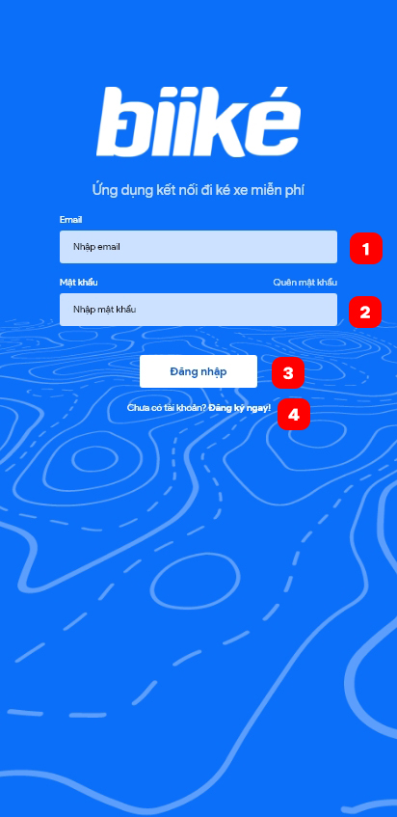

|  |  |  |  |  |  |  |
| --- | --- | --- | --- | --- | --- | --- |
| **No** | **Field Name** | **Description** | **Read only** | **Mandatory** | **Control type** | **Data type** |
| 1 | Email | Email of customer (biker/keer) | No | Yes | Text Box | String |
| 2 | Password | Password of customer (biker/keer) | No | Yes | Text Box | String |

|  |  |  |  |  |
| --- | --- | --- | --- | --- |
| **No** | **Function** | **Description** | **Validation** | **Outcome** |
| 3 | Login | Click to login to system | Yes | Navigate to Home screen if success or information pop up if fail |
| 4 | Sign up | Click to sign up | No | Navigate to Sign up screen |

* 1. Sign up

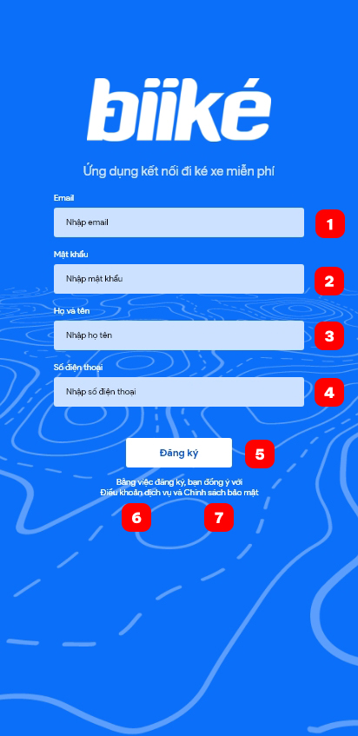

|  |  |  |  |  |  |  |
| --- | --- | --- | --- | --- | --- | --- |
| **No** | **Field Name** | **Description** | **Read only** | **Mandatory** | **Control type** | **Data type** |
| 1 | Email | Email of customer (biker/keer) | No | Yes | Text Box | String |
| 2 | Password | Password of customer (biker/keer) | No | Yes | Text Box | String |
| 3 | Full name | Email of customer (biker/keer) | No | Yes | Text Box | String |
| 4 | Phone number | Phone number of customer (biker/keer) | No | Yes | Text Box | String |

|  |  |  |  |  |
| --- | --- | --- | --- | --- |
| **No** | **Function** | **Description** | **Validation** | **Outcome** |
| 5 | Sign up | Create an account | Yes | Navigate to choose mode screen if success or information pop up if fail |
| 6 | Terms of use | View terms of use | No | Open terms of use on Biiké website |
| 7 | Privacy Policy | View privacy policy | No | Open privacy policy on Biiké website |

* 1. Choose mode

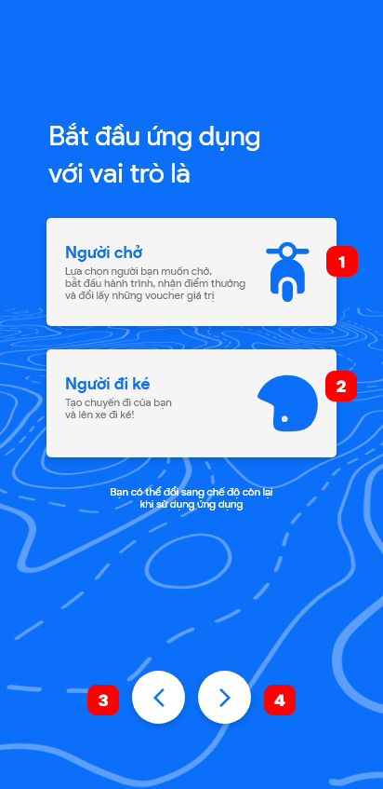

|  |  |  |  |  |  |  |
| --- | --- | --- | --- | --- | --- | --- |
| **No** | **Field Name** | **Description** | **Read only** | **Mandatory** | **Control type** | **Data type** |
| 1 | Biker Mode | Mode for biker or driver | No | Yes | Card | Number |
| 2 | Keer Mode | Mode for keer or hitchhiker | No | Yes | Card | Number |

|  |  |  |  |  |
| --- | --- | --- | --- | --- |
| **No** | **Function** | **Description** | **Validation** | **Outcome** |
| 3 | Previous | Back to previous screen | No | Previous screen |
| 4 | Next | Confirm mode and go to next screen | Yes | Navigate to Keer’s home screen (if keer) of Manage bike screen to add bike (if biker) |

1. Homepage
   1. Keer’s home page

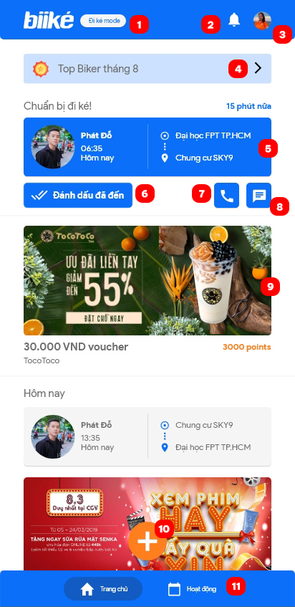

|  |  |  |  |  |
| --- | --- | --- | --- | --- |
| **No** | **Function** | **Description** | **Validation** | **Outcome** |
| 1 | Switch mode | Switch to biker mode | Yes | Navigate to Biker home screen or Manage bike screen to add bike |
| 2 | View notification | Notification | No | Navigate to notification screen |
| 3 | View profile | Profile | No | Navigate to profile page with customer information |
| 4 | View top bikers | Top 10 bikers with highest point from driving in the system | No | Navigate to top biker screen |
| 5 | View trip detail | More trip’s information | No | Navigate to trip detail screen |
| 6 | Mark as arrived | Mark the trip as arrived | Yes | Trip is marked as arrived or fail (due to customer location) |
| 7 | Call biker | Make a call to biker | No | Open call app with biker’s phone number |
| 8 | Message biker | Message to biker | No | Open message app with biker’s phone number |
| 9 | View ads or voucher | View adverting or voucher detail | No | Open advertising URL in browser or voucher detail in app |
| 10 | Create trip | Create a new trip | No | Navigate to create trip page |
| 11 | View activity | View upcoming trip and past trip | No | Navigate to activity screen |

* 1. Biker’s home page

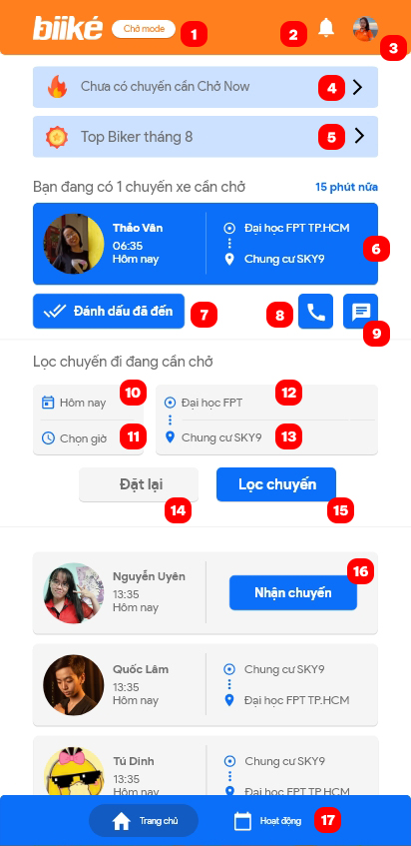

|  |  |  |  |  |  |  |
| --- | --- | --- | --- | --- | --- | --- |
| **No** | **Field Name** | **Description** | **Read only** | **Mandatory** | **Control type** | **Data type** |
| 10 | Choose date | Choose date of trip that want to filter | No | No | Date piker | String |
| 11 | Choose time | Choose time of trip that want to filter | No | No | Time piker | String |
| 12 | Choose departure | Choose departure of trip that want to filter | No | No | Dropdown | String |
| 13 | Choose destination | Choose destination of trip that want to filter | No | No | Dropdown | String |

|  |  |  |  |  |
| --- | --- | --- | --- | --- |
| **No** | **Function** | **Description** | **Validation** | **Outcome** |
| 1 | Switch mode | Switch to keer mode | Yes | Navigate to Keer home screen |
| 2 | View notification | Notification | No | Navigate to notification screen |
| 3 | View profile | Profile | No | Navigate to profile page with customer information |
| 4 | View Ride Now | View Ride Now trip and setting | No | Navigate to Ride Now screen |
| 5 | View top bikers | Top 10 bikers with highest point from driving in the system | No | Navigate to top biker screen |
| 6 | View trip detail | More trip’s information | No | Navigate to trip detail screen |
| 7 | Mark as arrived | Mark the trip as arrived | Yes | Trip is marked as arrived or fail (due to customer location) |
| 8 | Call keer | Make a call to keer | No | Open call app with keer’ s phone number |
| 9 | Message keer | Message to keer | No | Open message app with keer ‘s phone number |
| 14 | Reset | Reset field for filter trip | No | Field for filter trip (10,11,12,13) is reset |
| 15 | Filter trip | Filter trip with field (10,11,12,13) | Yes | Show trip is filtered below |
| 16 | Accept a trip | Accept a keer ‘s schedule trip | Yes | Trip is accepted |
| 17 | View activity | View upcoming trip and past trip | No | Navigate to activity screen |

1. Create and view trip
   1. Create trip

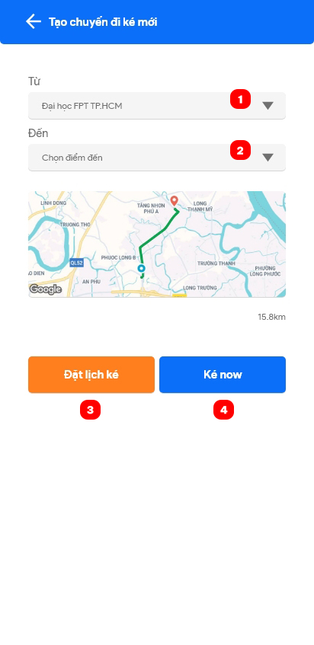

|  |  |  |  |  |  |  |
| --- | --- | --- | --- | --- | --- | --- |
| **No** | **Field Name** | **Description** | **Read only** | **Mandatory** | **Control type** | **Data type** |
| 1 | Choose departure | Choose departure of trip that want to filter | No | Yes | Dropdown | String |
| 2 | Choose destination | Choose destination of trip that want to filter | No | Yes | Dropdown | String |

|  |  |  |  |  |
| --- | --- | --- | --- | --- |
| **No** | **Function** | **Description** | **Validation** | **Outcome** |
| 3 | Schedule trip | Schedule a trip with date and time | No | Navigate to schedule trip screen |
| 4 | Trip Now | Request a trip right now | Yes | Information screen for processing Trip Now |

* 1. Create schedule trip

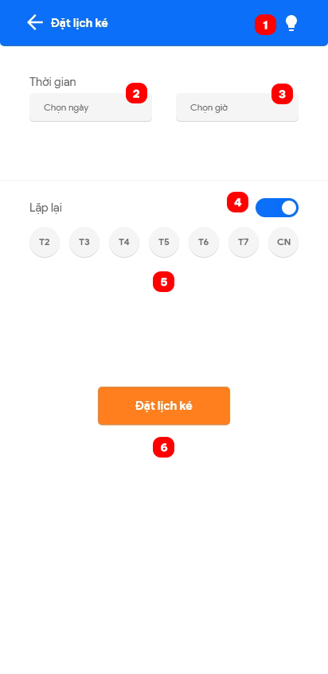

|  |  |  |  |  |  |  |
| --- | --- | --- | --- | --- | --- | --- |
| **No** | **Field Name** | **Description** | **Read only** | **Mandatory** | **Control type** | **Data type** |
| 2 | Choose date | Choose date of trip | No | Yes | Date piker | String |
| 3 | Choose time | Choose time of trip | No | Yes | Time piker | String |
| 4 | Turn on repeat | Turn on repeat feature if want to create multiple trips with the same time | No | No | Toggle | Boolean |
| 5 | Choose date in week | Choose date in week that want to repeat | No | No | Multiple check box | String |

|  |  |  |  |  |
| --- | --- | --- | --- | --- |
| **No** | **Function** | **Description** | **Validation** | **Outcome** |
| 1 | Open information pop-up | View information for schedule trip | No | Information pop-up with schedule trip rule |
| 6 | Create schedule trip | Create schedule trip with date, time and repeat data | Yes | Processing screen or fail if break the rule |

* 1. View trip

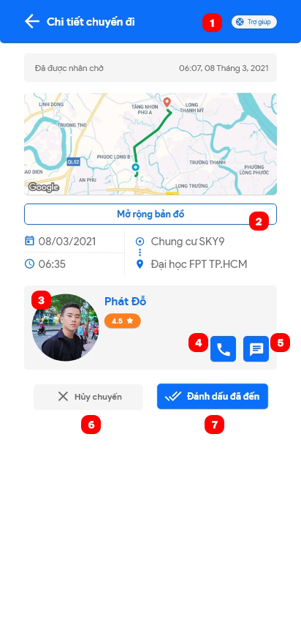

|  |  |  |  |  |
| --- | --- | --- | --- | --- |
| **No** | **Function** | **Description** | **Validation** | **Outcome** |
| 1 | Open Help Center | Open Help Center | No | Help Center pop-up is open |
| 2 | Extend map | Extend map to full screen | No | Map is extended to full screen |
| 3 | View partner | View partner information | No | Navigate to partner screen |
| 4 | Call partner | Make a call to partner | No | Open call app with partner s phone number |
| 5 | Message partner | Message to partner | No | Open message app with partner ‘s phone number |
| 6 | Cancel trip | Cancel a trip | Yes | Trip is canceled |
| 7 | Mark as arrived | Mark the trip as arrived | Yes | Trip is marked as arrived or fail (due to customer location) |

* 1. Trip help center

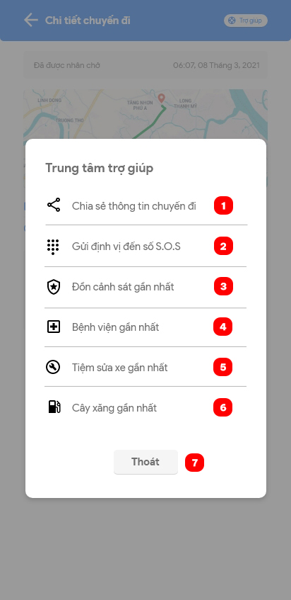

|  |  |  |  |  |
| --- | --- | --- | --- | --- |
| **No** | **Function** | **Description** | **Validation** | **Outcome** |
| 1 | Share location | Share real-time location | No | Location link is copy to clipboard |
| 2 | Send location to S.O.S numbers | Send location to S.O.S numbers | Yes | SMS include location link is sent to S.O.S numbers |
| 3 | View nearest police station | View nearest police station information | No | Open Google Maps with nearest police station is chosen |
| 4 | View nearest hospital | View nearest hospital information | No | Open Google Maps with nearest hospital is chosen |
| 5 | View nearest mechanic shop | View nearest mechanic shop information | No | Open Google Maps with nearest mechanic shop is chosen |
| 6 | View nearest gas station | View nearest gas station information | No | Open Google Maps with nearest gas station is chosen |
| 7 | Exit | Exit pop-up | No | Close Help Center pop-up |

1. View point

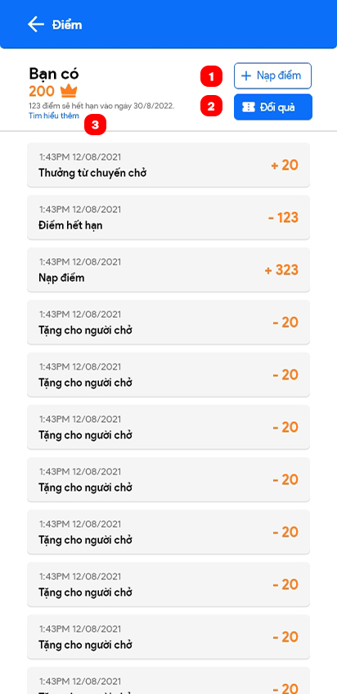

|  |  |  |  |  |
| --- | --- | --- | --- | --- |
| **No** | **Function** | **Description** | **Validation** | **Outcome** |
| 1 | Top up point | Top up point to wallet through MOMO wallet | No | Navigate to top up point page |
| 2 | Redeem reward | Redeem voucher from Biiké | No | Navigate to voucher page |
| 3 | See more | See more about point and reward | No | Open point and reward information URL on browser |

1. View partner/Manage profile
   1. View partner

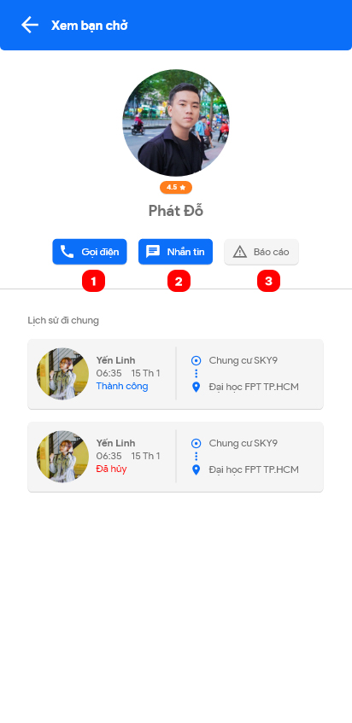

|  |  |  |  |  |
| --- | --- | --- | --- | --- |
| **No** | **Function** | **Description** | **Validation** | **Outcome** |
| 1 | Call partner | Make a call to partner | No | Open call app with partner s phone number |
| 2 | Message partner | Message to partner | No | Open message app with partner ‘s phone number |
| 3 | Report partner | Report partner to Biiké for bad behavior | No | Open Report pop-up to note reason or even block partner and confirm |

* 1. Unblock partner

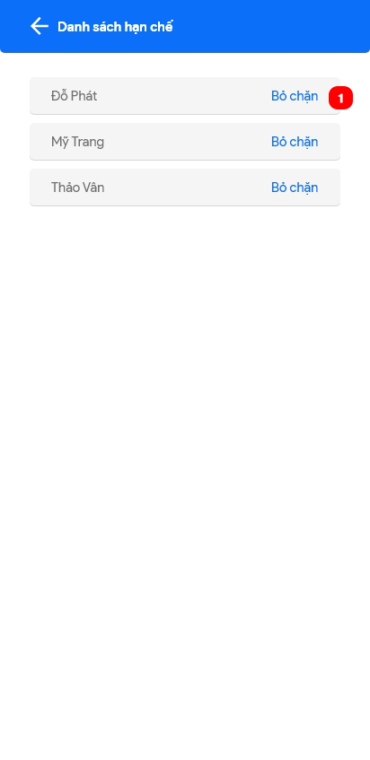

|  |  |  |  |  |
| --- | --- | --- | --- | --- |
| **No** | **Function** | **Description** | **Validation** | **Outcome** |
| 1 | Unblock partner | Unblock partner so they may have trip later | No | Partner is removed form ban list |

* 1. View profile

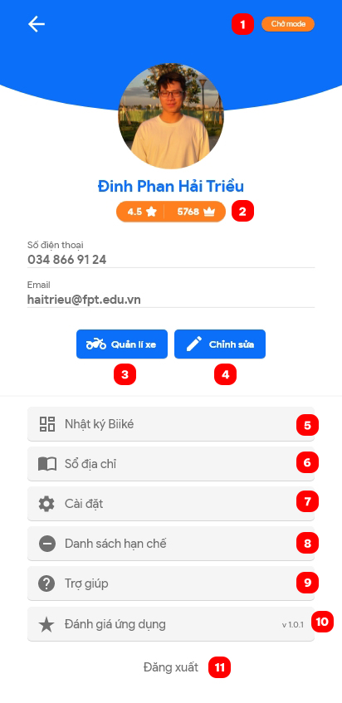

|  |  |  |  |  |
| --- | --- | --- | --- | --- |
| **No** | **Function** | **Description** | **Validation** | **Outcome** |
| 1 | Switch mode | Switch to other mode | Yes | Navigate to other home screen |
| 2 | View point | View point detail page | No | Navigate to view point screen |
| 3 | Mange bike | Manage bike information | No | Navigate to manage bike screen |
| 4 | Edit profile | Edit profile information | No | Navigate to edit profile page to edit |
| 5 | Manage address book | Manage addresses | No | Navigate to manage address screen |
| 6 | View app setting | Open settings | No | Navigate to app settings screen |
| 7 | Manage ban list | Manage list of partners was banned | No | Navigate to manage ban list screen |
| 8 | Manage S.O.S number | Manage S.O.S number to send SMS when call “Send location to S.O.S numbers” in Help Center screen | No | Navigate to manage S.O.S numbers screen |
| 9 | View help | View some help information; terms of use, privacy policy, point and voucher policy or contact to Biiké team | No | Navigate to help screen |
| 10 | Rate app | Rate Biiké on Google Play or App Store | No | Open Biiké app page on Google Play or App Store |
| 11 | Log out | Log out of Biiké | No | Customer logged out |

* 1. Add address

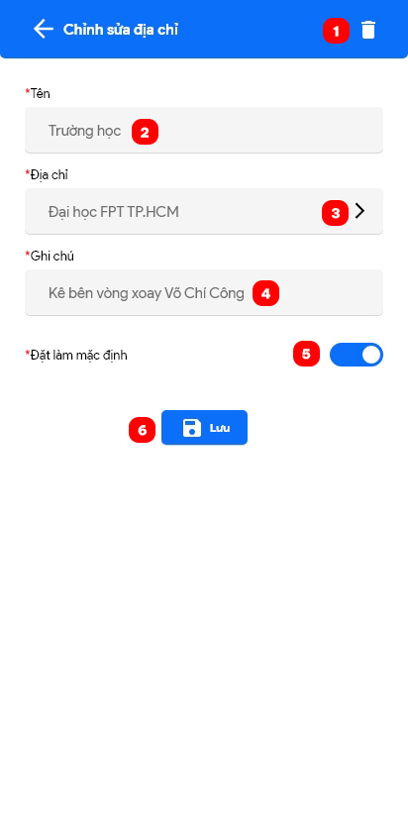

|  |  |  |  |  |  |  |
| --- | --- | --- | --- | --- | --- | --- |
| **No** | **Field Name** | **Description** | **Read only** | **Mandatory** | **Control type** | **Data type** |
| 2 | Address name | Name of address | No | Yes | Text box | String |
| 3 | Address detail | Detail of address (Use Google Maps to choose) | No | Yes | Text box | String |
| 4 | Note | Note to address | No | No | Text box | String |
| 5 | Set as default | Set address is default address | No | No | Toggle | Boolean |

|  |  |  |  |  |
| --- | --- | --- | --- | --- |
| **No** | **Function** | **Description** | **Validation** | **Outcome** |
| 1 | Delete address | Delete this address | Yes | Address is deleted or fail due to default address rule |
| 6 | Save address | Save this address | Yes | Address is added or fail due to duplicate address |

* 1. Add S.O.S number

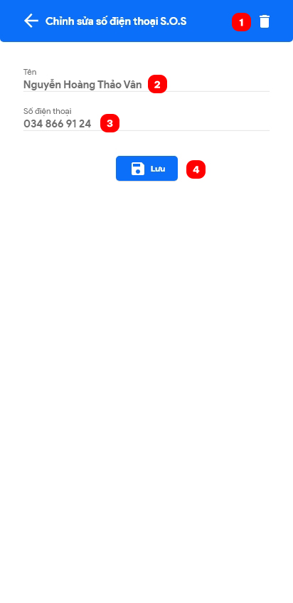

|  |  |  |  |  |  |  |
| --- | --- | --- | --- | --- | --- | --- |
| **No** | **Field Name** | **Description** | **Read only** | **Mandatory** | **Control type** | **Data type** |
| 2 | Name | Name of owner’s S.O.S number | No | Yes | Text box | String |
| 3 | Phone number | S.O.S phone number | No | Yes | Text box | String |

|  |  |  |  |  |
| --- | --- | --- | --- | --- |
| **No** | **Function** | **Description** | **Validation** | **Outcome** |
| 1 | Delete S.O.S number | Delete S.O.S number | No | S.O.S number is deleted |
| 4 | Save S.O.S number | Save S.O.S number | Yes | S.O.S number is saved or fail due to wrong number type |

1. Add bike

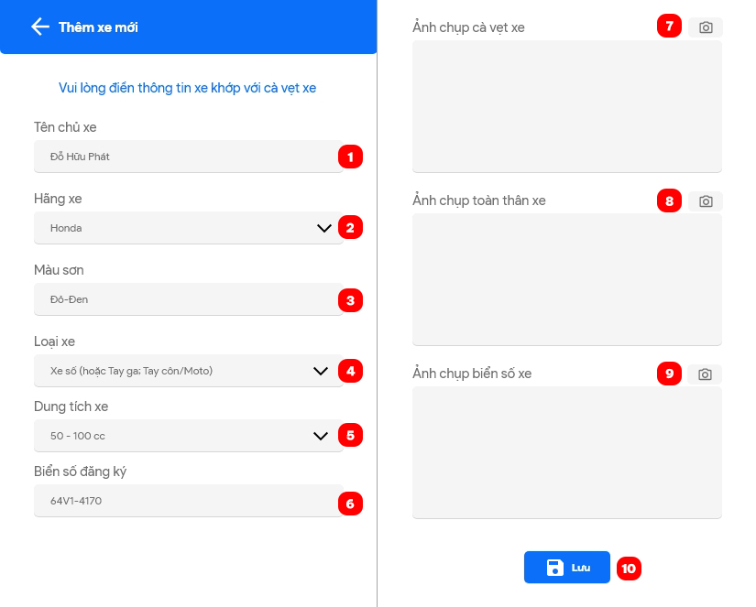

|  |  |  |  |  |  |  |
| --- | --- | --- | --- | --- | --- | --- |
| **No** | **Field Name** | **Description** | **Read only** | **Mandatory** | **Control type** | **Data type** |
| 1 | Owner name | Bike’s owner | No | Yes | Text box | String |
| 2 | Brand | Bike’s brand | No | Yes | Dropdown | String |
| 3 | Color | Bike’s color | No | Yes | Text box | String |
| 4 | Type | Bike’s type | No | Yes | Dropdown | String |
| 5 | Capacity | Bike’s capacity | No | Yes | Dropdown | String |
| 6 | Number plate | Bike’s number plate | No | Yes | Text box | String |

|  |  |  |  |  |
| --- | --- | --- | --- | --- |
| **No** | **Function** | **Description** | **Validation** | **Outcome** |
| 7 | Capture driver license | Take a picture of driver license by camera | No | Open camera |
| 8 | Capture bike’s body | Take a picture of bike’s body by camera | No | Open camera |
| 9 | Capture bike’s number plate | Take a picture of bike’s number plate by camera | No | Open camera |
| 10 | Save bike | Confirm bike, send to admin to verify | Yes | Bike is saved or fail due to wrong type |

1. Send trip feedback

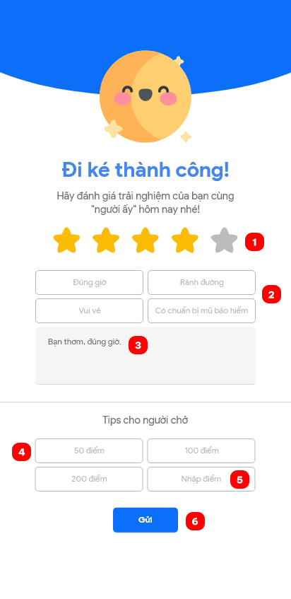

|  |  |  |  |  |  |  |
| --- | --- | --- | --- | --- | --- | --- |
| **No** | **Field Name** | **Description** | **Read only** | **Mandatory** | **Control type** | **Data type** |
| 1 | Trip star | Rate trip by star | No | Yes | Choose box | Number |
| 2 | Criteria | Criteria for quick feedback | No | Yes | Choose box | String |
| 3 | Feedback | Feedback about trip | No | Yes | Text box | String |
| 4 | Point for tip | Choose amount of point to tip for biker | No | No | Choose box | Number |
| 5 | Point for tip (input) | Input amount of point to tip for biker | No | No | Text box | Number |

|  |  |  |  |  |
| --- | --- | --- | --- | --- |
| **No** | **Function** | **Description** | **Validation** | **Outcome** |
| 6 | Send trip feedback | Send trip feedback | Yes | Feedback is sent or fail due to wrong type |

1. View notification

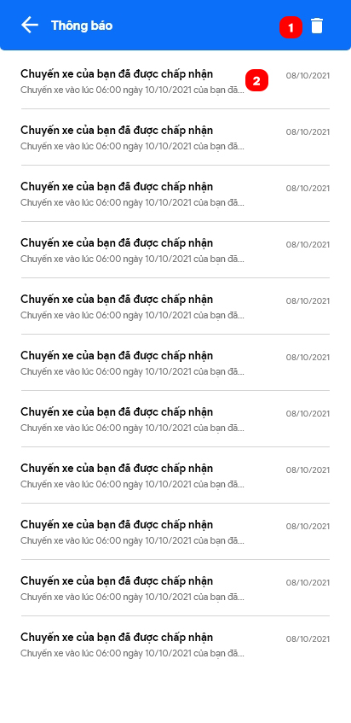

|  |  |  |  |  |
| --- | --- | --- | --- | --- |
| **No** | **Function** | **Description** | **Validation** | **Outcome** |
| 1 | Delete notification | Delete all notification | No | Confirm before delete all notification. If yes, all notification is deleted |
| 2 | View notification | View notification detail | No | Open notification detail screen |

1. View/Redeem voucher
   1. View voucher list

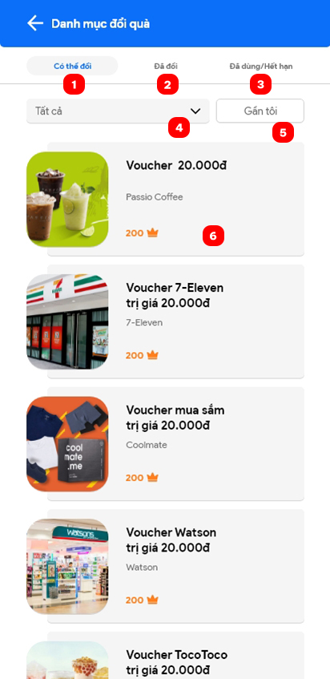

|  |  |  |  |  |  |  |
| --- | --- | --- | --- | --- | --- | --- |
| **No** | **Field Name** | **Description** | **Read only** | **Mandatory** | **Control type** | **Data type** |
| 4 | Choose voucher category | Choose one voucher category or all voucher | No | No | Dropdown | String |

|  |  |  |  |  |
| --- | --- | --- | --- | --- |
| **No** | **Function** | **Description** | **Validation** | **Outcome** |
| 1 | Can redeem | Voucher that can redeem tab | No | Open voucher that can redeem tab |
| 2 | Redeemed | Voucher that redeemed tab | No | Open voucher that redeemed tab |
| 3 | Used/Expired | Voucher that used or expired tab | No | Open voucher that used or expired tab |
| 5 | Near me | Sort voucher near customer | Yes | Voucher near customer is sorted |
| 6 | Voucher detail | View voucher details | No | Open voucher detail screen |

* 1. Voucher detail

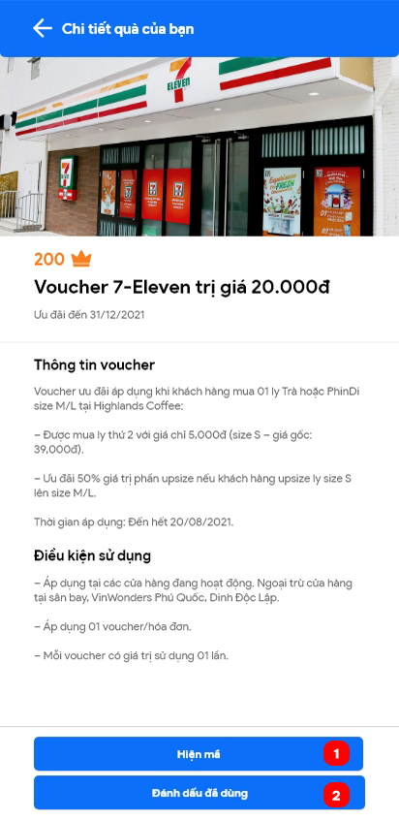

|  |  |  |  |  |
| --- | --- | --- | --- | --- |
| **No** | **Function** | **Description** | **Validation** | **Outcome** |
| 1 | Show code | Show voucher code | No | Voucher code is showed |
| 2 | Mark is used | Mark voucher as used | No | Voucher is marked as used |

1. App settings

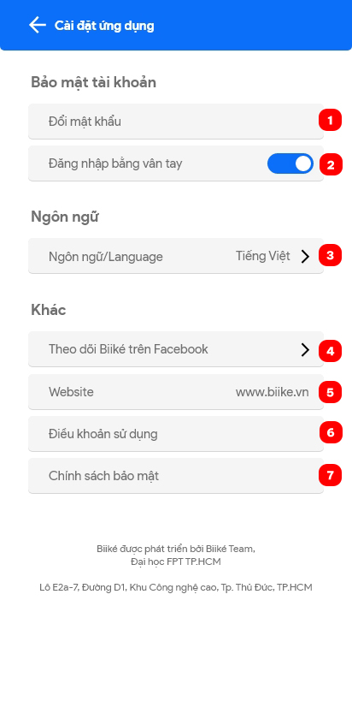

|  |  |  |  |  |
| --- | --- | --- | --- | --- |
| **No** | **Function** | **Description** | **Validation** | **Outcome** |
| 1 | Change password | Change password | No | Change password screen |
| 2 | Login by fingerprint | Turn on/off login by fingerprint | No | Login by fingerprint is turn on/off |
| 3 | Change language | Change language to English or Vietnamese | No | Language is changed to English or Vietnamese |
| 4 | Follow Biiké on Facebook | Open Biiké Facebook Page | No | Brower open Biiké’ s Facebook Page |
| 5 | Website | Open Biiké’ s website | No | Brower open Biiké’ s website |
| 6 | Terms of use | Open terms of use in Biiké’ s website | No | Brower open Biiké’ s Terms of use |
| 7 | Privacy Policy | Open privacy policy in Biiké ‘s website | No | Brower open Biiké’ s Privacy Policy |

1. Ride Now settings
   1. Ride Now page

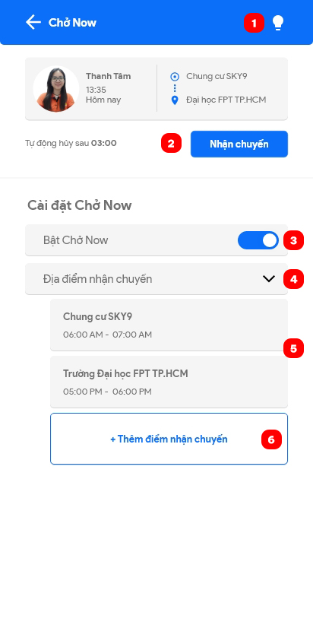

|  |  |  |  |  |
| --- | --- | --- | --- | --- |
| **No** | **Function** | **Description** | **Validation** | **Outcome** |
| 1 | View Ride Now instruction | Click to view Ride Now instruction | No | Ride Now Instruction pop-up is shown |
| 2 | Accept a Trip Now | Click to accept a Trip Now | No | Trip is accepted |
| 3 | Change Ride Now status | Turn Ride Now mode is on/off | No | Ride Now status is changed |
| 4 | Open Ride Now station list | Open to view all Ride Now stations | No | Ride Now stations are shown |
| 5 | View Ride Now station | Click to view Ride Now station | No | Ride Now station pop-up is shown |
| 6 | Add new Ride Now station | Click to add a new station for Ride Now | Yes | Ride Now station pop-up for add new is shown |

* 1. Add station to Ride Now

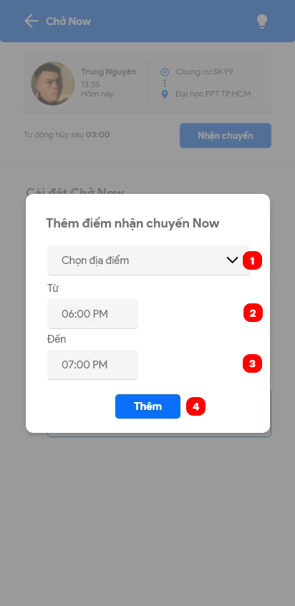

|  |  |  |  |  |  |  |
| --- | --- | --- | --- | --- | --- | --- |
| **No** | **Field Name** | **Description** | **Read only** | **Mandatory** | **Control type** | **Data type** |
| 1 | Station | Station from system that can choose to received Trip Now | No | Yes | Dropdown | String |
| 2 | Time from | Time to start to receive Trip Now on a day | No | Yes | Time picker | String |
| 3 | Time to | Time to stop to receive Trip Now on a day | No | Yes | Time picker | String |

|  |  |  |  |  |
| --- | --- | --- | --- | --- |
| **No** | **Function** | **Description** | **Validation** | **Outcome** |
| 4 | Add Ride Now station | Add a new station to Ride Now station | No | Ride Now station is added |

* 1. **Troubleshooting**

N/A

1. Appendix
2. Cloudinary

[https://cloudinary.com/](%20https://cloudinary.com/)

1. Email

[https://mail.google.com/mail/](https://dart.dev/)

1. Ant Design

[https://ant.design/](%20https://ant.design/)

1. Firebase

<https://firebase.google.com/>